Application for Public Unleased Land Permit
Section 45 of the Public Unleased Land Act 2013 (ACT)

Submit form to:
PERMIT NUMBER:
Public Land Use Team
Transport Canberra and City Services
tccs.commlanduse@act.gov.au
Ph. (02) 6205 9850

Please note a minimum of 3 business days is required for processing applications

Type of Activity
☐ Residential waste bins/skips (Non-Commercial use only)

Location
Street Address

Block and Section (if known) Suburb

Note: The placement of a waste/skip bin on public land is permitted for a maximum period of 7 days

Start Date Time Finish Date Time
 | / |  | / |  |  | : |  |  |  | / |  |  | / |  | :

Size of wastebin/skip to be placed on public land

Applicant’s Details
Please complete (A) if individually applying to use public unleased land, or (B) if applying on behalf of a company to use public unleased land.

Individual (Resident)
Full name

Email Phone

Have you had any proven non-compliance with a legal direction in relation to using public unleased land? (eg. failing to remove an object from public unleased land.
☐ Yes ☐ No
Have you had an application for a licence or permit to carry on activity on public unleased land refused?
☐ Yes ☐ No
If you answered YES to any of the above, please provide details:

Waste bin/skip provider
Note: Only an owner or director can apply on behalf of a corporation.

Full name of director/owner

Email Phone

Company name

ABN ACN

Company address

For the below questions, please note the following are relevant persons:
- executive officer of the corporation, the owner of the business;
- a person who exercises the power to take part in directorial, managerial or executive decision for the business or corporation;
- a person who has power to elect or appoint a person as an executive officer in the business or corporation;
- a person who has power to exercise a significant influence in relation to the conduct of the business or corporation;
- a related business or corporation; and
- an executive officer of a related business or corporation.

Have any relevant persons of the business or corporation had any convictions or finding of guilt within the last 10 years against a law of a state or territory for offences related to the use of public unleased land?
☐ Yes ☐ No

Have any relevant persons of the business or corporation had any proven non-compliance with a legal direction in relation to using public unleased land? (eg. failing to remove an object from public unleased land)
☐ Yes ☐ No

Have any relevant persons of the business or corporation had an application for a licence or permit to carry on activity on public unleased land refused?
☐ Yes ☐ No

If you answered YES to any of the above, please provide details:

Declaration

☐ I acknowledge I have read the ‘Important Information for Applicants’.
☐ I acknowledge I have read and accept all terms and conditions.
☐ I acknowledge I will abide by any additional conditions that may be attached to the permit.
☐ I declare that the information provided is true and correct.
☐ I understand it is an offence to make a false or misleading statement, give false or misleading information or produce a false or misleading document under the Criminal Code 2002 (ACT).

Applicant’s Signature Date

The below section is for office use only

☐ Approved Date: / /
☐ Not Approved

Authorised officer name Position number
This decision is made under section 57 of the Public Unleased Land Act 2013.

Street Address

Block and Section (if known) Suburb

Start Date Time Finish Date Time
 | / |  | / |  |  | : |  |  |  | / |  |  | / |  | :

Approval conditions

Important Information for Applicants

This application form is to be used for the use of a skip bin on public unleased land, generally known as a nature strip or verge, for further information – please contact tccs.commlanduse@act.gov.au

It is an offence to:
- use public unleased land without a permit (section 43 of the Public Unleased Land Act).
- fail to comply with conditions set out in a permit (section 44 of Public Unleased Land Act).

Terms and Conditions
‘Applicant’ - is defined as the person who completes and signs this ‘Application to Use a Public Place’. Where the applicant represents an organisation or company, the applicant is assumed to have authority from the organisation or company to act on its behalf and enter into this agreement.

‘Territory’ - refers to the Australian Capital Territory Government and its agencies.

‘Transport Canberra and City Services’ (TCCS) - is a Directorate within the Australian Capital Territory Government responsible for the management and use of Unleased Territory Land.

‘Nature strip or verge’ - refers to the section of Public Unleased Land directly adjacent to the front or side boundaries of the property, additional approval will be required to access the rear of a property from Public Unleased Land.

GENERAL CONDITIONS

A skip bin cannot be placed on a neighbouring nature strip, without written agreement from the owner of the adjacent property.

Non-adherence to the conditions within the permit are considered a breach under the ACT, warnings and infringements may apply.

Approval will be considered void, if all conditions are not adhered to during the use of the land.

As onsite conditions may vary, authorised officers may inspect the area and request additional conditions or relocation of the skip bin if there are concerns surrounding public safety or damage to Territory assets.

Skip bins are permitted within the permitted area for a maximum of 7 days from date of delivery. Additional approvals will be required for periods greater than 7 days.
All approvals that are required from relevant Authorities must be obtained and held for the duration of the permit.

Area to be restored back to original condition at removal of skip bin, including reseeding of grass if necessary.

LINE OF SIGHT
When placing the skip bin, the applicant must consider adequate sight distances for driveways and footpaths, as the skip bin may impact drivers vision of pedestrians below the height of the skip.

A minimum of 6m line of sight should be maintained around the skip when exiting / entering a driveway, as to not interfere with line of sight requirement for vehicles and pedestrians.

TREE CANOPY
No activity associated with the skip bin, such as Excavation, storage of materials and parking is permitted under the dripline of the tree canopy.

WASTE MANAGEMENT
Skip bin to remain covered when not in use and overnight
At the end of each day all litter and waste associated with the works must be contained within the skip or removed from site.
No material to be stored around skip. The applicant will be responsible for any illegal dumping which occurs during the term of the public land use permit.
Applicant responsible for removal of all waste associated with the skip bin once removed from public land.

CONTAMINATED WASTE
The applicant is responsible for investigating possible hazardous/contaminated waste within the permitted area.
The applicant must take all appropriate precautions and report to relevant authorities if any contaminated material is found.

EXISTING UTILITIES
The applicant is responsible for any damage to utilities or Territory assets.

CLEARANCE ZONES
Location of skip bin must comply with clearance zones image and description below:
Skip bin is not to be located within 1.5m of the kerb. This allows for safe pedestrian and cyclist movements and the use of the area, such as opening car doors and placement of wheelie bins.
Skip bin is not to be located within 1.5m of a driveway.
Skip bin is not to be located within 6 meters of a corner block, as imaged below.
Skip bin is not to be located within 1.0m on either side of the footpath.
Skip bin is not to be located within 1.5m of a utility e.g. meter pit/electrical box/ fire hydrant/ poles.
Skip bin is not to be located within 1.5m of an existing street tree (measured from the outside edge of the trunk).

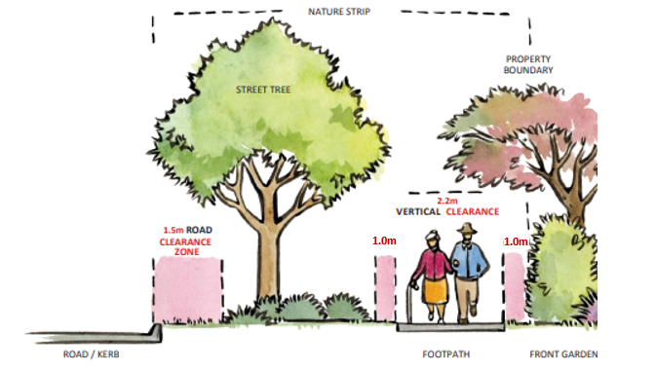 | 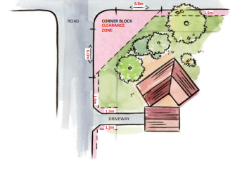
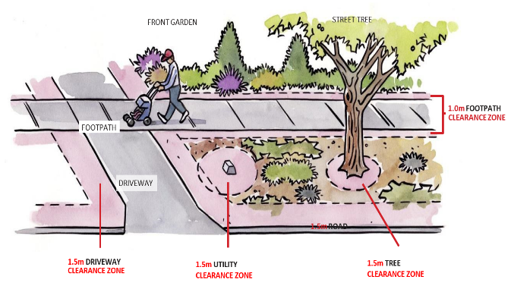 | 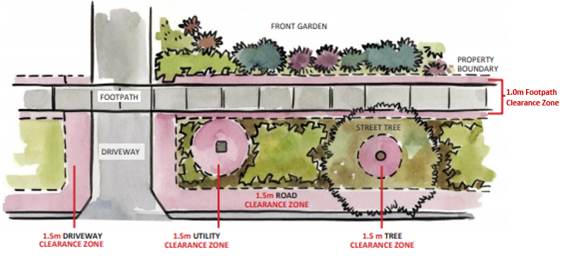

ADDITIONAL CONDITIONS
Approval for the activity may include site conditions as determined by TCCS.

APPLICANT RESPONSIBILITIES
This permit authorises the permit holder for the use of Public Unleased Land only. It is the responsibility of the Applicant to seek all necessary advice on further licensing requirements by other agencies (eg., Roads ACT for Road opening and closing, Environment Protection Authority for noise related permits and the National Capital Authority for the use of National Land) in relation to the activity.

CANCELLATION OR MODIFICATION OF APPROVAL
It may be necessary to include additional conditions or for an activity to be cancelled at any time if required for safety reasons; including the likelihood of damage to Territory Property as a result of rainfall, Total Fire Ban or other natural events or conditions.
In such cases; the Territory will not be liable for any losses incurred by the Applicant(s) but may consider refunding any fees paid, should the need arise for the area to be vacated as advised by the Territory. The Applicant should, as a matter of courtesy, inform the Land Use Team if an approved activity is to be cancelled or modified for any reason.

DAMAGE TO TERRITORY PROPERTY
The Applicant will be responsible for any damage to Territory property caused by the activity. This includes damage to roads, footpaths, kerbs and gutters, fences, gates, furniture, signs, BBQs, trees, verge vegetation (including turf), irrigation systems or any other property. The Applicant agrees to report any such damage to Land Use Team on (02) 6205 9850 as soon as practicable, and to repair the damage or reimburse the Territory for costs incurred in repairing the damage to TCCS satisfaction.

FEES
Fees are charged for the use of Public Unleased Land for Municipal Activities. Fees are determined under the Disallowable Instrument under the Public Unleased Land Act 2013. Please contact the Public Land Use Team on (02) 6205 9850 for further details. Failure to pay associated fees may result in the cancellation of the permit and a removal notice issued. All invoices carry a 7-day payment period, failure to pay invoices within this timeframe may result in cancellation of the permit and removal notices being issued.

LEGAL COMPLIANCE
The Applicant must ensure that all persons involved in the activity are aware of and abide by Laws and Regulations governing the area, as shown by local regulatory signage and any additional conditions that may be attached to the approved application.

PRIVACY STATEMENT
TCCS adheres to the ACT Information Privacy Act 2014. As a rule, the personal information that is provided to us is not passed on to private organisations or third parties without your written consent. However, your information may be provided to the ACT Civil and Administrative Tribunal (ACAT) or another court or tribunal if required by law. You can view our privacy policy on the About US page within the above link.

PUBLIC SAFETY AND INSURANCE
The Applicant will take all reasonable steps to ensure the safety of the general public in the activity. In particular, the Applicant will inspect the area immediately prior to use to ensure that it is safe for that use and report to the Territory as soon as possible any hazard detected on that inspection. Commercial operators must provide evidence of a current Public Liability Insurance Policy to a value of at least $20 million, or as determined by the ACT Insurance Authority in conjunction with TCCS.

SOUND
Applicants must ensure the sound generated does not impact adversely on nearby businesses or residents and must comply with the levels list below.
Further information on acceptable noise levels can be obtained by contacting the Environment Protection Authority on 13 22 81.

Location | 7am–10pm  (8am-10pm Sunday & Public Holidays) | 10pm–7am  (10pm-8am Sunday & Public Holidays)
Civic centre and other major town centres (Belconnen, Gungahlin, Woden, Tuggeranong) | 60dB(A) | 50dB(A)
Group centres such as Dickson and Kingston | 55dB(A) | 45dB(A)
Smaller local centres such as Griffith and Lyneham | 50dB(A) | 35dB(A)
Residential areas | 45dB(A) | 35dB(A)

