ACT Tree Registration - Tree Number RT1018
Species: Quercus macrocarpa (Burr oak)
Location: Nature strip trees of Bundeela Street Narrabundah
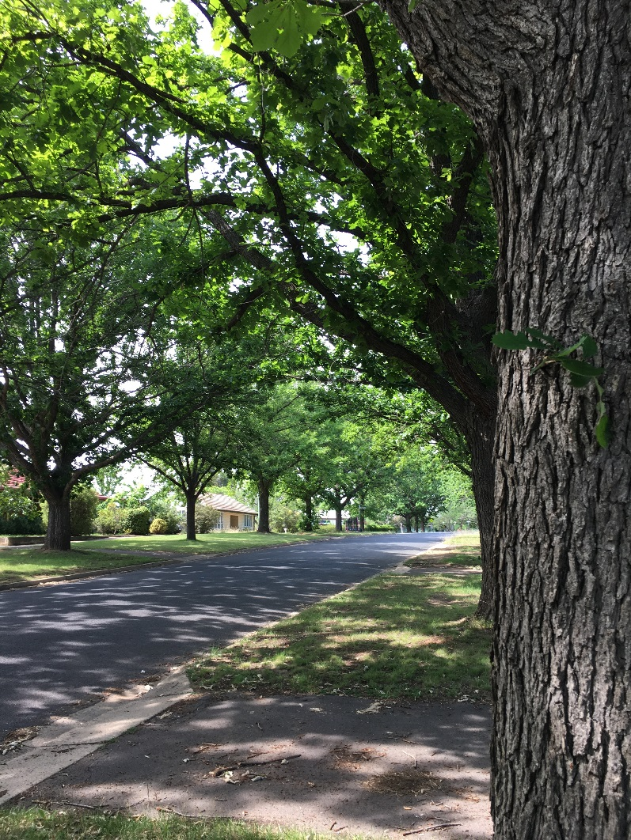
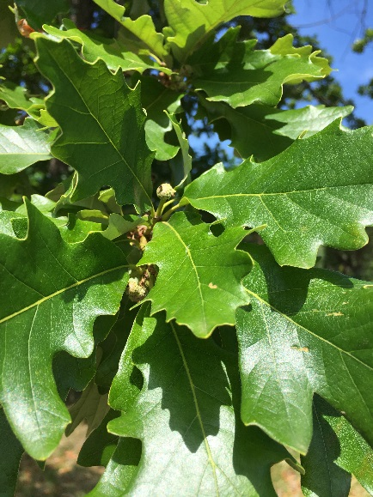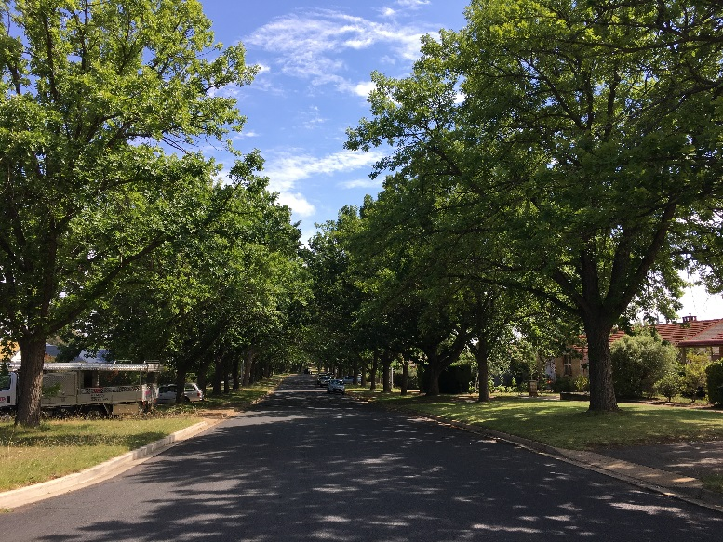

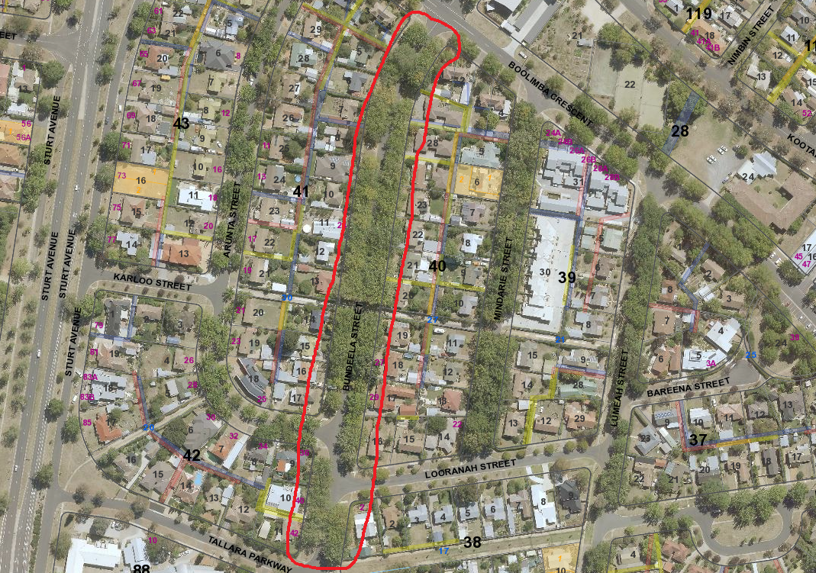
Location of Quercus macrocarpa in Bundeela Street Narrabundah
Field | Details of trees
Location | Nature strips of Bundeela Street Narrabundah
Botanical name | Quercus macrocarpa
Common name | Burr oak
Tree height | Range from 3.0m-16.0m
Canopy broadest diameter | various
Trunk circumference | 30cm-2.0m
Number of trunks | 1
Tree Protection Zone | Outside edge of canopy plus two (2) metres
Grid co-ordinates  MGA (centre of street) | X 695415.49  Y 6087936.21

Registration Criteria that presently apply, other criteria may apply after further assessment.
(2) Landscape and aesthetic value
The object of this value is to identify trees that are of particular importance to the community due to their substantial contribution to the surrounding landscape.
A tree may be considered to be of landscape and aesthetic value if it is situated in a prominent location when viewed from a public place and it:
(a) contributes significantly to the surrounding landscape based on its overall form, structure, vigour and aesthetic values; or
(b) represents an outstanding example of the species, including age, size or habit; or
(c) is an exceptional example of a locally native species that reached maturity prior to urban development in its immediate vicinity.
Statement against the Criteria
These trees are located on built-up urban area to which the above criteria applies. The tree meets the criteria of landscape and aesthetic value defined under the Tree Protection Act 2005. The broad spreading canopies of the street trees of Bundeela Street create an attractive and leafy archway along the entire street. The trees are sound and healthy and are an exceptional example of a mature streetscape using this species in Canberra.
For the above reasons I am satisfied that the landscape and aesthetic value is high, and that the tree significantly contributes to the surrounding landscape.
Furthermore, I am not satisfied that the tree meets the criteria for cancellation of registration.
Tree Number RT1018
Quercus macrocarpa (Burr oak)
ACT Tree Register
(Registration)
Pursuant to Division 7.2 of the Tree Protection Act 2005 as the Conservator of Flora and Fauna the following decision has been made under section 52(1) to enter or not enter the above tree(s) to the ACT Tree Register

Registration

Yes

Ian Walker
Conservator of Flora and Fauna 8 /1/2020

