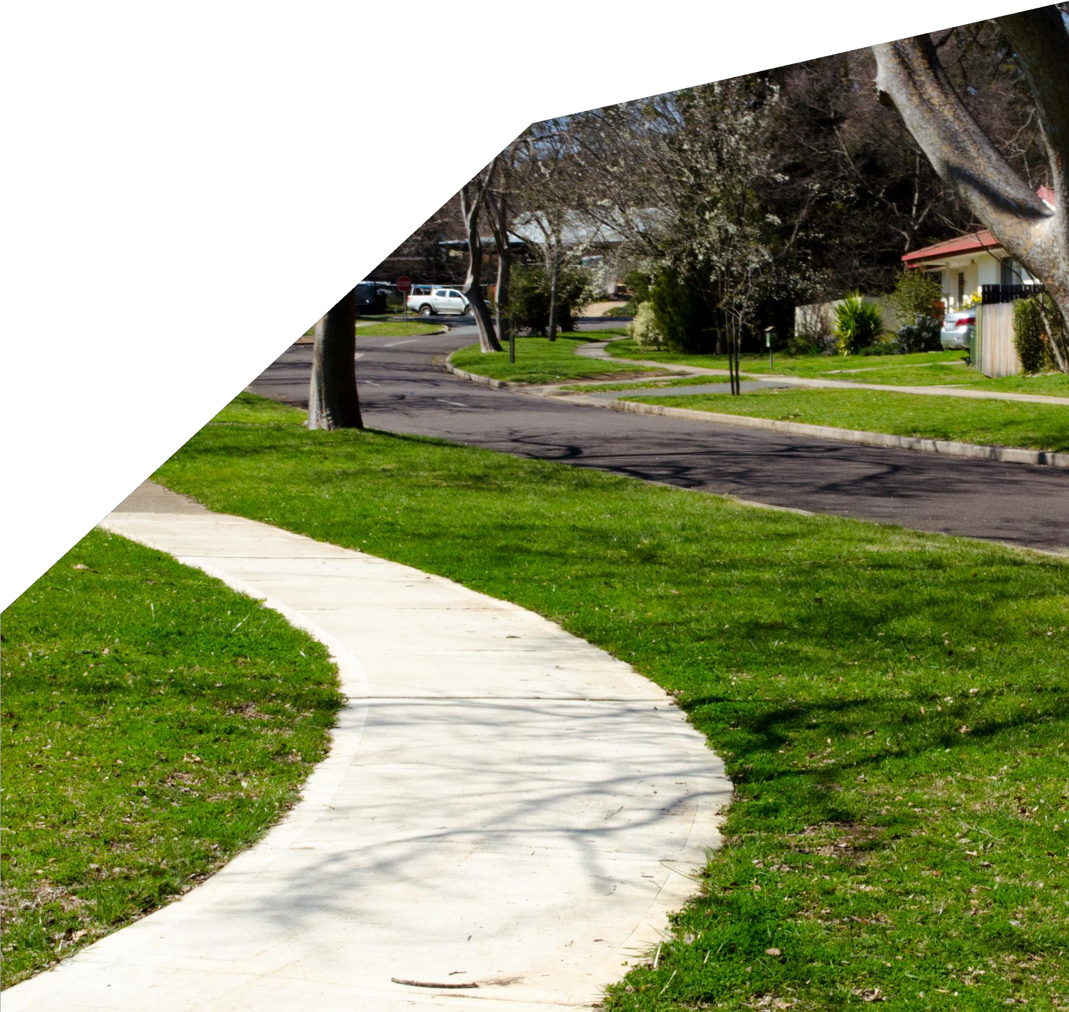

YOUR NATURE STRIP

GUIDELINES FOR USE OF RESIDENTIAL NATURE STRIPS

© Australian Capital Territory, Canberra 2019
Copyright of material contained in this document is owned by the Australian Capital Territory. Apart from any use as permitted under the Copyright Act 1968, no part may be reproduced by any process without written permission from:
City Services
Transport Canberra and City Services Directorate (TCCS) ACT Government
Telephone: 13 22 81
Website: www.tccs.act.gov.au
Printed on recycled paper Accessibility
The ACT Government is committed to making its information, services, events and venues as accessible as possible.
If you have difficulty reading a standard printed document and would like to receive this publication in an alternative format, such as large print, please phone Access Canberra on 13 22 81 or email the Environment and Planning Directorate at tccs_communications@act.gov.au
If English is not your first language and you require a translating and interpreting service, please phone 13 14 50.
If you are deaf, or have a speech or hearing impairment, and need the teletypewriter service, please phone 13 36 77 and ask for Access Canberra on 13 22 81.
For speak and listen users, please phone 1300 555 727 and ask for Access Canberra
on 13 22 81.
For more information on these services visit www.relayservice.com.au

DISCLAIMER: Guidelines are not law nor do they have the effect of a law, and they do not replace the law regulating the use of nature strips in the ACT. These Guidelines reflect TCCS’s intentions in prosecuting offences under the Public Unleased Land Act 2013. For instance, that Act provides offences if a person carries out work on nature strips (public unleased land) without approval, or if a person carries on an activity that excludes members of the public from the land without a permit. Application forms for approval and permits are available on the TCCS website.

You may be at risk of liability if someone is injured, or suffers damage or loss, as a result of the development of a nature strip. The liability might arise because of a failure to comply with the Guidelines or for some other reason. TCCS is unable to provide legal advice about this but you may wish to confirm with your insurance provider that your insurance arrangements cover you for liability which might be incurred while undertaking the development and when it has been completed.

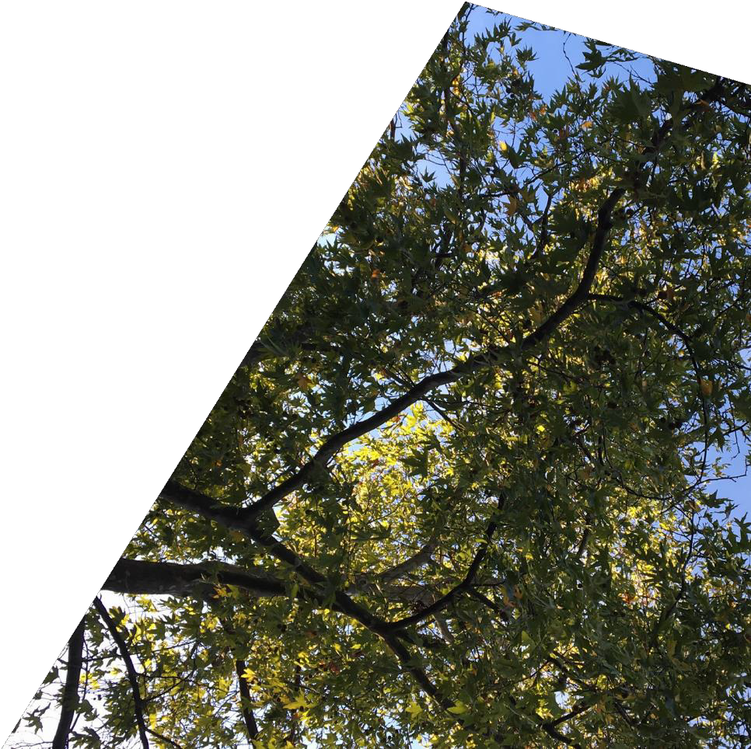

CONTENTS
CHECKLIST 3
ABOUT THESE GUIDELINES 4
USING THESE GUIDELINES 5
WHAT IS A NATURE STRIP? 6
WHY DO WE HAVE NATURE STRIPS? 7
MANAGING NATURE STRIPS 8
DO I NEED APPROVAL? 11
CLEARANCE ZONES 18
HERITAGE PRECINCTS & DESIGNATED AREAS 21
BUSHFIRE PRONE AREAS 22
APPLYING FOR A PERMIT OR WORK APPROVAL 24
APPENDIX A 26
APPENDIX B 28

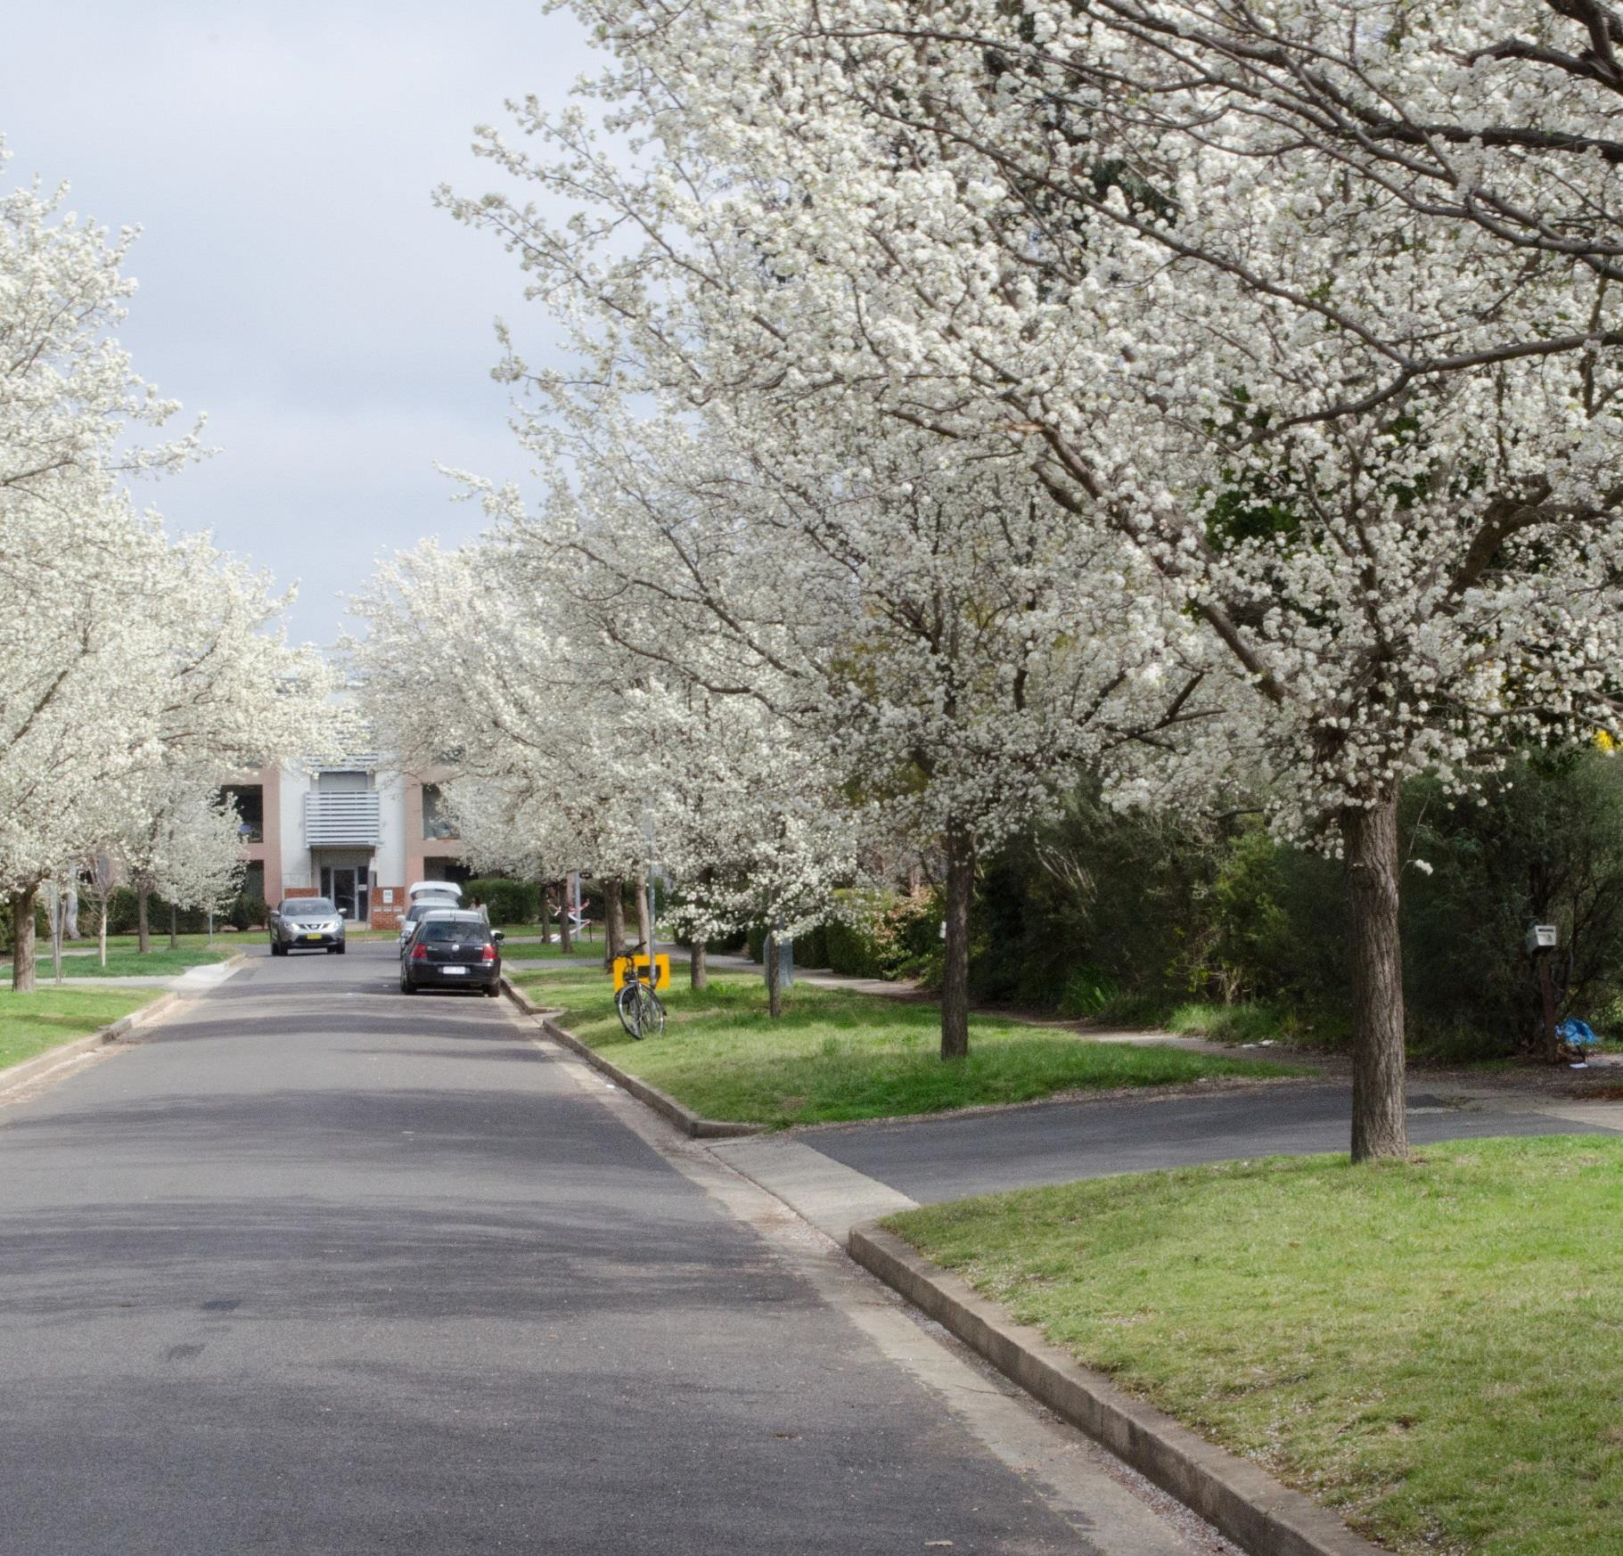

TABLE | DESCRIPTION | PAGE
Table 1: | Expectations for the management of | 8
 | Canberra’s residential nature strips
Table 2: | Nature strip uses UNLIKELY TO | 12
 | BE APPROVED
Table 3: | Activities you can do on your nature | 14
 | strip that DO NOT REQUIRE approval
Table 4: | Nature strip uses that DO REQUIRE approval | 16
Table 5: | Clearance zone requirements | 19
Appendix A | Plants recommended for Canberra nature | 27
 | strips in Bushfire Prone Areas
Appendix B | Further Information | 29
FIGURE | DESCRIPTION | PAGE
Figure 1: | What is a nature strip? | 6
Figure 2: | Nature strip rain garden | 10
Figure 3: | Protecting street trees | 13
Figure 4: | Nature strip clearance zones | 18
Figure 5: | Nature strip clearance zones - aerial | 20
Figure 6: | Nature strip clearance zones | 20
Figure 7: | Clearance zones - corner block | 20
Figure 8: | Bushfire prone area | 22

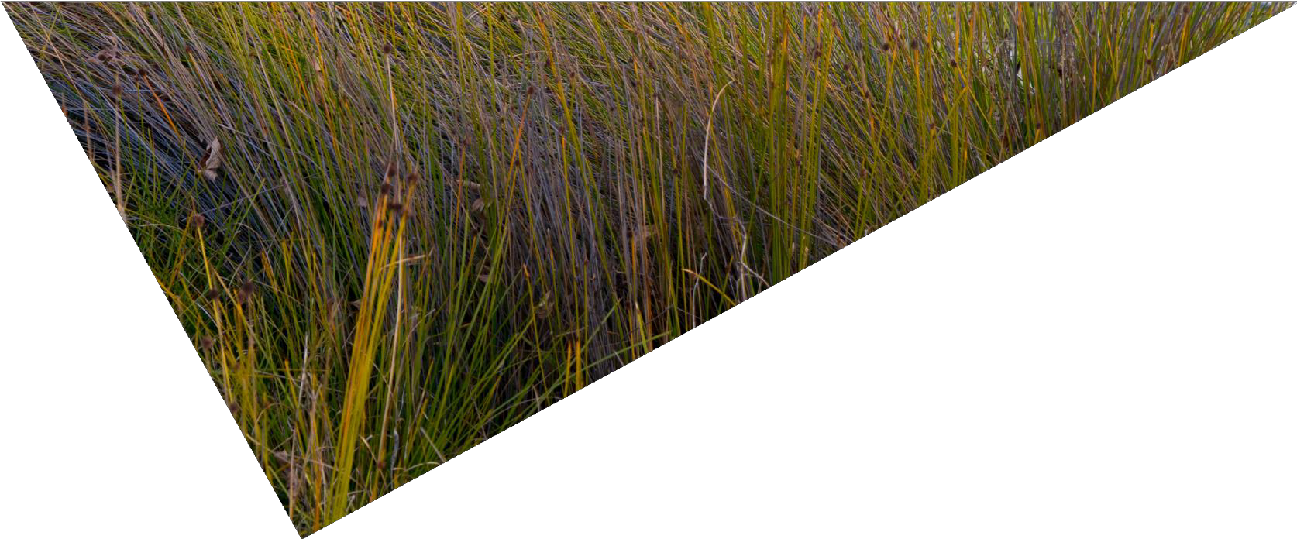

CHECKLIST
BEFORE MAKING ANY CHANGES TO THE NATURE STRIP, CHECK THE FOLLOWING:

DO YOU LIVE IN A HERITAGE PRECINCT OR DESIGNATED AREA?
▶ Refer to page 21

DO YOU LIVE IN A BUSHFIRE PRONE AREA?
▶ Refer to page 22

IS YOUR PROPOSED USE LIKELY TO GET APPROVAL?
▶ Refer to Table 2 (page 12)

DOES YOUR PROPOSED USE REQUIRE APPROVAL?
▶ Refer to Tables 3 and 4 (pages 14–17)
▶ If NO, make sure you meet the standards specified in Table 3
▶ If YES, refer to ‘Applying for a Permit or Work Approval’ (page 24)

DOES YOUR PROPOSED USE COMPLY WITH CLEARANCE ZONES?
▶ Refer to Table 5 (page 19) and Figures 5–7 (pages 20)

CONTACT ‘DIAL BEFORE YOU DIG’
▶ Call 1100 during business hours or visit: www.1100.com.au

YOUR NATURESTRIP GUIDELINES FOR USEOFRESIDENTIALNATURE STRIPS
3

ABOUTTHESE GUIDELINES

Nature strips are vital transport corridors for pedestrians and cyclists
It is very important that nature strips are maintained and accessible for pedestrian use

Nature strips are an important part of Canberra’s urban streetscape and help create the ‘garden city” character. In most suburbs, nature strips are generously sized, allowing ample space for trees and other plants to flourish. Nature strips are also vital transport corridors for pedestrians and cyclists. The urban design of Canberra

allows for easy walking access to local shops, playgrounds, parks and other facilities. As a result, it is very important that nature strips are maintained and accessible

for pedestrian use.
Nature strips are part of public unleased land which is regulated by the Public Unleased Land Act 2013 (the Act). The main objects of the Act are to protect the amenity and natural value of public land such as nature strips, and to facilitate the use of that land.
The public is entitled to use nature strips. This is why, if you want to do any construction work to the nature strip, or make any exclusive use of it, or interfere with any Territory property on it, you will need to make an application under the Act (see Applying for a Permit or Work Approval, page 24)

Nature strips are public land and not part of residential property leases,
however it is well recognised that a shared maintenance approach between government and the community provides the maximum opportunity for individual and city wide benefits.
Where this relationship exists, the nature strip can perform its essential role as a conduit of services and make a highly valuable contribution to Canberra’s picturesque street character, which in turn can lead to higher individual property value and sustainability benefits.
While many aspects of nature strips maintenance are the responsibility of the ACT Government, it is accepted practice that the adjacent landholder is responsible for some maintenance and for ensuring that
any landscaping development is safe and appropriate. For example, the landholder is expected to ensure that trees and shrubs growing on private
land do not impede access to the nature strip or the footpath. Likewise, residents who wish to landscape their nature strip may do so but only in a way that provides for safe access and use by the public.
These guidelines are designed to help Canberra residents determine what types of activities can be undertaken on a nature strip and when approval is required for an activity, as well as to encourage everyone to take pride in maintaining their nature strips.

USINGTHESE GUIDELINES

These guidelines are designed to help Canberra residents determine what types of activities can be undertaken on a nature strip and when approval
is required for an activity, as well as to encourage everyone to take pride
in maintaining their nature strips

The ACT Government has developed guidelines for use of residential nature strips in Canberra. These guidelines aim to reach a balance whereby residents can use the nature strip, but without causing amenity or public safety concerns.
The guidelines have been developed to clearly set out the respective responsibilities of residents and the ACT Government, as well as outline what is and isn’t likely to be approved on nature strips.
A summary of some of the key guidelines for nature strips are as below:

YOU CAN USE:
- groundcovers, native grasses and shrubs up to 50 cm in height (or 20 cm in a Bushfire Prone Area) to help maintain line of sight
- compacted gravel on up to 50% of the nature strip (but not within the drip line of trees), with the remainder being low level shrubs or grass (this allows for water filtration and has a cooling effect)
- organic mulch materials (eg pine bark, pine chip and flake, chipper waste)
- temporary protective fencing for new grass/shrubs up to 13 weeks
- garden edging of stone, brick and timber up 15 cm high.

YOU NEED APPROVAL FOR:
- irrigation systems, synthetic turf or bollards to prevent parking on the nature strip
- temporary storage of landscape material for longer than two weeks
- second driveway.

UNLIKELY TO BE APPROVED:
- ponds, water fountains, permanent fencing, retaining walls, letterboxes, shipping containers, chicken runs, play equipment, boulders, pavers/concrete paths, new trees.
- Note: Parking a vehicle (including cars, trailers and caravans) on the nature strip is prohibited under the Road Transport (Road Rules) Regulation 2017.

WHAT IS A NATURE STRIP?

A nature strip, also called a street verge, is the land between a residential property boundary and the roadside kerb.

In Canberra, it typically comprises a patch of grass with trees and
a footpath close to the property boundary. All of this land is publicly owned and not part of the neighbouring property.
This land often contains infrastructure for essential services like telecommunications, energy, water and wastewater.

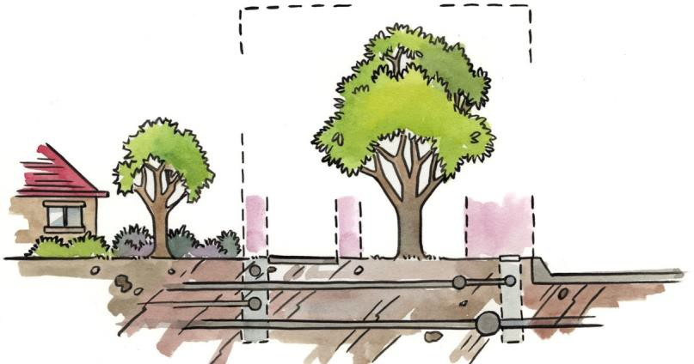ESSENTIAL SERVICES
NATURE STRIP
STREET TREE
PROPERTY
BOUNDARY
0.5m
0.5m
1.5m ROAD CLEARANCE ZONE
FOOTPATH
FIRE
HYDRANT
KERB / ROAD

ESSENTIAL SERVICES

Figure 1: A nature strip is the land between a residential property boundary and the roadside kerb.

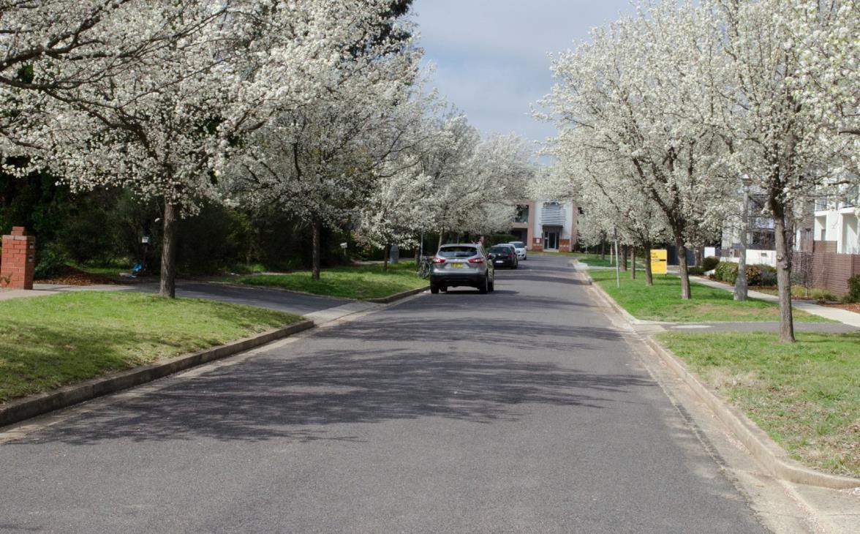

WHYDOWE HAVE NATURESTRIPS?

Use the CHECKLIST on page 3 before making any changes to the nature strip and refer to the relevant section in these guidelines

Nature strips are an integral part ofCanberra’s character as a ‘garden city’.
Nature strips provide:

Public safety – public walking spaces (with or without paved footpaths) that are safe from motor vehicle activity.
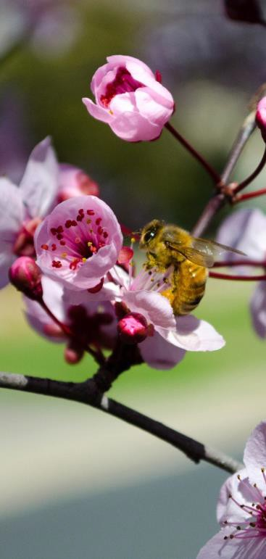
Essential services infrastructure – an area where both above-ground services such as electricity poles, fire hydrants and postal boxes
and below–ground services such as telecommunication wires and gas pipelines, may be placed.
Unified streetscapes – established trees that can unite a street through consistent planting which adds to real estate value.
Places for trees – leafy streetscapes that provide shade and shelter, often sources of habitat for urban wildlife.
Cooling effect – savings in heating and cooling costs. Vegetated nature strips have a cooling effect during hot weather with benefits for suburban energy demand and public health.
Flood control – an area where rainfall can soak in and help reduce flooding by slowing the rate at which water enters the stormwater system and local waterways.
Water filtration – an area where pollutants can be trapped before runoff water flows into storm drains connected to waterways.
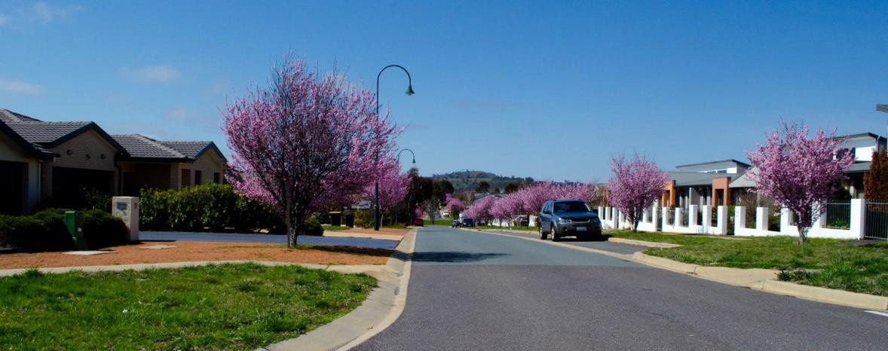

MANAGING NATURE STRIPS
TABLE 1: A summary of shared expectations for the management of Canberra’s residential nature strips

TOPIC | ACT GOVERNMENT | RESIDENTS
Street trees | - Manage all aspects of street trees, including species selection, planting, watering new plantings, pest control pruning and removal.  - Ensure that temporary fencing to protect street trees during construction or other activities is well maintained for the duration of the works.  - Ensure that the temporary storage of materials, such as by builders, landscapers, does not adversely affect street tree health.  - Conduct street sweeping during autumn to collect street tree leaf fall. | Trees are managed by the ACT Government but residents can help by:  - Watching out for newly planted trees by watering them and carefully removing any vegetation which may be at its base;  - Adding mulch when appropriate, but do not place grass clippings or other organic matter at the base of trees (refer to Tables 2 & 3);  - Repairing and/or replace any damage tonature strip developments  (e.g. irrigation systems, vegetable plantings, synthetic grass) arising from the growth or management of  street trees.
Plants on the nature strip and in front gardens (ie on private property) | - Not applicable. | - Maintain plants on the nature strip (except for trees – see above) and prune front garden trees and shrubs overhanging the footpath according to specifications in Table 3 and clearance zones in Table 5.  - You should prune a tree or other plant on your property which is overhanging a nature strip or likely to obstruct or inconvenience anyone on the nature strip. If you don’t, you may be directed to prune them, and it is an offence not to comply. However, you must not damage aprotectedtree without approval under the Tree Protection Act 2005. (for further information refer to  Appendix B)
Grass and weeds | - Not applicable. | - Maintain and mow including weeding.
Litter, domestic rubbish and recycling | - Provide waste and recycling collection services. | - Put out and bring in bins in a timely manner.  - Pick up litter deposited or blown onto the nature strip.  - Household goods are not to be left abandoned on the nature strip.
Leaves, debris and lawn clippings | - Not applicable. | - Remove leaves, lawn clippings and debris and dispose of appropriately or compost.  - Don’t sweep or rake leaves and other organic materials into gutters as they enter waterways and affect water quality.

TOPIC | ACT GOVERNMENT | RESIDENTS
Driveways | - Maintain original driveways. | - Do not park cars on the driveways where they cross over pedestrian paths.
Utilities | - Ensure access to utilities is maintained on verges adjoining public open space. | - Do not prevent access to above and below ground services by utility companies and contractors.
Rain gardens | - Manage all aspects of street trees (as above).  - Manage the stormwater drainage infrastructure. | - Hand-pull weeds.  - Preferably do not use weed control chemicals as they may harm the street tree and aquatic life.  - Remove any litter and dispose of in domestic rubbish collection.  - Remove leaves and twigs caught in the rain garden.  - Don’t add extra plants to the rain garden other than replacing dead plants with the same species (except trees).  - Don’t place grass clippings or other organic matter in the rain garden.
Safety | - Construct and maintain footpaths.  - Inspect construction sites to ensure works don’t adversely affect the street tree or nature strip.  - Manage fire risk and response. | - Maintain the clearance zones in line with this guideline, particularly safe use and access by pedestrians (including those using wheelchairs, scooters and prams, and with impaired vision) and cyclists.  - Provide safe access for users of the nature strip and vehicles on the adjacent roadway.  - Reduce vegetation load on the nature strip especially in designated Fire Prone Areas (see page 22).

Note: The ACT Government or utility companies are not responsible for reinstating any approved or unapproved landscaping or structures installed by residents on a nature strip, including irrigation systems, gravel, groundcover plants, garden edging and synthetic turf.

NEED ASSISTANCE IN MAINTAINING YOUR NATURE STRIP?
Residents unable to maintain their nature strip due to ill health may request assistance from organisations such as DUO Services which is a not-for-profit organisation that provides in-home support.
For further information visit www.duo.org.au

HOW YOU CAN HELP WATER QUALITY
Avoid placing lawn clippings or leaf litter in the rain garden as it is directly connected to our waterways and this will add unwanted nutrients into your local lakes and ponds.
Maintain weeds by hand weeding. Herbicides can affect the street tree (where one exists) and aquatic life.
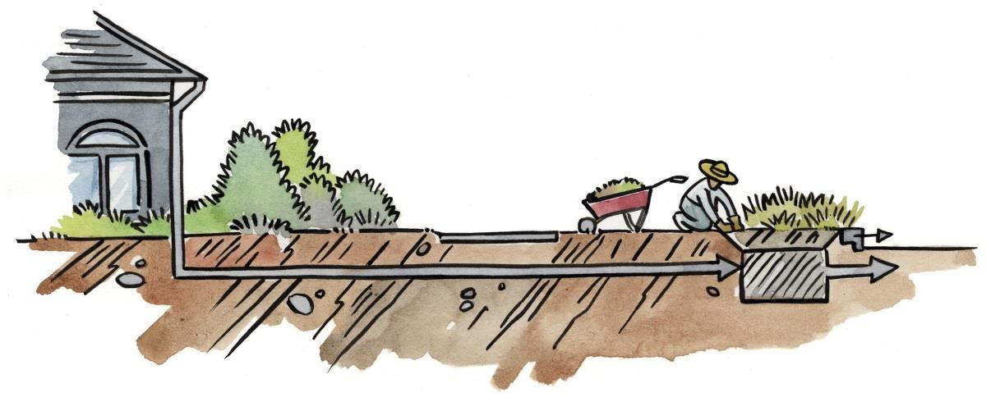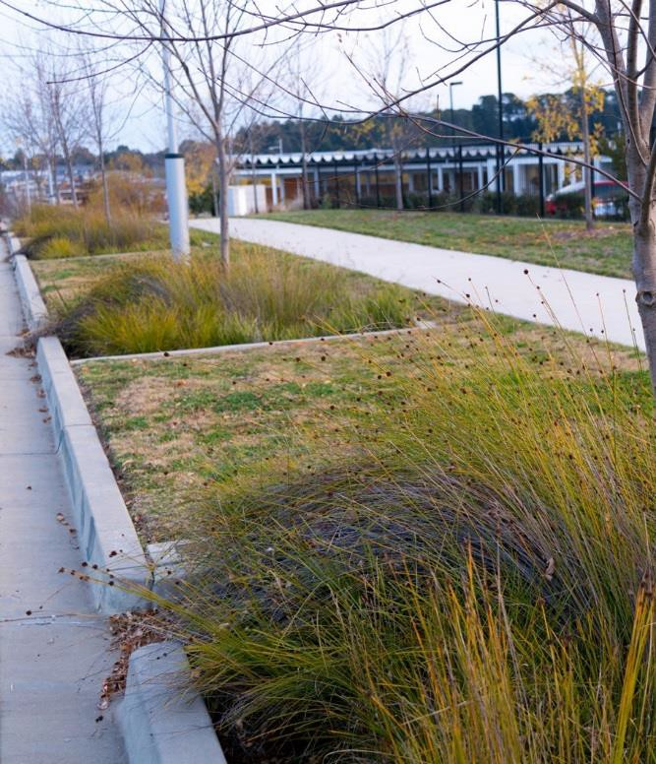
WHAT IS A RAIN GARDEN?

Some nature strips in Canberra’s suburbs have a rain garden. A rain garden is a filtration system that uses carefully-chosen plants to improve stormwater quality and to slow the movement of runoff to downstream ponds and waterways. Stormwater is diverted to the rain garden from roadways, paved areas and driveways so that pollutants like nutrients, sediment and heavy metals can be filtered out before entering the stormwater network.
By filtering the stormwater, rain gardens help to keep our lakes and rivers healthy.

Rain gardens have been constructed in some newer suburbs to filter stormwater before it enters

FIGURE 2: Some homes use rain gardens to filter roof runoff prior to entering waterways

RAIN GARDEN

FOOTPATH
KERB / ROAD

WATER FLOWS TO STORMWATER DRAIN / WETLANDS

DO I NEED APPROVAL?

The legislation that regulates the use of nature strips is the Public Unleased Land Act 2013. Further information regarding the Act may be obtained at www.legislation.act.gov.au
The tables 2, 3 and 4 show which activities are permitted on nature strips, which may be approved and which are unlikely to be approved.
There are some specific conditions that apply to the use of nature strips in Heritage Precincts, Designated Areas and Bushfire Prone Areas. Pages 21 and 22 of this document set these requirements out.
In Bushfire Prone Areas, any changes to a nature strip must not increase the risk of fire.

Note: If you’re a tenant, check with the property owner, body corporate and/or managing agent before making changes to the nature strip. This helps maintain good relationships.
In the case of an owner-occupied apartment, consent for any proposed changes to the nature strip must be obtained in accordance with the terms of the body corporate or other applicable legal arrangements.

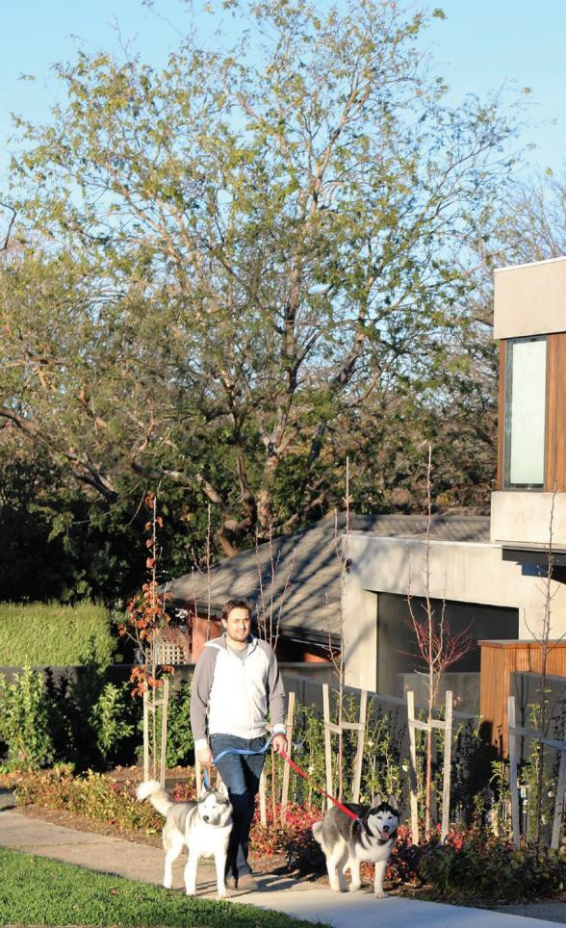
FOOD HYGIENE
You will need to consider food hygiene and possible sources of contamination e.g. motor vehicles when growing or consuming produce from your nature strip. Although under the Domestic Animals Act 2000 dog owners and carers must pick up after their dogs, other animals, particularly native possums, may defecate on the nature strip, so always wash your produce before consuming.
TALK WITH NEIGHBOURS
There is no obligation on the part of residents to inform their neighbours about any planned changes to their nature strip. As a courtesy, however, speaking with neighbours prior to making any changes will help to sustain good neighbourly relations.

Some uses that are unlikely to be approved are listed in Table 2 below. Should these activities be undertaken on the nature strip they are subject to penalties for non-compliance. Where relevant, the right column of the table below indicates related-use categories in Table 3 and Table 4.
TABLE 2: Nature strip uses UNLIKELY TO BE APPROVED

APPROVAL UNLIKELY | CHECK WHAT YOU CAN DO INSTEAD
Plant a tree¹ | Groundcovers, native grasses, food plants, and shrubs (Table 3)
Install boulders or large rocks | Garden edging (Table 3)
 | Bollards (Table 4)
Lay pavers or concrete paths | Compacted gravel or organic mulch (Table 3)  Driveways (Table 4)
Build permanent fencing, log barriers or retaining walls | Temporary protective fencing (Table 3)  Bollards (Table 4)
Install a pond, fountain or water tank | Irrigation systems (Table 4)
Trim, prune or remove a street tree | -
Park a vehicle, including cars, caravans or trailers² | -
Build a carport | -
Store a shipping container | -
Erect a letterbox | -
Erect an animal enclosure, including for chickens | -
Install play equipment, including swings, trampolines and tree-houses | -
Add an art installation | -
¹ To request a street tree contact Access Canberra on 13 22 81 or log an enquiry through Fix My Street
² Parking on the nature strip is prohibited under the Road Transport (Road Rules) Regulation 2017. Penalties apply for non-compliance with the legislation.

Always check ‘DIAL BEFORE YOU DIG’ before making any changes to a nature strip. It’s a free service.
www.1100.com.au or call 1100 during business hours.

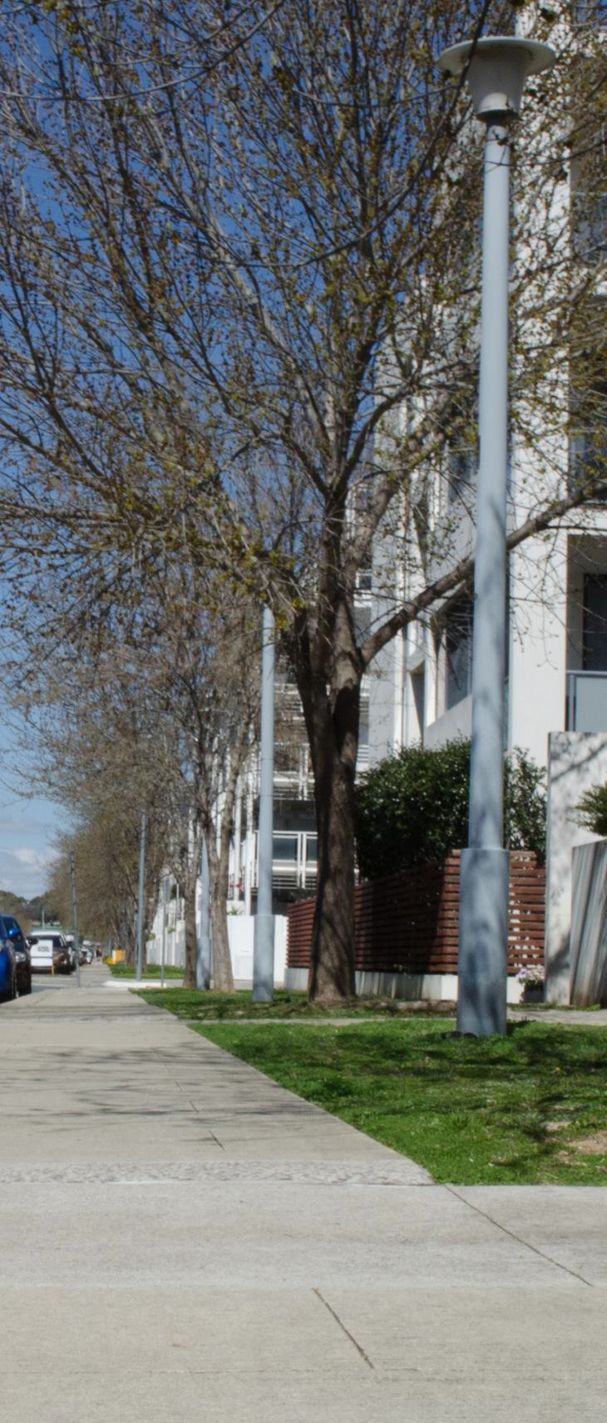
PROTECTING STREET TREES
Residents are required to protect street trees by:
- not parking on the nature strip. This compacts the soil, damaging the tree root system over time.
- not excavating soil under the drip line. This can lead to cuts in the tree root system and may leave the roots exposed.
- not mounding soil, mulch or grass clippings around the tree base. This material can generate heat and moisture, leading to decay and a decline in tree health.
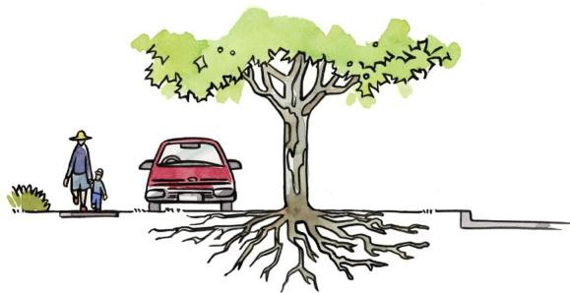
Do not park on the nature strip
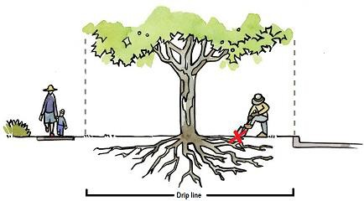
Do not excavate soil under the drip line of trees

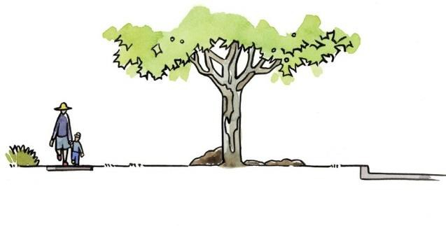Do not mound soil, mulch or grass clippings around the tree base

FIGURE 3: Protecting street trees

The ACT Government will not prosecute you for the use of the nature strip next to your residential property if it complies with this table.
TABLE 3: Nature strip uses that DO NOT REQUIRE approval

NO APPROVAL REQUIRED
USE OF NATURE STRIP | SPECIFICATIONS (for further information refer to Appendix B)
Grassing | - Ensure any turf is free of Madagascan Fireweed and other weeds.
RECOMMENDED
- Use an exotic dryland grass mix that is suitable for Canberra.
Groundcovers, native grasses, food plants, and shrubs | - Comply with all clearance zones.  - Keep all plants at a height of no more than 50 cm from natural ground (in line with Austroads Guidelines) or 20 cm in Bushfire Prone Areas. This includes any mounding up to 150mm or excavating down to 10 cm.  - Do not cut tree roots greater than 50mm in diameter if planting under the street tree canopy.  - Don’t plant prickly or spiky plants or any plants that have been declared pest plants under the Pest Plants and Animals Act 2005 (to view full list go to the ACT Legislation Register at www.legislation.act.gov.au )  - Keep soil, mulch or grass clippings away from roads and footpaths.  - Use non-flammable mulches in Bushfire Prone Areas (e.g. decomposed granite).  - Do not use snail bait or chemical sprays, as they pose a risk to the safety of children and pets, and the quality of runoff to water bodies.
RECOMMENDED
- Test soil for potential contaminants such as lead before planting vegetables or other food plants.
- Learn more about soil contamination by consulting expert information sources.
- Apply 75mm depth mulch to plants.
- Use organic methods to control pests and diseases.
- Refer to the Appendix (page 26) for a list of hardy plants that grow well in Canberra.
- Choose from the plants identified in the Appendix (page 26) as suitable for Bushfire Prone Areas.
- Maintain a minimum area of 50 percent plants
Compacted gravel | - Comply with clearance zones – compacted gravel must not be placed within 1.5m of a tree trunk.  - Care must be taken not to cut or damage tree roots with diameter greater than 50 mm when preparing to install gravel.  - Do not use more than 50 percent of the area for compacted (i.e. stabilised) gravel.  - Use compacted gravel (or granite) that is less than 1 cm in diameter.  - Install compacted gravel to a depth of 75–100mm.  - Use gravel only on slopes that are less than or equal to 3 percent.  - Ensure gravel does not wash into gutters to avoid polluting stormwater and local water bodies.  - Keep gravel away from footpaths and roads as it causes a hazard to pedestrians and cyclists.
RECOMMENDED
- Maximise the proportion of plants because this will help to cool the local climate and allow water to infiltrate the soil for flood control and water quality benefits.

NO APPROVAL REQUIRED
USE OF NATURE STRIP | SPECIFICATIONS (for further information refer to Appendix B)
Organic mulch (pine bark, pine chip and pine flake) | - Comply with requirements for Bushfire Prone Areas (page 22)  - Do not mound around the base of trees -maintain 50mm clearance from trunk  - Do not excavate under drip line (Figure 3)  - Care must be taken not to cut or damage tree roots with diameter greater than 50 mm when preparing to mulch (Figure 3).  - Must be uniform in size and free of stones, soil and other contaminants  - Should be raked smooth and flush with surrounding finish levels  - Use mulch only on slopes that are less than or equal to 3 percent  - Install to a depth no greater than 100mm to allow for water infiltration
Temporary protective fencing | - Comply with clearance zones.  - Use only temporarily for the purpose of protecting newly sown grass and/or plants.  - Erect for a maximum period of 13 weeks.  - Must not present a safety hazard to the public.  - Install only rope or string, supported by stakes.
Garden edging | - Comply with clearance zones.  - Use only stone, brick or timber.  - Maximum height of 150mm.  - Maximum depth of 100mm below the surface of the nature strip.  - Care must be taken not to cut or damage tree roots with diameter greater than 50 mm.

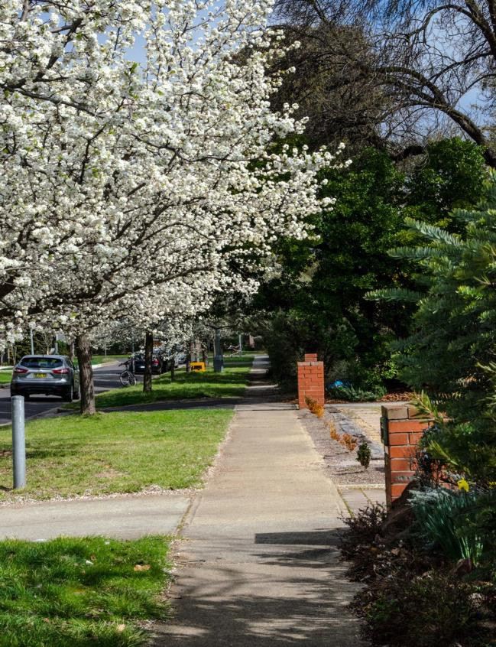
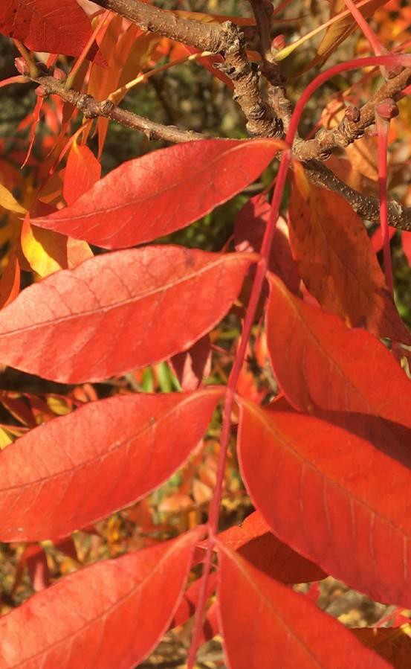

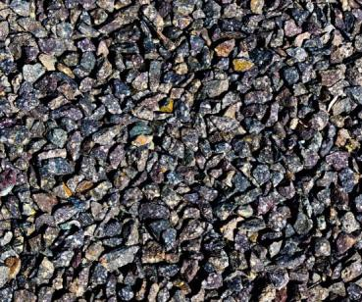
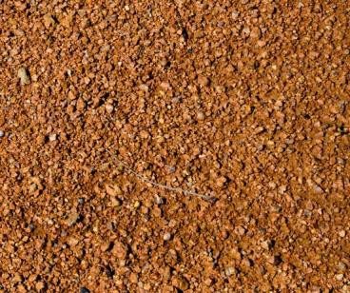
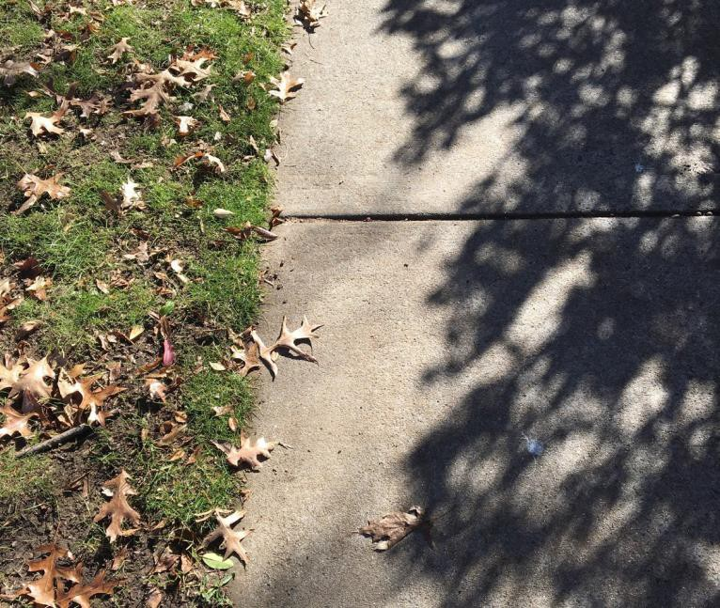
The specifications in this table show conditions which will be taken to apply to any work approval or permit granted under the Act.

TABLE 4: Nature strip uses that DO REQUIRE APPROVAL. Refer to Page 24 for details of the approval process.

APPROVAL REQUIRED
USE OF NATURE STRIP | SPECIFICATIONS
Irrigation systems | COMPULSORY  - Maximum trench depth of 15 cm.  - Ensure no trip hazards are created when laying irrigation systems.  - Direct sprinkler heads to avoid wetting footpaths and roads.  - Comply with any water restrictions in force.  - Install in compliance with the ‘allowable distance from the street tree’ defined in the approval (which will be species-dependent).
RECOMMENDED
- Consider any damage that may be caused to the watering system through the necessary maintenance of street trees or public utilities.
Synthetic turf | COMPULSORY  - Do not install within the drip line of trees (Figure 3) on nature strips due to the risk of poor permeation, compaction, potential flooding and damage to trees.  - Must demonstrate minimal adverse impacts on the environment (e.g. local cooling effects, birdlife, flood control).  - Must use synthetic turf of high quality installed to meet manufacturers specifications.  - Not to be installed in Bushfire Prone Areas.  - Secure edges to avoid trip hazards meeting the manufactures recommendations.
NOTE
- Repair to any damage caused to the synthetic turf during maintenance by ACT Government or an essential service is at the resident’s expense.

APPROVAL REQUIRED
USE OF NATURE STRIP | SPECIFICATIONS
Bollards | COMPULSORY  - Comply with clearance zones.  - Use only to prevent parking on the nature strip.  - Use posts of 10–15 cm diameter.  - Install at 1.0–1.2 m from natural ground height.  - Install at least 60 cm in ground (contact Dial Before You Dig).  - Allow at least 1.2 m between bollards for pedestrian movement (including for people with disabilities).  - Use only frangible materials (i.e. able to be broken into fragments when hit).  - Install reflective markers around the upper circumference of bollards adjacent to driveways and pedestrian paths.
RECOMMENDED
- Consider the potential utility of the following frangible materials—hardwood, tanalith pine and recycled plastic.
Driveways | COMPULSORY  - Seek approval (information and specifications are detailed in the form) when proposing to:  - modify an existing driveway.  - construct a new driveway.  - add a second driveway.
RECOMMENDED
- Consider the potential for repair and/or replacement costs as any damage caused to driveways by the ACT Government or utility companies in accessing infrastructure is limited to the use of standard materials like concrete and bitumen.
Landscape material storage | COMPULSORY  - Comply with clearance zones.  - Use only temporarily for the purpose of storing landscape materials.  - Store for a period of more than two weeks but less than 12 months.  - Must not present a safety hazard to the public.
Construction material storage | COMPULSORY  - Comply with clearance zones.  - Must be insured for $20 m in public liability for all construction activities.  - Valid permit period is up to three years.

Note: The ACT Government accepts no responsibility for damage caused to assets on the nature strip.
Residents are reminded they develop the nature strip at their own expense and own risk. It is recommended that the owner/occupier considers house and contents insurance that includes nature strip landscaping.

CLEARANCE ZONES

Clearance zones enable pedestrians and cyclists to safely use footpaths and roads and to safely traverse nature strips without designated footpaths

Clearance zones enable pedestrians and cyclists to safely use footpaths and roads (Figures 4, 5 and 6), and to safely traverse nature strips without designated footpaths.

For nature strips without a footpath, the clearance zone

of 1.5 metres beside the road is critical for the safe passage of pedestrians and cyclists. To aid visibility, dwellings on corner blocks are required to have larger clearance zones (Figure 7).

Furthermore, clearance zones allow a range of practical functions, including growing healthy street trees, opening the doors of parked vehicles, and placing and collecting household rubbish bins.
A clearance zone of 1.5 metres is required for essential services to allow easy access, such as power poles, electricity minipillars, manholes, meter boxes, water and wastewater utilities.
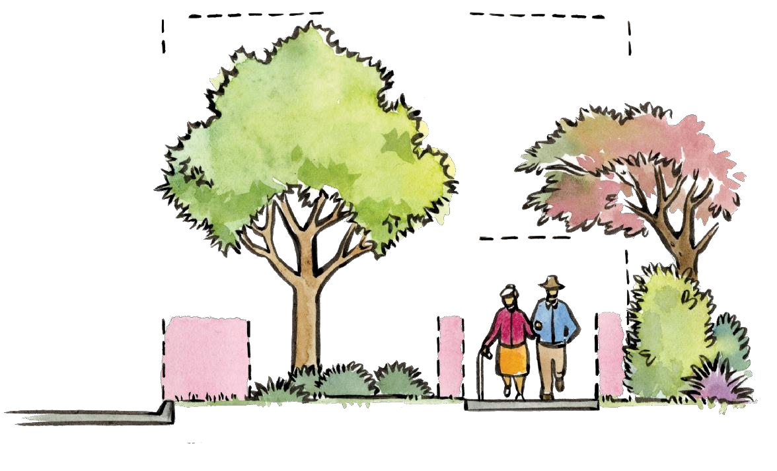
NATURE STRIP
PROPERTY BOUNDARY
STREET TREE
2.2m
VERTICAL CLEARANCE
1.5m ROAD
CLEARANCE ZONE
0.5m
0.5m
ROAD / KERB
FOOTPATH
FRONT GARDEN

FIGURE 4: A HORIZONTAL VIEW OF CLEARANCE ZONES
The nature strip is safe for pedestrians and cyclists. Pedestrians can readily step off the road onto the nature strip, and trimmed vegetation gives full access to footpaths, particularly for those with mobility constraints.

TABLE 5: Clearance zone requirements

UNLIKELY TO BE APPROVED WITHIN THE CLEARANCE ZONE
Plants or structures within: (except those listed as permitted)
- 1.5m of a kerb and, for a corner block, 6m from the road intersection for the area shown in Figure 7
- 1.5m of a driveway
- 0.5m either side of a footpath, including front garden hedges and tree foliage
- 1.5m of an essential service, such as a power pole, street light or hydrant
Plants or structures within:
- 1.5m from a street tree (measured from the outside edge of the trunk)
- A Tree Protection Zone (see Figures 5 & 6) that may cause damage to a protected tree
Foliage overhanging the footpath below 2.2m vertical clearance
Pebbles
Rough tanbark/mulch (see Table 3 under organic mulch)

PERMITTED WITHIN THE CLEARANCE ZONE^
Grass
Groundcovers that can be walked or ridden over
Compacted gravel (except for within 1.5m of tree trunk)
Organic mulch (see Bushfire Prone Areas page 22)

^ see Table 3 for specific specifications
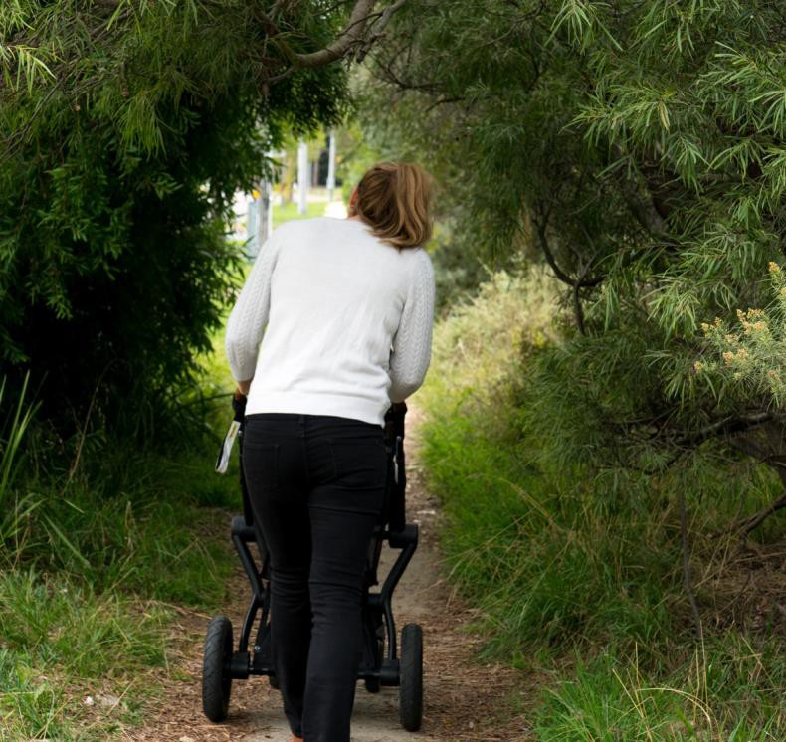
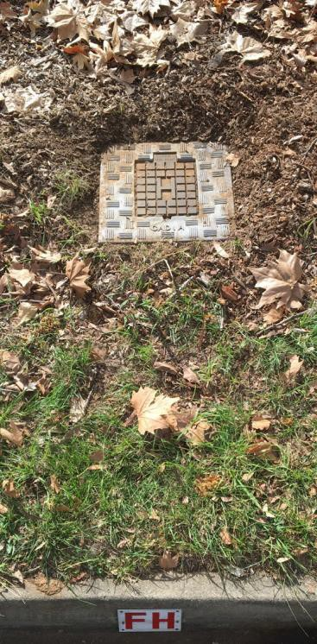
Overgrown nature strips can restrict pedestrian access. A fire hydrant on a nature strip.

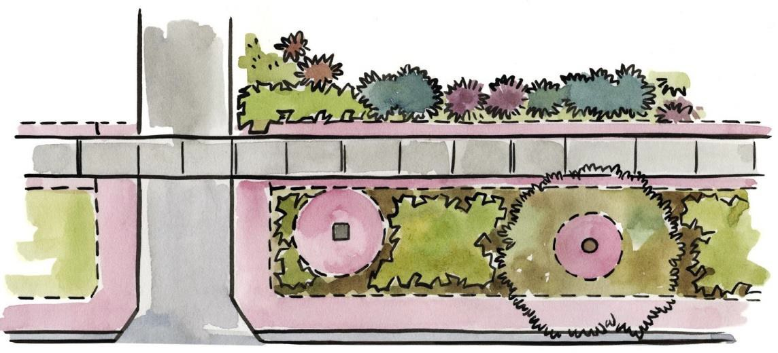0.5m FOOTPATH CLEARANCE ZONE
FRONT GARDEN
PROPERTY BOUNDARY
FOOTPATH
STREET TREE
DRIVEWAY
1.5m ROAD
CLEARANCE ZONE

1.5m DRIVEWAY CLEARANCE ZONE
1.5m UTILITY CLEARANCE ZONE
1.5 m TREE CLEARANCE ZONE

FIGURE 5: AN AERIAL VIEW OF NATURE STRIP CLEARANCE ZONES

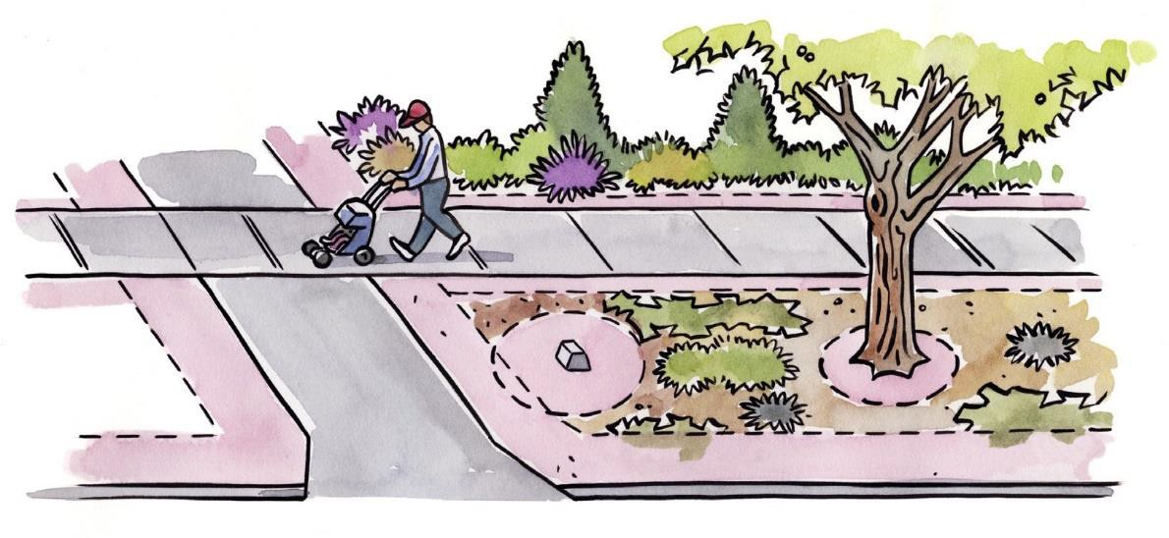
FRONT GARDEN
STREET TREE
FOOTPATH
0.5m FOOTPATH CLEARANCE ZONE
1.5m ROAD
CLEARANCE ZONE
DRIVEWAY

1.5m DRIVEWAY CLEARANCE ZONE
1.5m UTILITY CLEARANCE ZONE
1.5m TREE CLEARANCE ZONE

FIGURE 6: A HORIZONTAL VIEW OF NATURE STRIP CLEARANCE ZONES
  - m
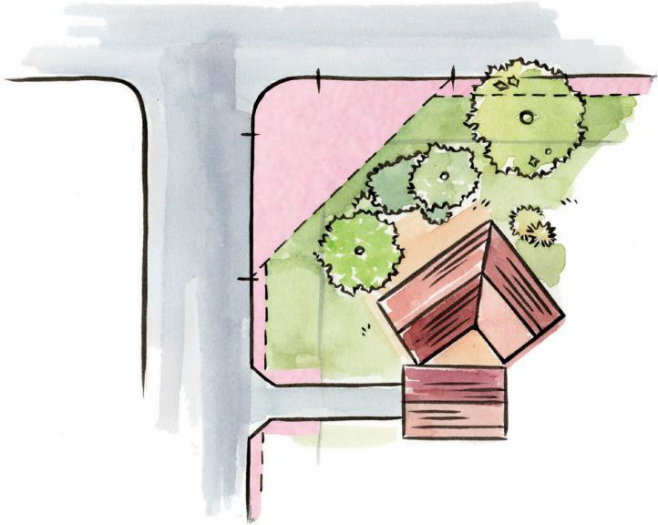These clearance zones protect street trees, allow for the safe passage of pedestrians and give clear access to utility companies when carrying out utility works.
6.0m
1.5m
ROAD CORNER BLOCK CLEARANCE ZONE
0m
1.5m
DRIVEWAY
1.5m

FIGURE 7: Nature strip clearance zones for a corner block
1.5m
6.0m

HERITAGE PRECINCTS & DESIGNATEDAREAS

Residents living in Heritage Precincts or Designated Areas may not be able to make changes to the nature strip in front of their home

Residents living in Heritage Precincts or Designated Areas may not be able to make changes to the nature strip in front of their home.

A Heritage Precinct is a place or an object designated by the ACT Government under the Heritage Act 2004, and is entered on the ACT Heritage Register. For the following Garden City Heritage Precincts, nature strips must remain open and grassed:
NORTHSIDE

- Alt Crescent Housing Precinct, Ainslie
- Corroboree Park Housing Precinct, Ainslie
- Wakefield Gardens Housing Precinct, Ainslie
- Braddon Housing Precinct, Braddon
- Reid Housing Precinct, Reid SOUTHSIDE
- Barton Housing Precinct, Barton
- Blandfordia 5 Housing Precinct, Griffith
- Forrest Housing Precinct, Forrest
- Kingston/Griffith Housing Precinct
A Designated Area is a place identified by the National Capital Authority as having special characteristics of the ‘National Capital’, and is identified in both the National Capital Plan and the Territory Plan.
For more information contact:

Heritage Precincts (and the ACT Heritage Register): www.environment.act.gov.au or call Access Canberra on 13 22 81.
Designated Areas:
www.nationalcapital.gov.au or call the National Capital Authority on 6271 2888.

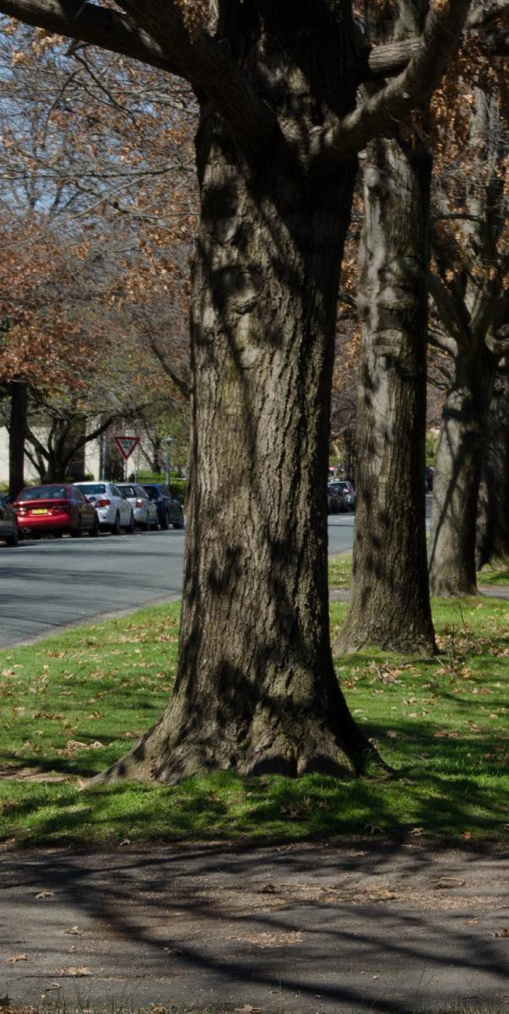
Kennedy Street in Kingston is part of the Kingston / Griffith Garden City Heritage Precinct

BUSHFIRE PRONE AREAS

It is essential to select plant species carefully when landscaping home
gardens and nature strips in Bushfire Prone Areas

Urban land adjacent to forest and grassland may be designated as a Bushfire Prone Area. A map of these areas, together with a search tool (based on entering a street address), can be accessed at: actmapi.act.gov.au.
It is essential to select plant species carefully when landscaping home gardens and nature strips in Bushfire Prone Areas—see Appendix: ‘Plants recommended for Canberra nature strips’.
It is preferable to choose plants with low oil content and fleshy leaves. Tussock grasses should be avoided. Flammable mulch is not recommended, especially when spread over a large area. Inorganic
mulches like decomposed granite will retain moisture in the garden bed. Dead or dying material from plants should be removed to reduce the overall fuel load.
As the total area of planted nature strips increases, so too does the fire hazard. Before deciding to plant a nature strip in a Fire Prone Area, it is important to consider plantings on neighbouring land, and the potential fire hazard of adding more plants to the streetscape.
Fire hydrants must have a clearance zone of 1.5 metres from the outside edge, as well as a pathway of 1.2 metres from the road to the hydrant.
This allows emergency service crews to easily locate and access the hydrant.
The managing nature strips section (page 8) of these guidelines outlines the expectations of residents for the upkeep of nature strips. If a nature strip poses a fire risk to the neighbourhood, a rectification order may be issued under the Emergency Act 2004.

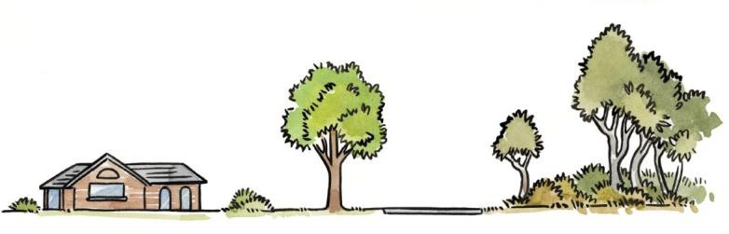
FIGURE 8: Reduced natural fuel loads in fire prone areas is essential.

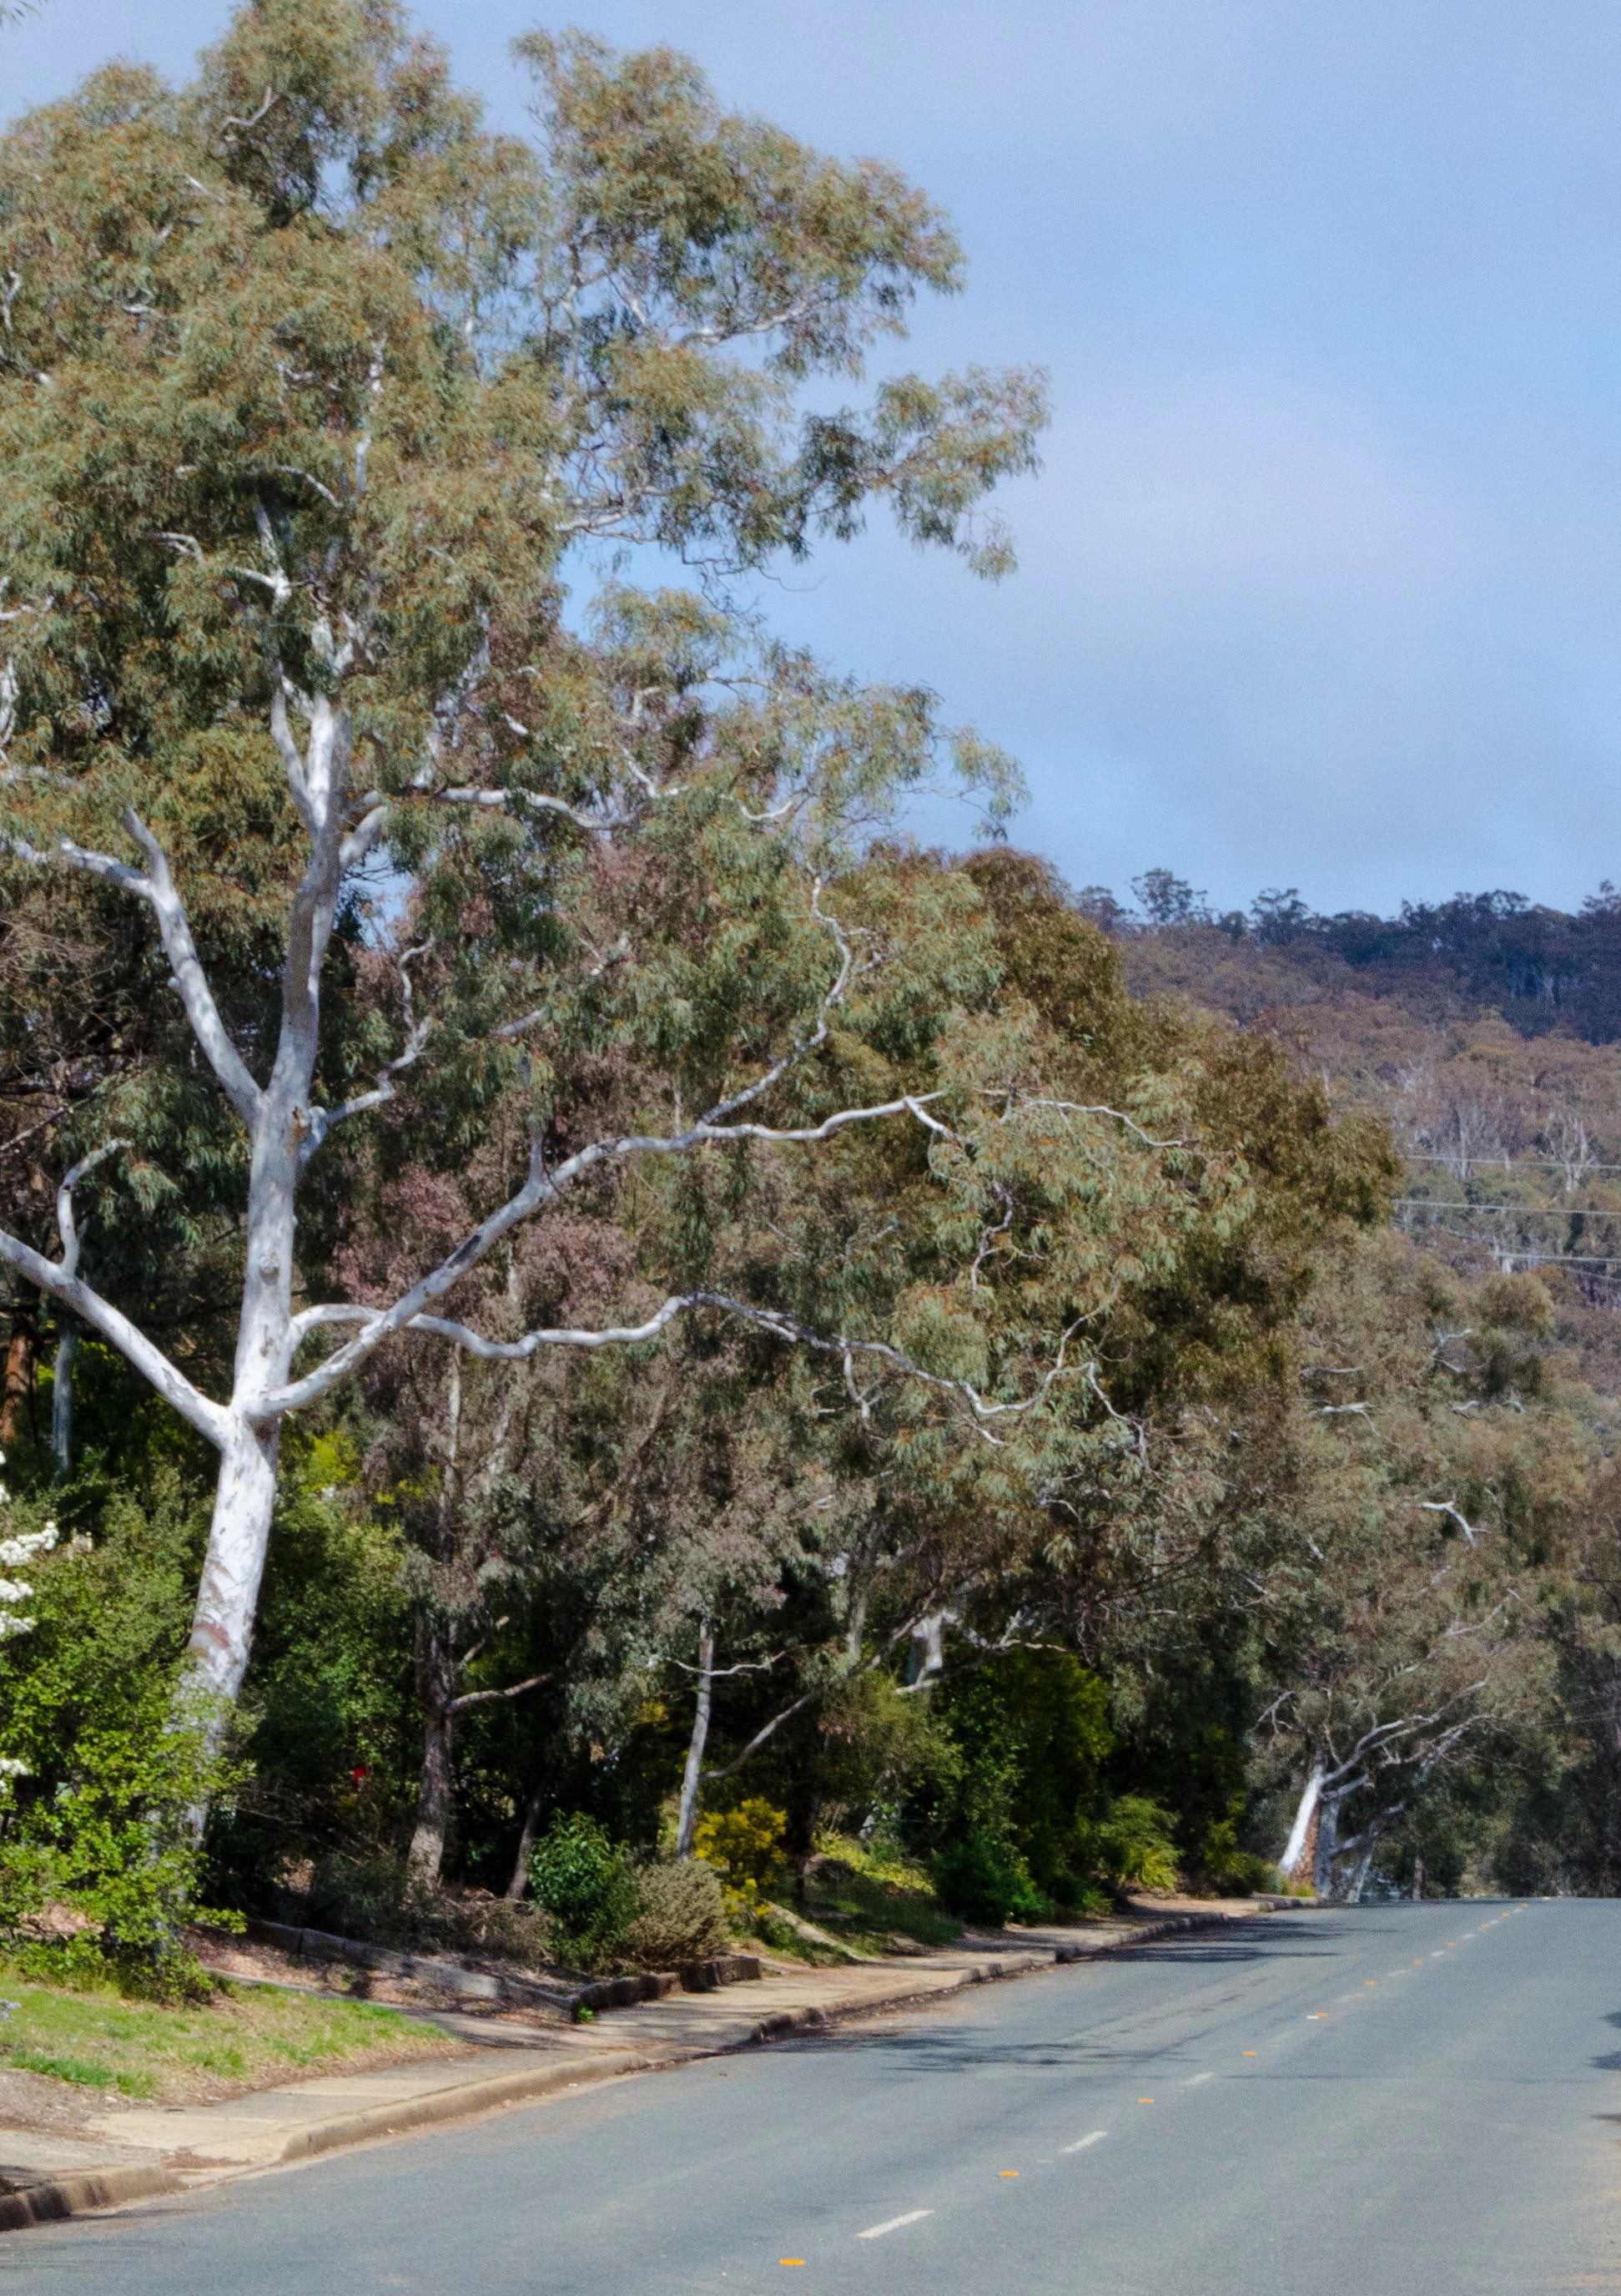

APPLYINGFORAPERMITOR WORK APPROVAL

Before causing any damage to a nature strip, you must have a valid authorisation such as a work approval or permit under the Act, or a nature conservation licence. If you cause damage without that authorisation, you may be directed to repair the damage and it is an offence not to comply.

WORK APPROVAL

You need to apply for a permit or work approval if anything you propose to do to a nature strip will be construction work. Construction work includes building or erecting anything on the nature strip, such as irrigation systems, synthetic turf, bollards, and driveways.
Applications will be considered in accordance with the Act. Approval will only be given if the work is not likely to:

    - unacceptably affect people around the nature strip; and

    - cause an unacceptable risk.

Approval may be subject to conditions that eliminate or minimise such effects or risks. It is an offence to carry out work on a nature strip without approval.

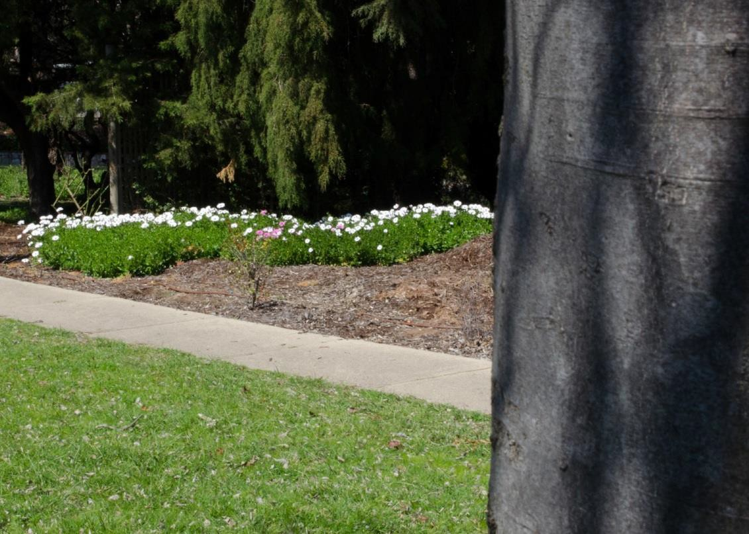
Fill out and submit the application form, which is available at www.tccs.act.gov.au
A minimum of 28 days is
required for application processing
YOUR NATURE STRIP

EXCLUSIVE USE PERMIT

If you want exclusive use of any part of a nature strip, you may need to apply for a permit. The permit is for a particular period and activity. For example, exclusive use includes the placement of a construction skip or shipping container on the nature strip.
Applications will be considered in accordance with the Act. This includes the suitability of the activity. For instance, if it involves placing an object on the nature strip, consideration will be given to the nature, size, and intended use of the object, as well as any risks which the object may cause, how those risks are to be minimised, and generally the appropriateness of the object on the nature strip. Consideration will also be given to whether you are suitable to hold a permit, such as whether you have previously committed an offence against the Act. If granted, the permit may be made subject to various conditions.
It is an offence to exclusively use a nature strip without approval.

NATURE STRIP LANDSCAPE DEVELOPMENT (for approved uses shown in Table 4)

- Fill out and submit the Nature Strip Development application form, which is available at www.tccs.act.gov.au
- A minimum of 28 days is required for application processing.
- No fee is charged (correct at time of publication).

CONSTRUCTION MATERIAL STORAGE ON THE NATURE STRIP (Table 4)

- Fill out and submit the Application to use a public place for construction activities form, which is available at www.tccs.act.gov.au
- A minimum of 28 days is required for application processing.
- No fee is charged (correct at time of publication).
- Applicant must hold public liability insurance to the value of $20 million.

For more information contact Access Canberra on 13 22 81 or
online at https://www.accesscanberra.act.gov.au/app/ask/
YOUR NATURE STRIP
GUIDELINES FOR USEOF RESIDENTIAL NATURE STRIPS
25

APPENDIX A

PLANTS RECOMMENDED FOR CANBERRA NATURE STRIPS

(less than 0.5m high or less than 0.2m in Bushfire Prone Areas)

SPECIES | COMMON NAME | NATIVE (N) / EXOTIC (E) | SUITABLE FOR BUSHFIRE PRONE AREAS
Ajuga reptans | Bugle flower | E | Yes
Aptenia cordifolia | Heartleaf Iceplant (succulent) | E | Yes
Blechnum penna marina | Antarctic hard-fern or Alpine water fern | N | Yes
Bothriochloa macra | Red leg grass | N | Yes
Brachyscome multifida | Native daisy | N | Yes
Bulbine bulbosa | Bulbine lily | N | Yes
Calocephalus citreus | Lemon beauty heads | N | No
Convolvulus cneorum | Silver bush | E | No
Chloris truncata | Windmill grass | N | Yes
Chrysocephalum apiculatum | Common everlasting | N | Yes
Convolvulus mauritanicus | Ground morning glory | E | Yes
Correa decumbens | Spreading correa | N | No
Correa ‘Dusky Bells’ | ‘Dusky Bells’ | N | No
Correa reflexa var. Nummularifolia | Roundleaf correa | N | No
Dianella revoluta | Blueberry lily, Blue flax-lily, Black anther flax-lily or Spreading flax- lily | N | No
Dichondra repens | Kidney weed | N | Yes
Grevillea lanigera  ‘Mt Tamboritha’ | Prostrate grevillea | N | No
Grevilla lanigera  ‘Kangarutha form’ | Prostrate grevillea | N | Yes
Hardenbergia violacea | False sarsparilla | N | Yes

26
YOUR NATURE STRIP
GUIDELINES FOR USEOF RESIDENTIAL NATURE STRIPS

YOUR NATURE STRIP
GUIDELINES FOR USEOF RESIDENTIAL NATURE STRIPS
27
SPECIES | COMMON NAME | NATIVE (N) / EXOTIC (E) | SUITABLE FOR BUSHFIRE PRONE AREAS
Hibbertia procumbens | Spreading guinea flower | N | Yes
Juniperus conferta | Shore juniper | E | No
Leucochrysum albicans | Hoary sunray | N | Yes
Leucophyta brownii | Cushion bush | N | No
Liriope muscari | Lily turf | E | No
Microlaena stipoides | Weeping grass | N | Yes
Myoporum parvifolium | Creeping boobialla | N | Yes
Ophiopogon japonicus | Mondo grass | E | No
Origanum vulgare | Oregano | E | No
Poa sieberiana | Grey tussock-grass or Snow grass | N | No
Rhagodia spinescens | Salt bush | N | No
Rosmarinus officinalis  (prostrate form) | Prostrate rosemary | E | No
Santolina chamaecyparissus | Lavender cotton | E | No
Scaevola aemula  ‘Sunfan’ | Fan flower | N | No
Scaevola ‘Mauve Clusters’ | Fan flower | N | No
Scleranthus biflorus | Cushion bush | N | Yes
Selliera radicans | Swampweed | N | Yes
Themeda triandra | Kangaroo grass | N | No
Thrachelospermum asiaticum | Asiatic jasmine | E | No
Thymus vulgaris | Thyme | E | No
Viola hederacea | Native violet | N | Yes
Wahlenbergia communis | Native bluebells | N | No

APPENDIX B

FURTHER INFORMATION
TERMINOLOGY | DEFINITION/DESCRIPTION
Protected Trees  (Regulated Trees and Registered Trees) | The Tree Protection Act 2005 legislation has two types of protected trees, and Regulated Trees and Registered Trees.  A Regulated Tree is a tree on leased (private) land that is either:  - 12 metres or more in height; or  - 1.5 metres or more in circumference at 1 metre above ground level; or  - with two or more trunks and the total circumference of all the trunks, 1 metre above ground level, is 1.5 m or more, or  - 12 metres or more in crown width.  A tree identified as a pest plant under the Pest Plants and Animals Act 2005 is not a Regulated Tree.  A Registered Tree is a tree on public or leased (private) land that has been identified as being exceptional for its: natural or cultural heritage value; landscape and aesthetic value; scientific value; and is listed on the ACT Tree Register or Provisional Tree Register. The Tree Registers can be viewed on the TCCS website at: www.tccs.act.gov.au/city-living/trees/act_tree_register  Penalties apply for offences against the Tree Protection Act 2005. Offences and penalties are listed under Schedule 1 of the Magistrates Court (Tree Protection Infringement Notices) Regulation 2006.  Public trees, such as street or park trees in urban areas, may be listed on the Tree Register. Otherwise, these trees are not covered by the Tree Protection Act 2005. Instead, they are protected under the Trespass on Territory Land Act 1932.  To view the legislation go to: https://www.legislation.act.gov.au
‘Damage’ to a protected tree | Any work which may cause damage to a protected tree (as defined above) requires approval. Under the Tree Protection Act 2005 damage to a protected tree includes:  - killing or destroying the tree  - poisoning or ringbarking the tree  - felling or removing the tree  - Lopping (cutting branches or stems of the tree between branch unions)  - Pollarding (removing branches of the tree to a previously prunes or lopped point)  - Major pruning  - Any other activity that causes it to die or significantly reduces its expected life or adversely affects its life, stability or general appearance.
Municipal Infrastructure Standards and Specifications | These documents provide further details about undertaking works on public land, including nature strips. They describe the types of materials that should be used and how works should be undertaken. The suite of documents can be viewed here: https://www.tccs.act.gov.au/Development_and_Project_Support/st andards-codes-and-guidelines

28
YOUR NATURE STRIP
GUIDELINES FOR USEOF RESIDENTIAL NATURE STRIPS

