## Tree Registration

### Nomination 1017 PTR1017

Species: *Eucalyptus mannifera* (Red spotted gum)

Location: adjacent to Block 3 Section 79 Ainslie

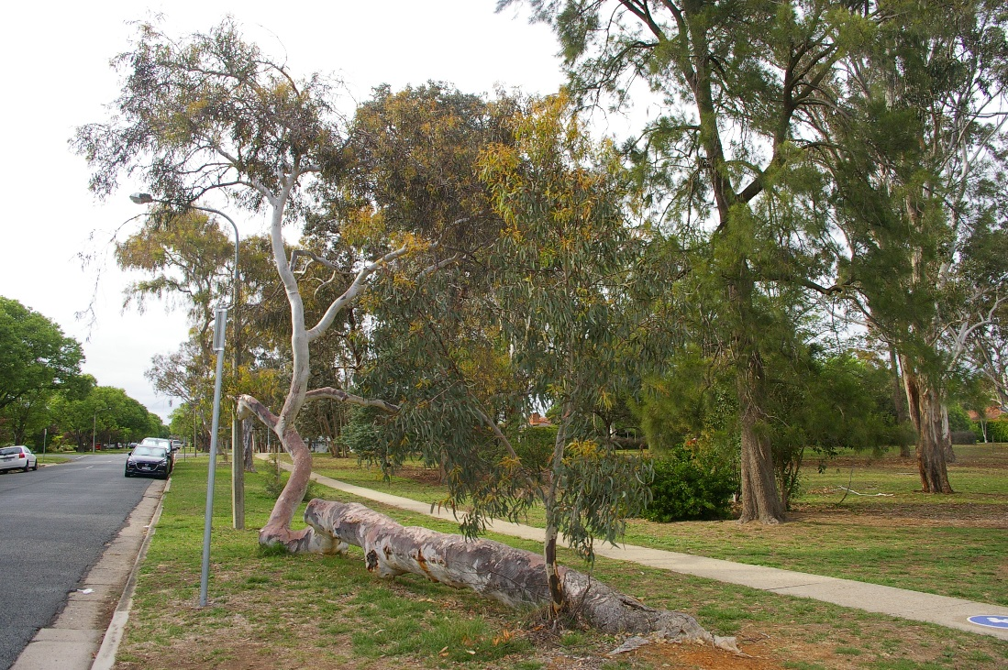

Location of *Eucalyptus mannifera*  PTR1017 in Ainslie

|  |
| --- |
| Aerial photo showing location of Eucalyptus mannifera PTR1017 in Ainslie |

| Criteria | Details of tree | |
| --- | --- | --- |
| Street address | Opposite 40 Paterson Street Ainslie | |
| Location on block | Located on the nature strip | |
| Botanical name | *Eucalyptus mannifera* | |
| Common name | Red spotted gum | |
| Tree height | Horizontal trunk 6.5m, vertical trunk 5.5m | |
| Canopy broadest diameter | 10.0m | |
| Description of radial measurement | Diagram of description of radial measurement in relation to north. Radial measurement 1 is located to the north of the tree trunk, radial measurement 2 is located on the east of the tree trunk, radial measurement 3 is located to the south of the tree trunk and radial measurement 4 is located to the west of the tree trunk. | |
| Canopy radial measurement | R1: 4.4m  R2: 4.4m  R3: 3.9m  R4: 5.6m |
| Trunk circumference | 1.7 (at 1m along horizontal trunk) |
| Number of trunks | 1 |
| Grid co-ordinates  MGA | X 694924.27  Y 6095038.16 |

### Registration Criteria that presently apply, other criteria may apply after further assessment.

(2) **Landscape and aesthetic value**

The object of this value is to identify trees that are of particular importance to the community due to their substantial contribution to the surrounding landscape.

A tree may be considered to be of landscape and aesthetic value if it is situated in a prominent location when viewed from a public place and it:

(a) contributes significantly to the surrounding landscape based on its overall form, structure, vigour and aesthetic values; or

(b) represents an outstanding example of the species, including age, size or habit; or

(c) is an exceptional example of a locally native species that reached maturity prior to urban development in its immediate vicinity.

**Statement against the Criteria**

This individual *Eucalyptus mannifera* located on the nature strip of Corrobboree Park is iconic to the suburb of Ainslie. It’s interesting, unique partially horizontal form makes it stand out as a feature of the park and contributes significantly to the surrounding landscape. The tree is important to the surrounding residents and visitors to the park and has provided a point of interest and even an unofficial seat for many passers-by. Its uniqueness means that it has high landscape and aesthetic value and has been included on the ACT Tree Register for this reason.

This tree is located on built-up urban area to which the above criteria applies. The tree appears to meet the criteria of 1a and 1b as defined under the Tree Protection Act 2005.

Furthermore, I am not satisfied that the trees meet the criteria for cancellation of registration.

**Number PTR1017**

***Eucalyptus mannifera* (Red spotted gum)**

## ACT Tree Register

**(Registration)**

Pursuant to Division 7.2 of the *Tree Protection Act 2005* as the Conservator of Flora and Fauna and for the reasons stated against the criteria above, I hereby make a decision under section 52 (1) to register the above tree on the ACT Tree Register.

### Registration

#### Yes

Ian Walker

Conservator of Flora and Fauna 8/11/2019

Requests for further information should be made to:

Tree Protection Unit Telephone: (02) 6207 8145

PO Box 158 Facsimile: (02) 6207 5956

Canberra City, ACT 2601 Email: [treeprotection@act.gov.au](mailto:tree.protection@act.gov.au)