Tree Registration

Nomination 1027 RT1027-Group Deakin/Hughes
Species: Eucalyptus blakeyli (Blakely’s red gum)
Location: Block 13 Section 78 Deakin, Block 8 Section 66 Deakin and
Block 3 Section 57 Hughes
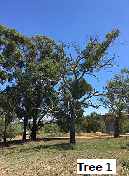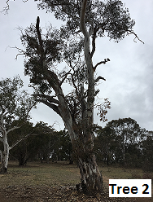
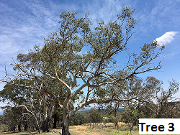
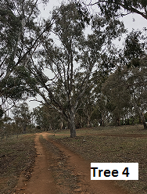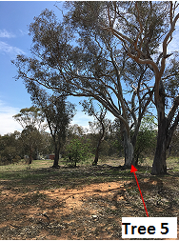
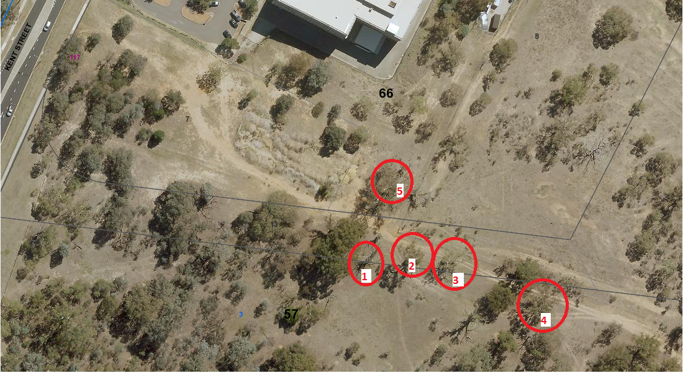Location of Eucalyptus blakelyi RT1027 in Deakin and Hughes
Field | Details of tree
Street address | Off Kent Street Deakin/Hughes
Location | Trees 1-3 are located on an urban registered block  Tree 4 is located in urban open space  Tree 5 is located inside the lease of Block 8 Section 66 Deakin
Botanical name | Eucalyptus blakelyi
Common name | Blakely’s red gum
Tree height | Tree 1: 13.5m  Tree 2: 18.0m  Tree 3: 10.5m  Tree 4: 15.5m  Tree 5: 16.0m
Canopy broadest diameter | Tree 1: 12.34m  Tree 2: 16.8m  Tree 3: 10.9m  Tree 4: 19.1m  Tree 5: 19.8m
Description of radial measurement | 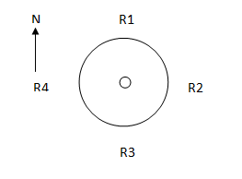
Canopy radial measurement | Tree 1  R1: 7.0m  R2: 7.2m  R3: 3.34m  R4: 5.14m | Tree 2  R1: 9.7m  R2: 6.6m  R3: 4.9m  R4: 10.2m
 | Tree 3  R1: 6.3m  R2: 4.8m  R3: 4.5m  R4 6.1m | Tree 4  R1: approx. 9.7m  R2: 8.9m  R3: 9.4m  R4: approx. 10.0m
Tree 5
R1: 10.10m
R2: 9.8m
R3: 9.2m
R4: 10.0m
Trunk circumference | Tree 1: 1.95m  Tree 2: 3.45m  Tree 3: 2.2m  Tree 4: 2.4m  Tree 5: 2.7m
Number of trunks | 1 (for each tree)
Tree Protection Zone | Canopy plus two (2) metres for each tree
Grid co-ordinates  MGA GDA 94 | Tree 1  X: 690622.99  Y: 6088628.04 | Tree 2  X: 690642.44  Y: 6088629.63
 | Tree 3  X: 690656.86  Y: 6088626.72 | Tree 4  X: 690697.86  Y: 6088609.92
Tree 5
X: 690632.25
Y: 6088659.53
Registration Criteria that presently apply, other criteria may apply after further assessment.
(3) Scientific value
The object of this value is to identify trees that are of particular importance to the community due to values associated with their ecological, genetic or botanical significance or ability to substantially contribute to the scientific body of knowledge and understanding.
A tree may be considered to be of scientific value when it:
(a) is evidence of the former range limits or extent of the species or an ecological community; or
(b) is endangered or vulnerable species that is endemic to the Territory or local region now reduced in range or abundance; or
(c) demonstrates a likelihood of providing information which will contribute significantly to a wider understanding of natural history by virtue of its use as a research site, teaching site, type locality or benchmark site; or
(d) is of botanical or genetic value and is not well represented elsewhere in the Territory; or
(e) is a significant habitat element for a threatened native species.
Statement against the Criteria
These trees are located on built-up urban area to which the above criteria applies. The tree meets the criteria of scientific value defined under the Tree Protection Act 2005.
These trees form part of an Endangered Ecological Community, the Yellow Box –Blakey’s Red Gum woodland, and are breeding habitat for a regionally vulnerable species (the Gang Gang – Callocephalon fimbriatum) that is part of that community. The Gang Gang is reliant on mature hollow bearing trees, whose loss contributes to the further decline of the community. The trees contain a number of defects, which only increases their habitat value.
For the above reasons I am satisfied that the scientific value is high, and that the trees significantly contributes to this value.
Furthermore, I am not satisfied that the trees meet the criteria for cancellation of registration.
Number 1027 RT1027-Group Deakin/Hughes

Eucalyptus blakelyi (Blakely’s red gum)

ACT Tree Register
(Registration)
Pursuant to Division 7.2 of the Tree Protection Act 2005 as the Conservator of Flora and Fauna and for the reasons stated against the criteria above, I hereby make a decision under section 52 (1) to register the above trees on the ACT Tree Register.
Ian Walker
Conservator of Flora and Fauna 3/7/2020

