## **Tree Registration**

### **Nomination 1033 RT1033 – Group Griffith**

Species: *Eucalyptus globulus subsp. bicostata* (Blue gum)

Location: Corner of Grant Crescent and La Perouse Street Griffith

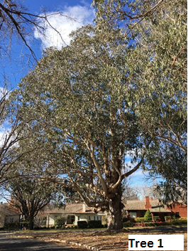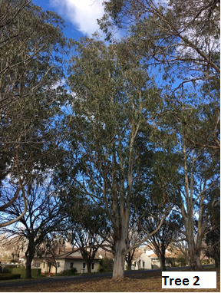

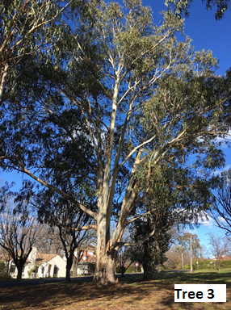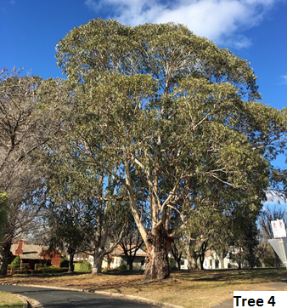

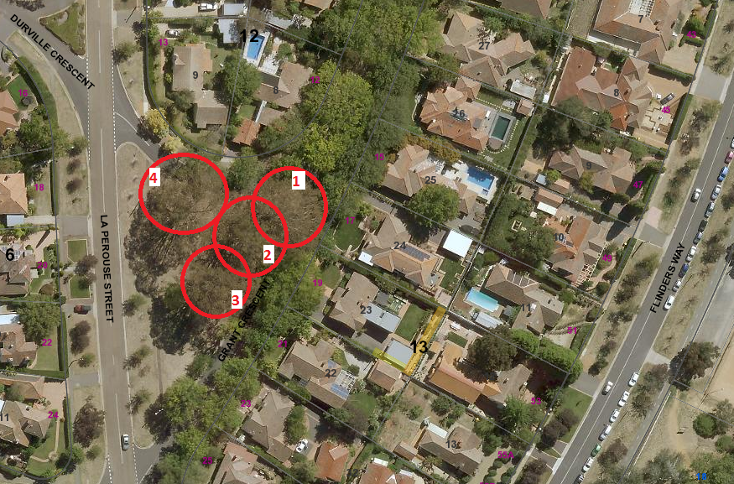

Location of *Eucalyptus globulus subsp. bicostata* RT1033 in Griffith

| **Field** | **Details of tree** | |
| --- | --- | --- |
| Street address | Opposite 17 Grant Crescent Griffith | |
| Location | In open space on the corner of Grant Crescent and La Perouse Street | |
| Botanical name | *Eucalyptus globulus subsp. bicostata* | |
| Common name | Blue gum | |
| Tree height m | Tree 1: 24.0m  Tree 2: 26.0m  Tree 3: 21.0m  Tree 4: 20.5m | |
| Canopy broadest diameter | Tree 1: 28.2m  Tree 2: 21.7m  Tree 3: 27.5m  Tree 4: 30.4m | |
| Description of radial measurement | Diagram of description of radial measurement in relation to north. Radial measurement 1 is located to the north of the tree trunk, radial measurement 2 is located on the east of the tree trunk, radial measurement 3 is located to the south of the tree trunk and radial measurement 4 is located to the west of the tree trunk. | |
| Canopy radial measurement | Tree 1  R1: 14.2m  R2: 14.9m  R3: 14.0m  R4: 12.5m  Tree 2  R1: 11.1m  R2: 11.0m  R3: 10.6m  R4: 9.2m  Tree 3  R1: 7.3m  R2: 11.8m  R3: 14.5m  R4: 15.7m  Tree 4  R1: 14.2m  R2: 12.5m  R3: 16.2m  R4: 15.9m |
| Trunk circumference | Tree 1: 5.7m  Tree 2: 3.7m  Tree 3: 4.4m  Tree 4: 6.5m |
| Number of trunks | Tree 1: 1  Tree 2: 1  Tree 3: 1  Tree 4: 1 |
| Tree Protection Zone | Canopy plus two (2) metres |
| Grid co-ordinates  MGA Zone 55 | Tree 1  X 693729.56  Y 6088934.59  Tree 2  X 693721.89  Y6088926.02  Tree 3  X 693714.48  Y6088914.37  Tree 4  X 693701.51  Y6088942.68 |

**Registration Criteria that presently apply, other criteria may apply after further assessment.**

(2) **Landscape and aesthetic value**

The object of this value is to identify trees that are of particular importance to the community due to their substantial contribution to the surrounding landscape.

A tree may be considered to be of landscape and aesthetic value if it is situated in a prominent location when viewed from a public place and it:

(a) contributes significantly to the surrounding landscape based on its overall form, structure, vigour and aesthetic values; or

(b) represents an outstanding example of the species, including age, size or habit; or

(c) is an exceptional example of a locally native species that reached maturity prior to urban development in its immediate vicinity.

**Statement against the Criteria**

This group of trees are located in the built-up urban area to which criteria (2) (a) Landscape and aesthetic values apply. These beautiful, large blue gum trees make a significant contribution to the surrounding landscape and therefore meet the landscape and aesthetic values as defined under the provisions of the *Tree Protection Act 2005.*

For the above reasons I am satisfied that the landscape and aesthetic values would be considered high, and that the trees significantly contribute to this value.

Furthermore, at the current time I am not satisfied that the trees meet the criteria for cancellation of registration.

**Number RT1033**

***Eucalyptus globulus subsp. bicostata* (Southern blue gum)**

## **ACT Tree Register**

**(Registration)**

Pursuant to Division 7.2 of the *Tree Protection Act 2005* as the Conservator of Flora and Fauna and for the reasons stated against the criteria above, I hereby make a decision under section 52 (1) to register the above trees on the ACT Tree Register.

Ian Walker

Conservator of Flora and Fauna 3/7/2020