Provisional Tree Registration RT1116 Group
Species: Eucalyptus melliodora (Yellow Box)
Eucalyptus pauciflora (Snow Gum)
Eucalyptus blakelyi (Blakely’s Red Gum)
Eucalyptus elata (River peppermint)
Eucalyptus globulus ssp. bicostata (Blue Gum)
Photos of nomination RT1116 Trees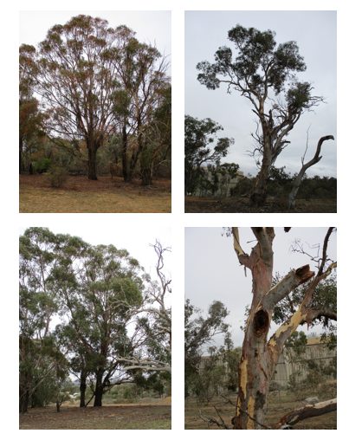
Photos of trees nomination RT1116 on Block 3 Section 57, Hughes

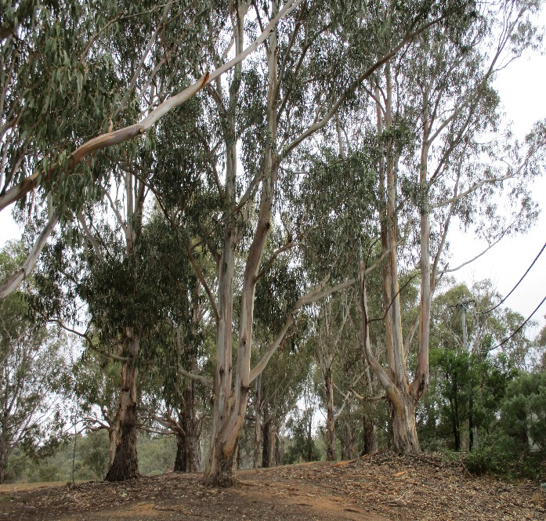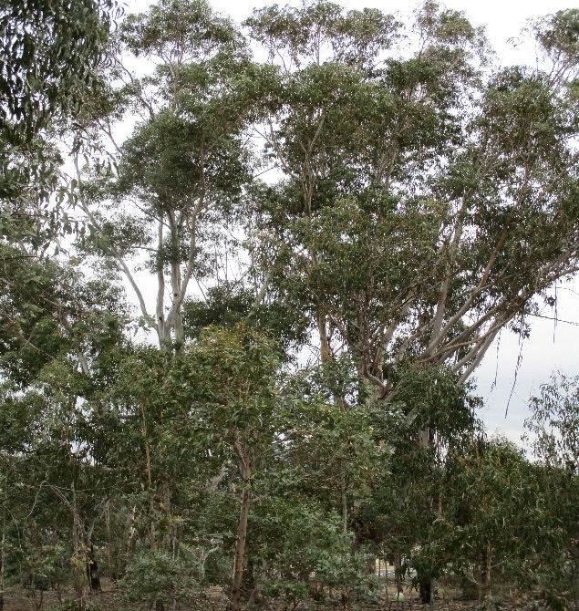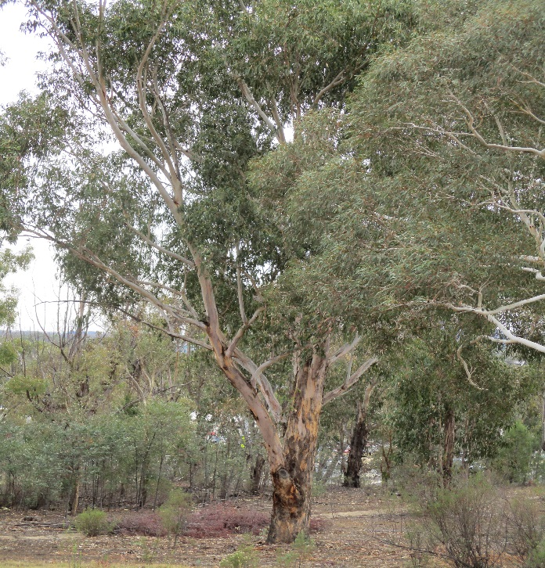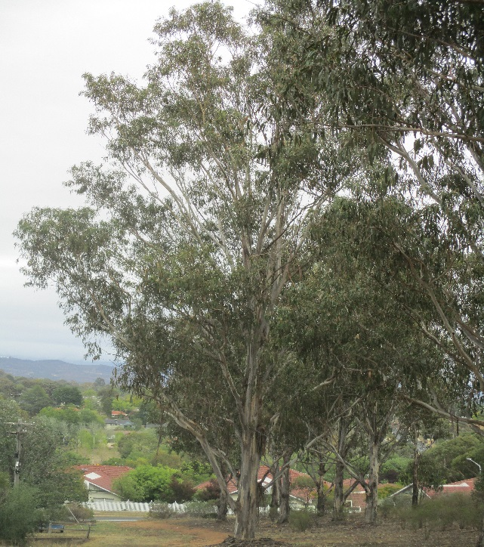
Photos of trees nomination RT1116 on Block 1 Section 58, Hughes
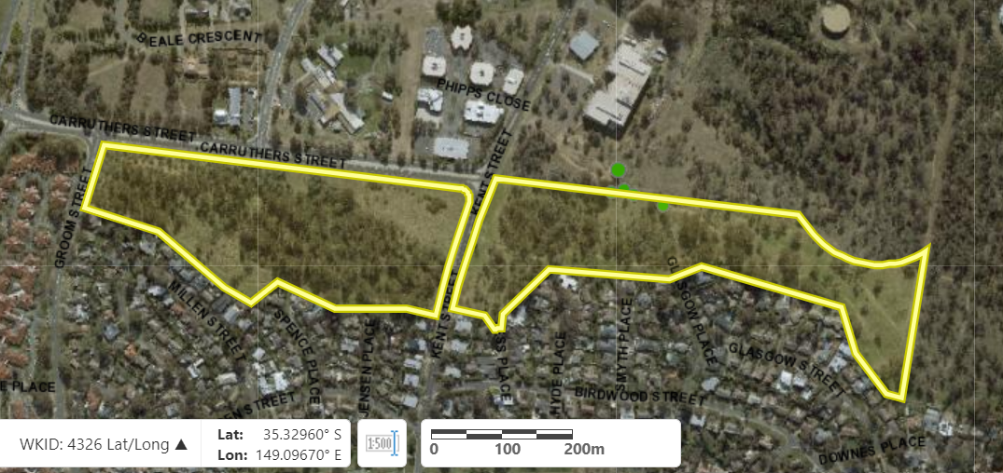
Aerial view showing the location of Block 3 Section 57 and Block 1 Section 58, Hughes

Field | Details of tree
Street address | Off Kent Street in Hughes
Location | All of Block 3 Section 57 and Block 1 Section 58
Botanical name | Eucalyptus melliodora, Eucalyptus pauciflora, Eucalyptus blakelyi, Eucalyptus elata, Eucalyptus globulus ssp. bicostata
Common name | Yellow Box, Blue Gum, River peppermint, Blakely’s Red Gum, Snow Gum
Tree height | Range from 1.0m-24.0m
Canopy broadest diameter | Various
Canopy radial measurement | Various
Trunk circumference | Various
Number of trunks | Single to multi stemmed examples
Grid co-ordinates  WKID 4326 Lat/Long | Block 3 Section 57  X: 35.32791  Y: 149.09218
Grid co-ordinates  WKID 4326 Lat/Long | Block 1 Section 58  X: 35.32797  Y: 149.09216

Registration Criteria that presently apply, other criteria may apply after further assessment.
(3) Scientific value
The object of this value is to identify trees that are of particular importance to the community due to values associated with their ecological, genetic or botanical significance or ability to substantially contribute to the scientific body of knowledge and understanding.
A tree may be considered to be of scientific value when it:
(a) is evidence of the former range limits or extent of the species or an ecological community; or
(b) is endangered or vulnerable species that is endemic to the Territory or local region now reduced in range or abundance; or
(c) demonstrates a likelihood of providing information which will contribute significantly to a wider understanding of natural history by virtue of its use as a research site, teaching site, type locality or benchmark site; or
(d) is of botanical or genetic value and is not well represented elsewhere in the Territory; or
(e) is a significant habitat element for a threatened native species.
Statement against the Criteria
The trees in these sections are located on built-up urban area to which the above criteria applies. The trees meet the criteria of scientific value defined under the Tree Protection Act 2005.

Nomination RT1116
RT1116-Group
Eucalyptus melliodora (Yellow Box)
Eucalyptus pauciflora (Snow Gum)
Eucalyptus blakelyi (Blakely’s Red Gum)
Eucalyptus elata (River peppermint)
Eucalyptus globulus subsp bicostata (Blue Gum)

ACT Tree Register
(Provisional Registration)
Pursuant to Division 7.2 of the Tree Protection Act 2005 as the Conservator of Flora and Fauna and for the reasons stated against the criteria above, I hereby make a decision under section 47 (1) to provisionally register the above trees on the ACT Tree Register.
Period of provisional registration: 1 year beginning from today. The provisional registration may end earlier if, prior to the end of that period, I decide to fully register, or not to fully register, the trees.

Provisional Registration

Conservator of Flora and Fauna / /2023

