WHEN A DOG
ATTACK OCCURS

If an attack is in progress, contact ACT Policing on Emergency Triple Zero (000).
The owner/carer of a dog responsible for an attack must self report a serious attack against another person/animal, exchange details with the victim/s and provide reasonable assistance if requested.

Dog attacks can be reported 24 hours a day, seven days a week to Access Canberra on 13 22 81.

KEEPING A
DANGEROUS DOG
D OMESTIC ANIMAL
SER VICES

Opening hours
Monday – Tuesday 10 am to 3 pm Wednesday Closed
Thursday 10 am to 5 pm
Friday – Saturday 10 am to 3 pm Sunday Closed

www.tccs.act.gov.au 13 22 81

Dogs and Community Safety
In the ACT


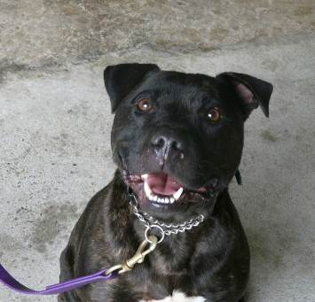
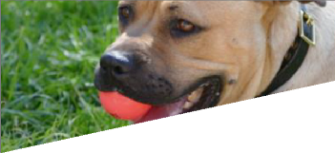
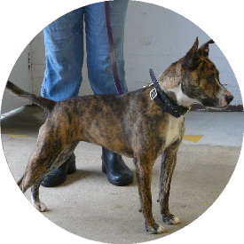


Keeping a declared dangerous dog is an onerous responsibility. An application for a dangerous dog licence must be lodged in writing to the Domestic Animal Services Registrar. If a licence is granted, an annual licence renewal fee must be paid. Details are available at www.tccs.act.gov.au.

Strict conditions are placed on the licence. These include the erection of escape proof gates, muzzling the dog when it leaves its specified premises, ensuring it wears a dangerous dog collar, and the erection of warning signage on all gates/ doors at the premises.

Dogs make wonderful companions. All dogs, however, can be unpredictable and have the capacity to be aggressive if not managed responsibly.

As a pet owner, it is your responsibility to ensure your dog is happy, healthy and not negatively impacting the community in any way.

ARE YOU A
RESPONSIBLE PET OWNER

Responsible pet ownership is key to preventing dog attacks. DAS works to educate the community on responsible dog management, care and control including through the Paws For Thought campaign. You can be banned from owning a dog in the ACT if you are not a responsible pet owner.

Registration
Dogs over eight weeks old must be registered in the ACT. While a yellow registration tag does not need to be displayed, dogs should wear an identification tag at all times.

Desexing
Dogs over six months old must be desexed unless the keeper of the dog holds a sexually entire permit.

Microchipping
Dogs in the ACT must be microchipped. Microchipping is not an alternative to registration.

If you are unsure about your responsibilites as an owner contact DAS on 13 22 81 or

visit www.tccs.act.gov.au/pawsforthought
THREE-TIERED SYSTEM OF
MANAGING DOGS

If your dog is a nuisance or presents a risk, the following mechanisms can be used by DAS rangers:

A nuisance notice for the owner of a dog that is a nuisance, for example, damaging property, causing excessive noise or repeatedly found to be roaming.

A control order for the owner of a dog that is harassing, has caused a non-serious injury or is aggressive. Conditions such as fencing restrictions can be placed through a control order.

A dangerous dog licence for the owner of a dog that is declared dangerous.

Dangerous dogs
A dog is declared dangerous because it:
- has attacked or harassed a person/animal
- is aggressive or menacing and poses an unacceptable safety risk if not kept in accordance with a dangerous dog licence.

There are no restricted breeds in the ACT. Each dog involved in an attack is assessed on its behaviour, history and the circumstances of an incident, taking into account the owner’s ability to
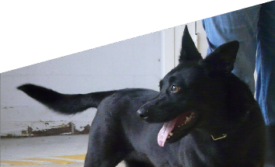

be a responsible pet owner.

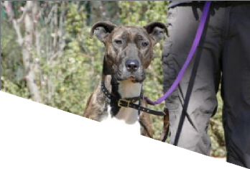
The Domestic Animals Act 2000 has strong provisions to manage dog attacks and dangerous or potentially dangerous dogs. The legislation focuses on community safety and targets irresponsible dog owners.

DANGEROUS
DOG LEGISLATION

The legislation was amended at the end of 2017 and provides for the following new offences:

- not having effective control of a dog in a public place, whether on or off a lead
- not staying at the scene of an attack to provide your details to the victim, or reasonable assistance if requested
- a keeper or carer not reporting a serious dog attack to the Domestic Animal Services Registrar
- failing to comply with a dog control order
- breeding a dog without a licence, regardless of whether it is for profit or gain
- not showing an authorised officer a breeding permit within 24 hours of being asked
- putting a dog in the care of someone without taking reasonable steps to ensure they are able to responsibly manage/control the dog
- provoking a dog to attack.

