Open Data Strategy 2019-2021

| **Document ID**  **Insert # here** | **Title**  **Insert Document title** | |
| --- | --- | --- |
| **REVISION**  **V1** | **DOCUMENT OWNER**  **Selva Murugesan** | **DATE PREPARED**  08/11/2019 |
| **TYPE**  Policy | **APPROVED BY**  Chief Operating Officer | **REVIEW DATE** |
| **DATE APPROVED**  **26/11/2019** |  |  |

Cherie Hughes

Chief Operating Officer

# Background

**What is open data**

Open data is a concept that encourages organisations and governments to make data publicly available. Open data increases citizen’s participation and engagement with the government which helps to build trust and facilitate partnering, and it is also a key driver for innovation whereby entrepreneurs can build new data-driven products and provide new value-added services to our citizens.

**Our vision**

To advance the use of open data to improve service delivery and encourage innovation.

There is a great opportunity for Transport Canberra and City Services (TCCS) to deliver community benefits by engaging with open data as a leader in this field, by acting not only as the provider of data, but also as a catalyst, policy maker, user, and consumer of insights and beneficiary of potential outcomes. TCCS is uniquely placed to make the most of this opportunity as it holds many valuable open datasets including suburb spatial information, bus schedules, active travel infrastructure, dog parks, and so on.

# Purpose

In 2015 ACT Government released a [Proactive Release of Data (Open Data) policy](http://www.cmd.act.gov.au/__data/assets/pdf_file/0011/859430/2016-Proactive-Release-of-Data-Open-Data-Policy.pdf) to support data release on ‘disclosure by default’ philosophy, which aimed to unlock the economic and productivity benefits to the citizen.

This Open Data Strategy 2019-2021 builds on the previous policy and provides a roadmap for how TCCS can practically fulfil its roles in accordance with the ACT Government Open Data policy.

# Principles

We are committed to releasing open data proactively to unlock its economic and productivity benefits based on the following principles

* **Open by default** philosophy – adhering to privacy legislations and regulations
* **Quality** –Releasing high quality open data
* **Accessible** – data is discoverable, accessible, usable and machine-readable by default
* **Free** – free open datasets licensed under Creative Commons Attribution License
* **Timely** – timely release of open datasets
* **In partnership** – encouraging public and business feedback

# Our Commitment

Through this policy, we commit to:

* increasing the availability of information about government activities
* increasing our efforts to systematically collect and publish data for essential public services and activities
* pro-actively provide high-value information, including raw data, in a timely manner, in formats that the public can easily locate, understand and use, and in formats that facilitate reuse
* creating a platform for open data consumers to enable collaboration leading to greater outcomes for citizens
* reporting our open data activities in our government publications and provide updates on industry engagements.

# Objectives

We will achieve our commitment to the ACT Government [Proactive Release of Data (Open Data) policy](http://www.cmd.act.gov.au/__data/assets/pdf_file/0011/859430/2016-Proactive-Release-of-Data-Open-Data-Policy.pdf) by implementing this strategy to achieve the below objectives.

## To solve business problems through open data

We will **solve business problems through open data** by creating a forum that encourages collaboration from internal and external stakeholders to find innovative around open data use and trusted solutions to challenges faced by business units. This leads to improving service delivery and optimising business operations within our organisation.

**Creating a developers collaboration forum** to facilitate innovation around open data use

* Creating a forum that enables our business units to share business problems with external stakeholders (developers, academia, start-ups, map providers, vendors) and co-design solutions with them
* Create a platform for collaboration, knowledge sharing and interaction for internal and external stakeholders
* Collaborate with start-ups to create strong knowledge sharing partnerships
* Increase participation in GovHack to strengthen the TCCS relationship with the broader data community
* Empower local Canberra start-ups and small businesses to utilise our open datasets to accelerate economic activities

**Targeting industry** which could benefit from open data to help our community

* Understand the requirements of industry and release open datasets to support their needs
* Promote the role of Open Data through storytelling to communicate the benefits of embracing data in an accessible manner
* Identify high value datasets to help identify internal business areas which would benefit from making their data open
* Build partnerships with app developers and third-party vendors to utilise our open datasets for increased public engagement

**Building trust in open datasets** to consequently increase trust and reliability of decisions and solutions derived from open data

* Implement our Enterprise Data Management Framework to develop a sustainable, dynamic and robust data management platform which allows to perform quality assurance and control checks
* Provide documentation for published datasets including a data dictionary and descriptions to give context to information and mitigate the chances of misinterpretation and misuse
* Increase the number and diversity of datasets available to expand the kinds of data which can be drawn from and potentially fill information gaps

## To improve the quality of life of Canberrans through open data

We will **improve the quality of life of Canberrans through Open Data** by strengthening our relationship with community, encouraging the use of open data and increasing the customer experience of our services, promoting participation of cultural events utilising our services and enhancing public safety through our infrastructure.

**Increasing the customer experience of our services** to strengthen our relationship with the communityand encourage the use of open data

* Encourage the community to utilise our developer apps which enhance visibility of our services and make it easier to access our infrastructure/services
* Improve map data to enhance navigational experiences and provide accessibility information to access roads, footpath and transport services
* Provide resources to utilise open data that stimulates active community participation
* Promote safe walking and cycling routes for our community and school children

**Increasing awareness** of the benefits of Open Data

* Implement the Open Data Value Measurement Framework to provide quantifiable benefits to internal and external stakeholders on the benefits of open data work
* Build partnerships and develop initiatives across directorates to raise the profile of open data
* Publish and circulate case studies on the successful use of TCCS open datasets in order to educate the organisation on the potential benefits of making data open
* Increase the data literacy of our community to understand our open data to derive insights

**Improving government transparency** to strengthen government accountability and build trust

* Increase the number of datasets published which are used for strategic decision making to provide transparency on government prioritisation and reasoning processes
* Provide education resources to the community to expand the public’s understanding of how data influences decisions
* Facilitate and respond to community requests for new datasets to promote participation in the open data community.

# Accountability

We will keep ourselves accountable by tracking our progress against key performance indicators.

## We will demonstrate solving business problems through open data by:

| **Key Performance Indicator** | **Baseline (2018)** | **Target (2020)** | **Target (2021)** |
| --- | --- | --- | --- |
| Increase new open data requests by 20% | N/A | 10 | 22 |
| Ratio of solutions built (apps, product, services) to new data requests | N/A | 1:8 – 1:10 | 1:4 – 1:6 |
| Increase the number of datasets published by 30% | 62 | 71 | 80 |

## We will demonstrate improved quality of life of Canberrans through open data by:

| **Key Performance Indicator** | **Baseline (2018)** | **Target (2020)** | **Target (2021)** |
| --- | --- | --- | --- |
| Community satisfaction of playground & sportsground use (survey) | N/A | > 70% | > 75% |
| Increase in access to transport services by 20% (Journey planner & MyWay) | 1 million | > 1.2 million | > 1.8 million |
| Increase in community satisfaction index (community survey)  Max satisfaction index is 4 | 2.99 | > 3 | > 3.5 |

# Progress Status

TCCS has been active in publishing open datasets every month since 2012 and we have released 96 dataset until 30 June 2019. The innovation and data analytics team have been liaising with app developers, citizen data scientists, open data enthusiasts, and academia to maximise the utilisation of our published dataset.

During 2019-20, TCCS has published 7 datasets (till date) which is in-line with our target of 20% increase open data publication.

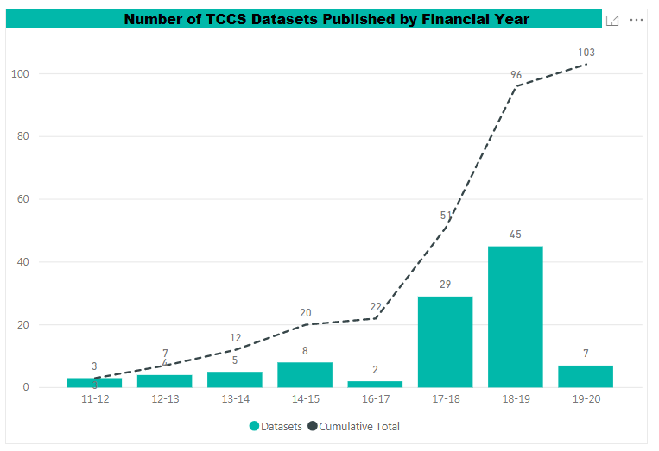

# Roadmap

