## **Provisional Tree Registration**

### **Nomination RT1163 A & B**

Species: *Eucalyptus blakelyi* (Blakely’s Red Gum)

Location: Open Space near Halfrey Circuit Playground, Wanniassa

These two *Eucalyptus blakelyi* are exceptional examples of a local keystone species that reached maturity prior to development in the area. They are equally important both aesthetically and for their exceptional contributions to habitat and habitat connectivity in the surrounding ecosystem.

**Photos of tree A**

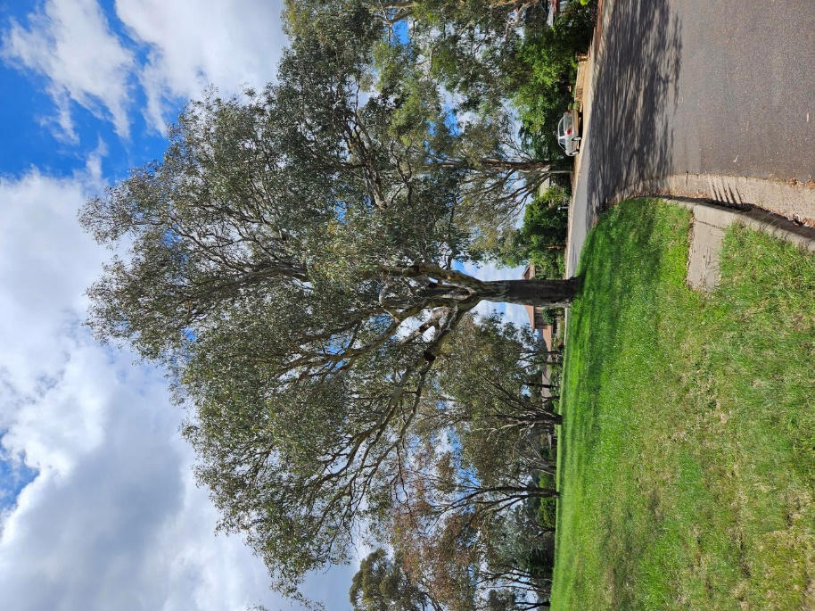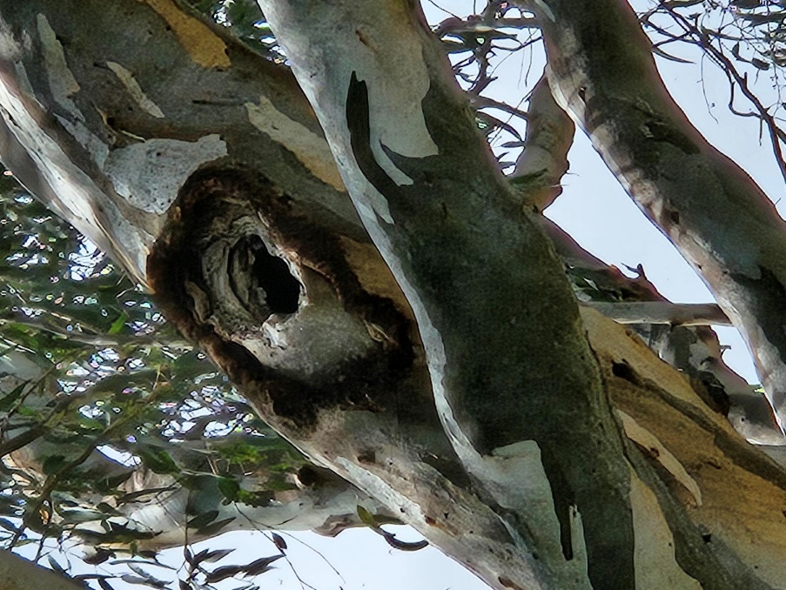

**Photos of tree B**

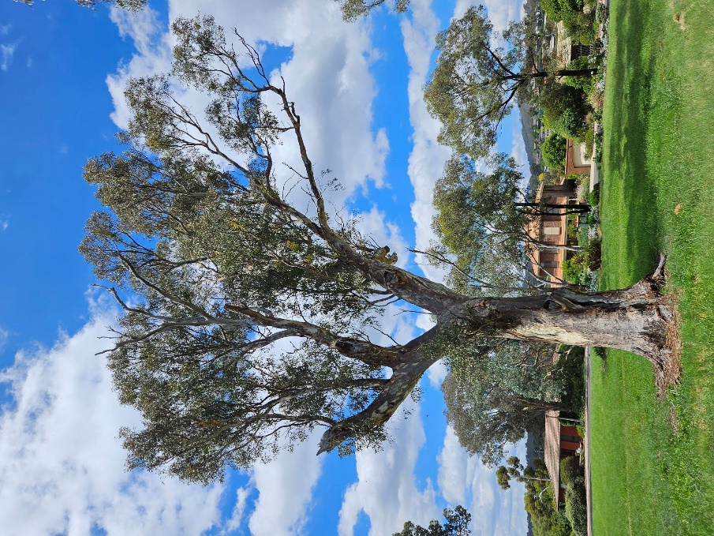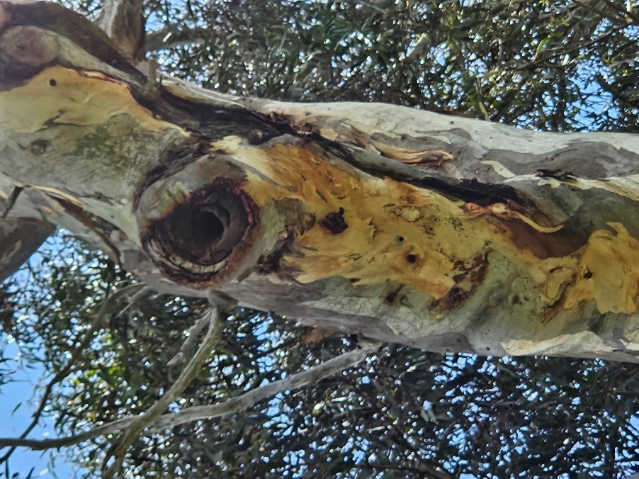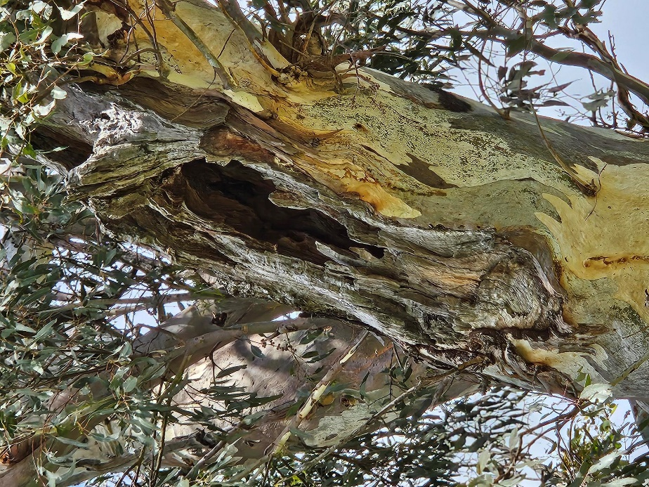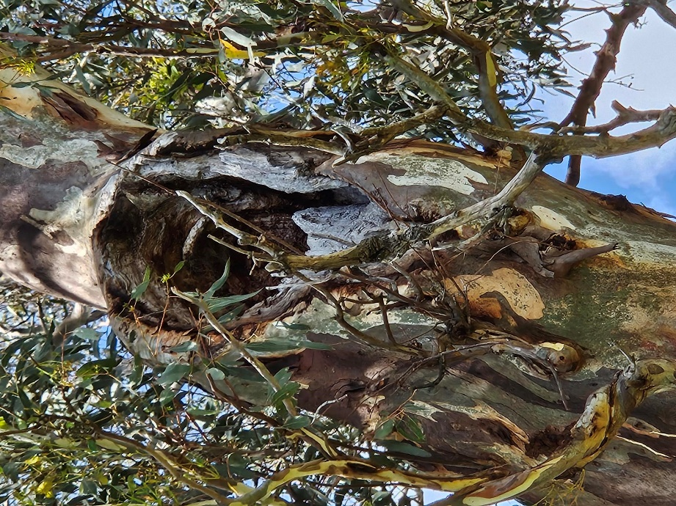

**Aerial image showing location of the trees**

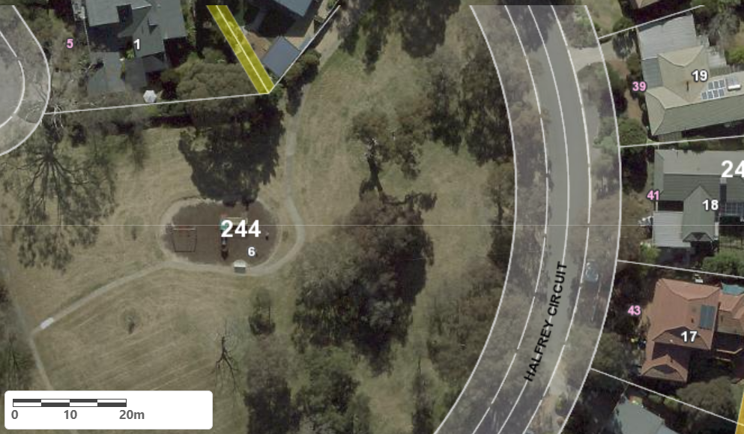

A

B

Location of 2 x *Eucalyptus blakelyi* RT1163 A & B in Wanniassa

| **Field** | **Details of tree** | |
| --- | --- | --- |
| Street address | Halfrey Circuit, Wanniassa | |
| Location | Open Space near Halfrey Circuit Playground | |
| Botanical name | *Eucalyptus blakelyi* | |
| Common name | Blakely’s Red Gum | |
| Tree height | A – 16.0m  B – 20.0m | |
| Canopy broadest diameter | A – 21.0m  B – 14.0m | |
| Description of radial measurement |  | |
| Canopy radial measurement | A - R1: 10.0m R2: 9.0m R3: 10.0m R4: 12.0m  B – R1: 1.0m R2: 4.0m R3: 13.0m R4: 9.0m |
| Trunk circumference | A – 348cm  B – 377cm |
| Number of trunks | Both have single trunks |
| Tree Protection Zone | Canopy plus two (2) metres |
| Grid co-ordinates  MGA Zone 55 | A: X – 690037.39, Y – 6080681.35  B: X – 690015.57, Y – 6080714.89 |

**Registration Criteria that presently apply, other criteria may apply after further assessment.**

(2) **Landscape and aesthetic value**

The object of this value is to identify trees that are of particular importance to the community due to their substantial contribution to the surrounding landscape.

A tree may be considered to be of landscape and aesthetic value if it is situated in a prominent location when viewed from a public place and it:

(a) contributes significantly to the surrounding landscape based on its overall form, structure, vigour and aesthetic values; or

(b) represents an outstanding example of the species, including age, size or habit; or

(c) is an exceptional example of a locally native species that reached maturity prior to urban development in its immediate vicinity.

(3) **Scientific and ecological value**

The object of this value is to identify trees that are of particular importance to the community due to values associated with their ecological, genetic or botanical significance or ability to substantially contribute to the scientific body of knowledge and understanding.

A tree may be considered to be of scientific and ecological value when it:

a)  is evidence of the former range limits or extent of the species or an ecological community; or

(b) is a listed threatened native species that is now reduced in range or abundance; or

(c) demonstrates a likelihood of providing information which will contribute significantly to a wider understanding of natural history by virtue of its use as a research site, teaching site, type locality or benchmark site; or

(d) is of botanical or genetic value and is not well represented elsewhere in the Territory; or

(e) is a significant habitat element, including mature native trees (including hollow-bearing trees) for a threatened native species; or

(f) provides exceptional contributions to habitat, habitat connectivity or the surrounding ecosystem and is/are irreplaceable.

**Statement against the Criteria**

These trees are located on built-up urban area to which the above criteria apply. The trees meet the criteria of Landscape and Aesthetic value and Scientific value as defined under the *Urban Forest Act 2023*.

For the above reasons I am satisfied that the landscape and aesthetic value is high, and that the trees significantly contribute to habitat and habitat connectivity value.

Furthermore, I am not satisfied that the trees meet the criteria for cancellation of registration.

**Number RT1163 Wanniassa**

***Eucalyptus blakelyi* (Blakely’s Red Gum)**

## **ACT Tree Register**

**(Provisional Registration)**

Pursuant to Division 4.3 of the *Urban Forest Act 2023* as the Conservator of Flora and Fauna and for the reasons stated against the criteria above, I hereby make a decision under section 55 (1) to provisionally register the above trees on the ACT Tree Register.

Period of provisional registration: 1 year beginning from today. The provisional registration may end earlier if, prior to the end of that period, I decide to fully register, or not to fully register, the trees.

Conservator of Flora and Fauna / /20