## **Tree Registration**

### **Nomination 1026 RT1026**

Species: *Eucalyptus blakelyi* (Blakely’s red gum)

Location: Block 54 Section 249 Wanniassa

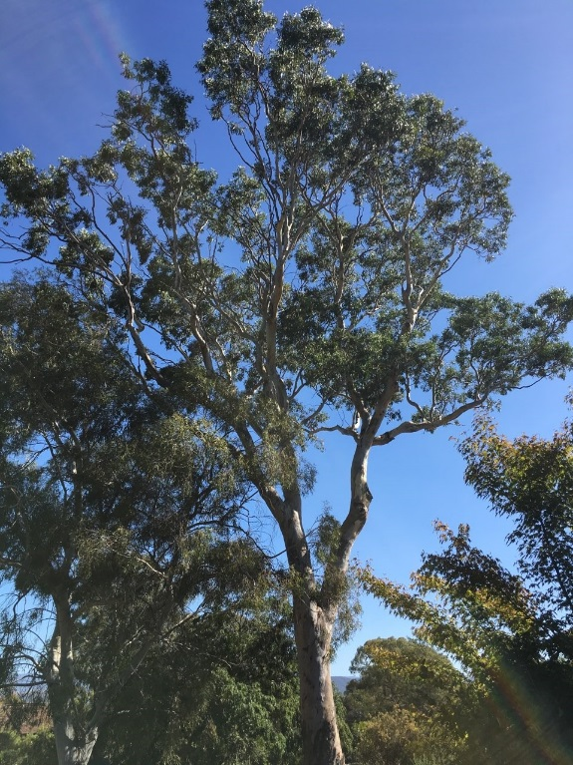 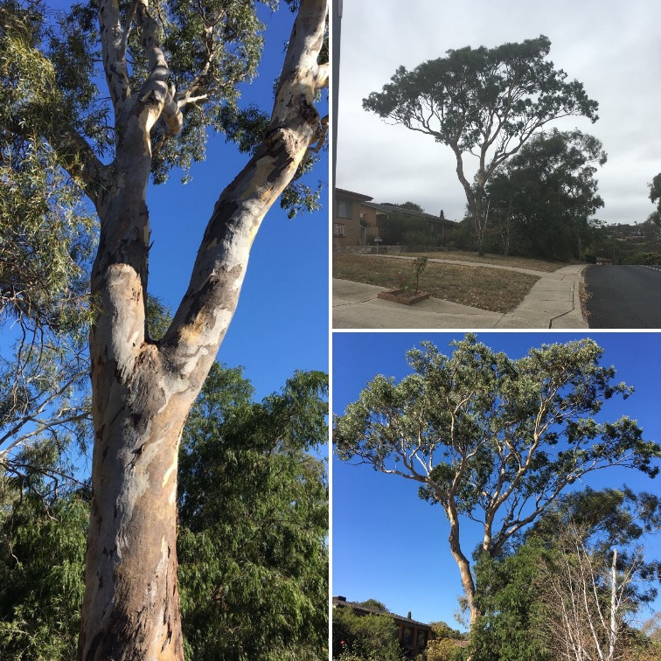

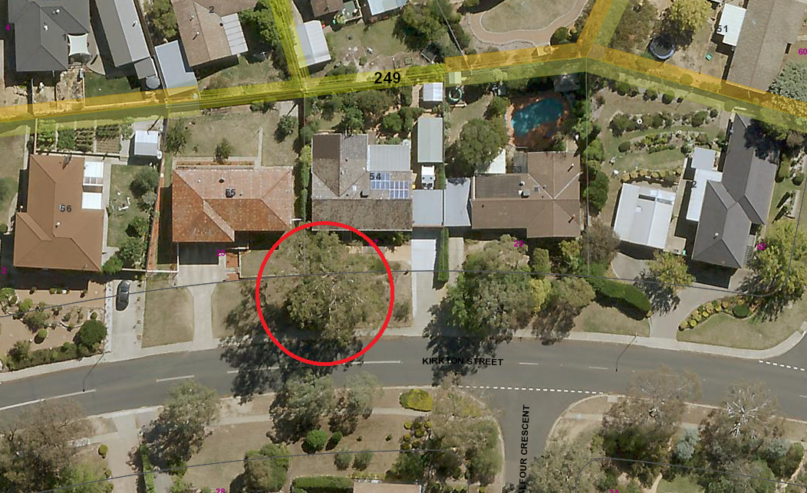

Location of *Eucalyptus blakelyi* RT 1026 in Wanniassa

| **Field** | **Details of tree** | |
| --- | --- | --- |
| Street address | 27 Kirkton Street Wanniassa | |
| Location | Front yard of property | |
| Botanical name | *Eucalyptus blakelyi* | |
| Common name | Blakely’s red gum | |
| Tree height | 24.0m | |
| Canopy broadest diameter | 20.9m | |
| Description of radial measurement |  | |
| Canopy radial measurement | R1: approx. 7.5m  R2: 10.8m  R3: 13.4m  R4: 8.9m |
| Trunk circumference | 2.98m |
| Number of trunks | 1 |
| Tree Protection Zone | Canopy plus two (2) metres |
| Grid co-ordinates | E 149.09246  S 35.39694 |

**Registration Criteria that presently apply, other criteria may apply after further assessment.**

(2) **Landscape and aesthetic value**

The object of this value is to identify trees that are of particular importance to the community due to their substantial contribution to the surrounding landscape.

A tree may be considered to be of landscape and aesthetic value if it is situated in a prominent location when viewed from a public place and it:

(a) contributes significantly to the surrounding landscape based on its overall form, structure, vigour and aesthetic values; or

(b) represents an outstanding example of the species, including age, size or habit; or

(c) is an exceptional example of a locally native species that reached maturity prior to urban development in its immediate vicinity.

**Statement against the Criteria**

This tree is located on built-up urban area to which the above criteria applies. The tree meets the criteria of landscape and aesthetic value as defined under the *Tree Protection Act 2005.* This remnant Eucalypt is an exceptional example of a local keystone species that has reached maturity prior to urban development in the area. The tree is in excellent health and provides valuable habitat to a number of native bird species. It contributes significantly to the surrounding landscape based on its overall form, size, vigour and aesthetic value.

For the above reasons I am satisfied that the landscape and aesthetic value is high, and that the tree significantly contributes to landscape and aesthetic value.

Furthermore, I am not satisfied that the tree meets the criteria for cancellation of registration.

**Number RT1026**

***Eucalyptus blakelyi* (Blakely’s red gum)**

## **ACT Tree Register**

**(Registration)**

Pursuant to Division 7.2 of the *Tree Protection Act 2005* as the Conservator of Flora and Fauna the following decision has been made under section 52(1) to enter or not enter the above tree(s) to the ACT Tree Register

Ian Walker

Conservator of Flora and Fauna 10/02/2020