## **Provisional Tree Registration**

### **Nomination RT1146 Richardson**

Species: *Cedrus libani* (Cedar of Lebanon)

Location: Open space East of Tuggeranong Creek, North side of Johnson Drive, Richardson

**Photos of the trees**

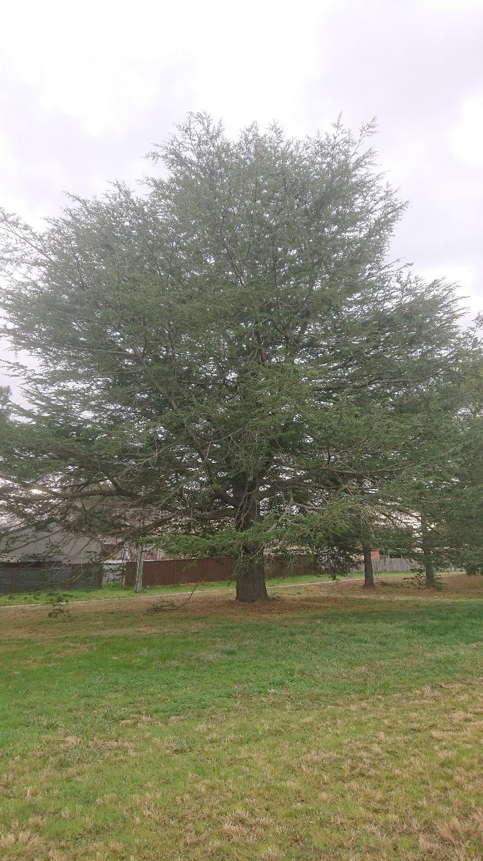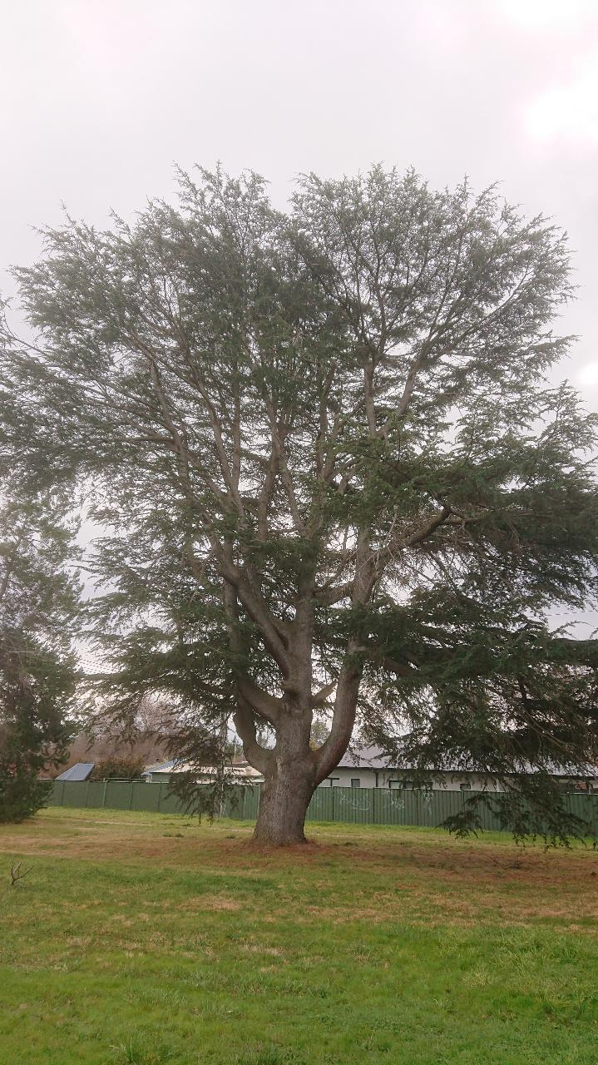

**Aerial image showing location of the trees**

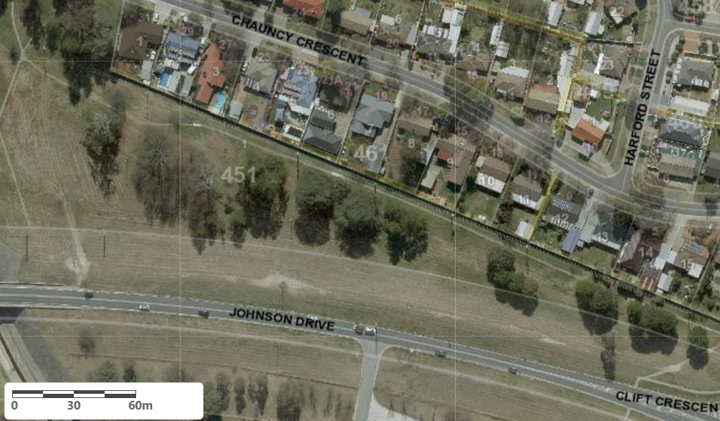

Location of 2 x *Cedrus libani* RT1146 in Richardson

| **Field** | **Details of trees** | |
| --- | --- | --- |
| Street address | Johnson Drive, Richardson | |
| Location | Open Space Block 1 Section 451 Richardson | |
| Botanical name | *Cedrus libani* | |
| Common name | Cedar of Lebanon | |
| Tree height | Tree 767 – 17m  Tree 768 – 21m | |
| Canopy broadest diameter | Tree 767 – 20.5m  Tree 768 – 24.0m | |
| Description of radial measurement |  | |
| Canopy radial measurement  Tree 767 | R1: 9.5m  R2: 9.0m  R3: 12.0m  R4: 15.0m |
| Canopy radial measurement  Tree 768 | R1: 9.0m  R2: 11.0m  R3: 9.5m  R4: 9.5m |
| Trunk circumference | Tree 767 – 380cm  Tree 768 – 410cm |
| Number of trunks | Both trees single trunk |
| Tree Protection Zone | Canopy plus two (2) metres |
| Grid co-ordinates  MGA Zone 55 | Tree 767  X – 692073.82  Y – 6076900.30  Tree 768  X – 692053.18  Y – 6076910.23 |

**Registration Criteria that presently apply, other criteria may apply after further assessment.**

(1) **Natural or cultural heritage value**

The object of this value is to identify trees that are of particular importance to the community due to their intrinsic heritage values.

A tree may be considered to be of natural or cultural heritage value when it is:

(a) associated with a significant public figure or important historical event; or

(b) of high cultural heritage value to the community or cultural group, including trees associated with aboriginal heritage and culture; or

(c) associated with a heritage nominated place and representative of that same historic period.

(2) **Landscape and aesthetic value**

The object of this value is to identify trees that are of particular importance to the community due to their substantial contribution to the surrounding landscape.

A tree may be considered to be of landscape and aesthetic value if it is situated in a prominent location when viewed from a public place and it:

(a) contributes significantly to the surrounding landscape based on its overall form, structure, vigour and aesthetic values; or

(b) represents an outstanding example of the species, including age, size or habit; or

(c) is an exceptional example of a locally native species that reached maturity prior to urban development in its immediate vicinity.

**Statement against the Criteria**

These trees are located on built-up urban area to which the above criteria apply. The trees meet the criteria of Natural or Cultural Heritage Value, and Landscape and Aesthetic Value as defined under the Tree Protection Act 2005.

For the above reasons I am satisfied that the Heritage, Landscape and Aesthetic value is high, and that the trees significantly contribute to the above values.

Furthermore, I am not satisfied that the trees meet the criteria for cancellation of registration.

**Number RT1146**

***Cedrus libani* (Cedar of Lebanon)**

## **ACT Tree Register**

**(Provisional Registration)**

Pursuant to Division 7.2 of the *Tree Protection Act 2005* as the Conservator of Flora and Fauna and for the reasons stated against the criteria above, I hereby make a decision under section 47 (1) to provisionally register the above tree on the ACT Tree Register.

Period of provisional registration: 1 year beginning from today. The provisional registration may end earlier if, prior to the end of that period, I decide to fully register, or not to fully register, the tree.

Conservator of Flora and Fauna / /2023