## **Provisional Tree Registration**

### **Nomination RT1159**

Species: *Eucalyptus melliodora* (Yellow Box)

Location: 140 The Valley Avenue, Gungahlin

**Photos of the tree**

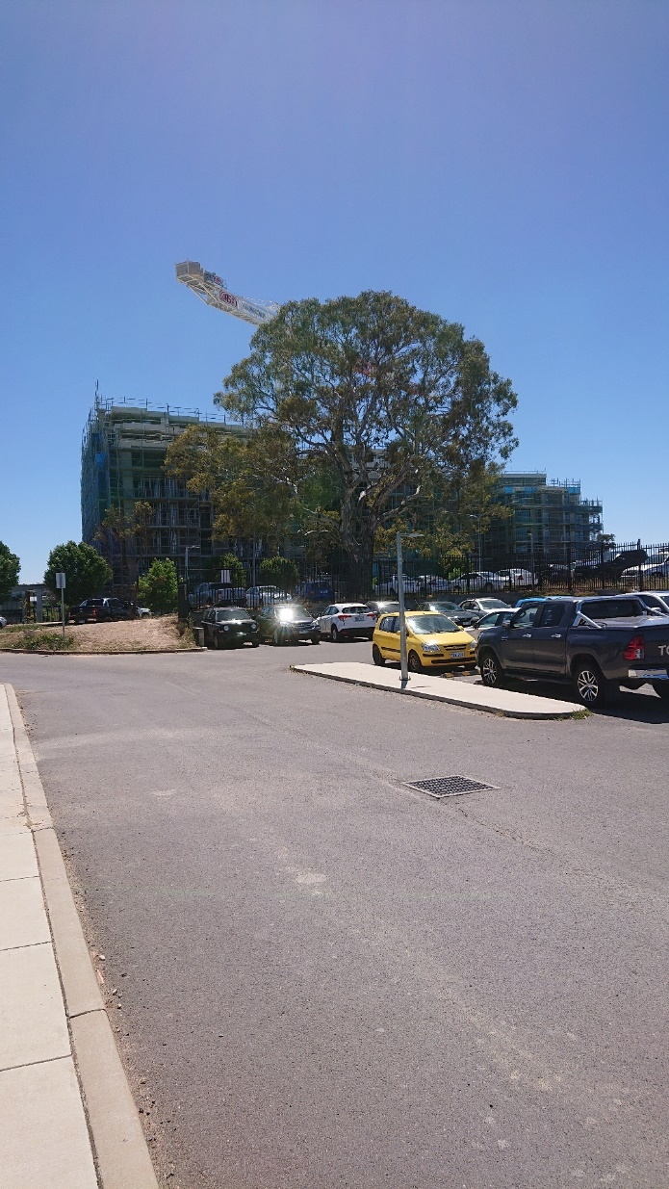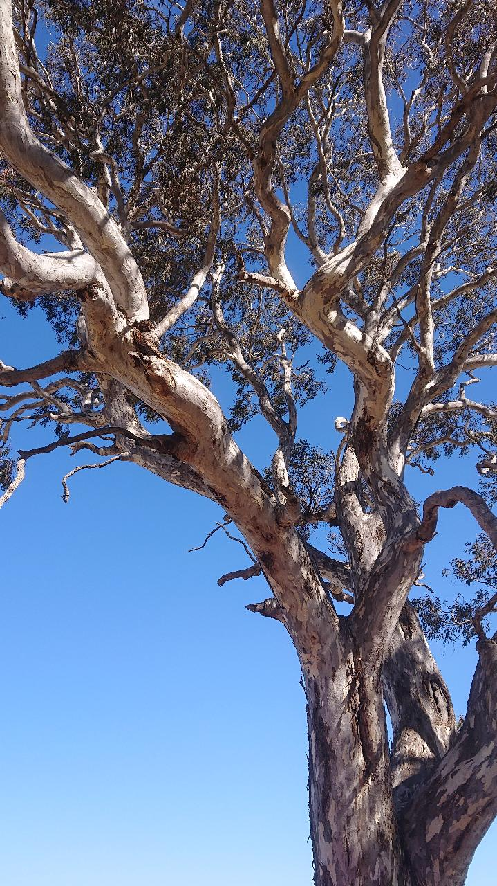

**Aerial image showing location of the tree**

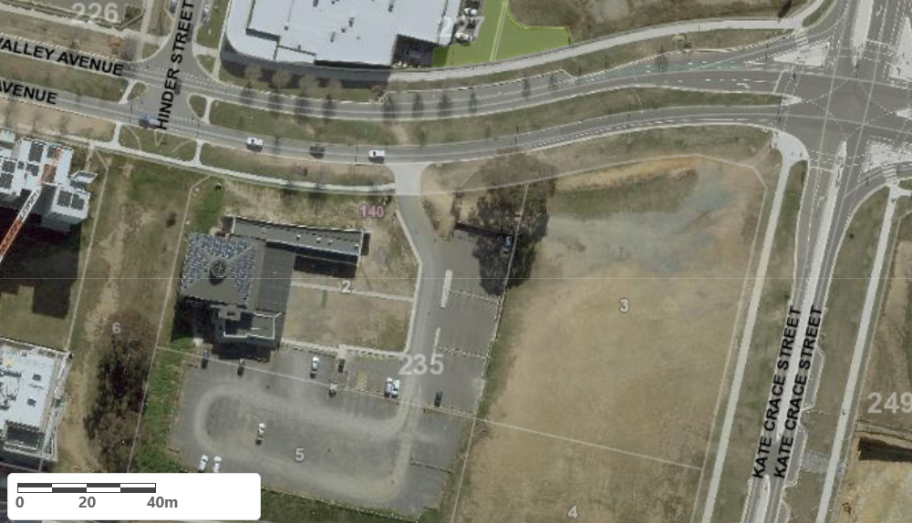

Location of *Eucalyptus melliodora* RT1159 in Gungahlin

| **Field** | **Details of tree** | |
| --- | --- | --- |
| Street address | 140 The Valley Avenue, Gungahlin | |
| Location | North-East Corner of block | |
| Botanical name | *Eucalyptus melliodora* | |
| Common name | Yellow Box | |
| Tree height | 21m | |
| Canopy broadest diameter | 24m | |
| Description of radial measurement |  | |
| Canopy radial measurement | R1: 13.0m  R2: 12.0m  R3: 9.0m  R4: 12.0m |
| Trunk circumference | 428cm |
| Number of trunks | 1 |
| Tree Protection Zone | Canopy plus two (2) metres |
| Grid co-ordinates  MGA Zone 55 | X – 694640.19  Y – 6103992.83 |

**Registration Criteria that presently apply, other criteria may apply after further assessment.**

(2) **Landscape and aesthetic value**

The object of this value is to identify trees that are of particular importance to the community due to their substantial contribution to the surrounding landscape.

A tree may be considered to be of landscape and aesthetic value if it is situated in a prominent location when viewed from a public place and it:

(a) contributes significantly to the surrounding landscape based on its overall form, structure, vigour and aesthetic values; or

(b) represents an outstanding example of the species, including age, size or habit; or

(c) is an exceptional example of a locally native species that reached maturity prior to urban development in its immediate vicinity.

**Statement against the Criteria**

This tree is located on built-up urban area to which the above criteria apply. The tree meets the criteria of Landscape and Aesthetic value as defined under the Tree Protection Act 2005.

For the above reasons I am satisfied that the landscape and aesthetic value is high, and that the tree significantly contributes to the above value.

Furthermore, I am not satisfied that the tree meets the criteria for cancellation of registration.

**Number RT1159 Gungahlin**

***Eucalyptus melliodora* (Yellow Box)**

## **ACT Tree Register**

**(Provisional Registration)**

Pursuant to Division 7.2 of the *Tree Protection Act 2005* as the Conservator of Flora and Fauna and for the reasons stated against the criteria above, I hereby make a decision under section 47 (1) to provisionally register the above tree on the ACT Tree Register.

Period of provisional registration: 1 year beginning from today. The provisional registration may end earlier if, prior to the end of that period, I decide to fully register, or not to fully register, the tree.

Conservator of Flora and Fauna / /2023