Tree Registration

Nomination 256B RT256B-Group
Species: Platanus x hispanica syn. Platanus x acerifolia (London plane)
Location: Section 1 City
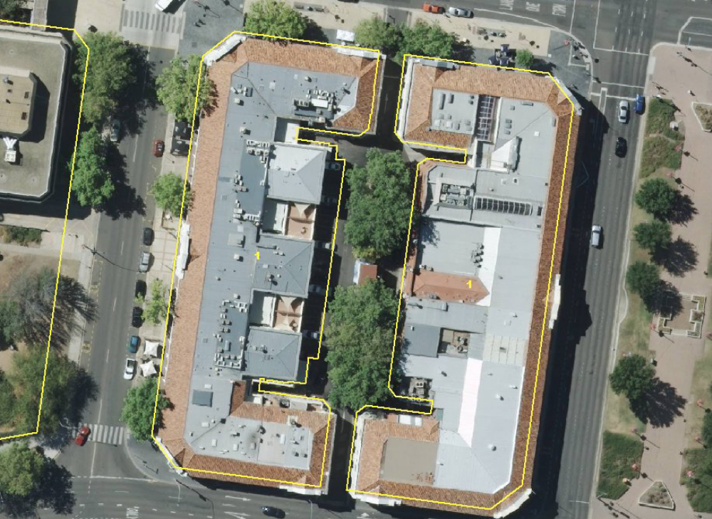

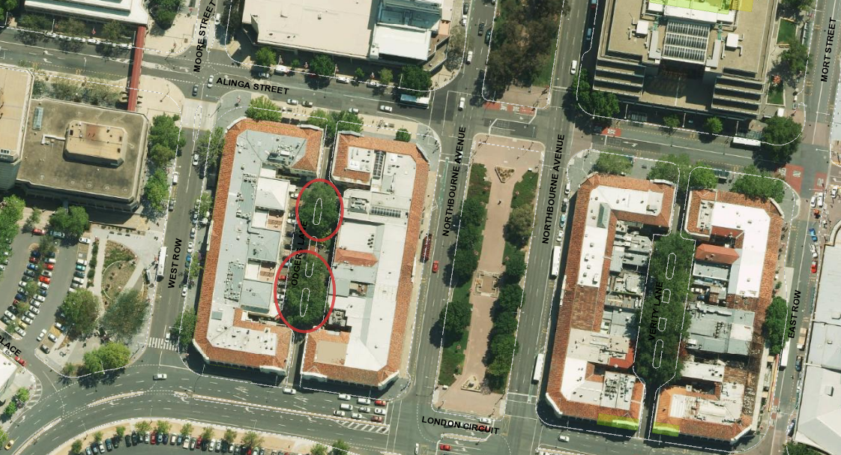
Criteria | Details of tree
Street address | Odgers Lane City – Melbourne Building
Location on block | In the middle of the block
Botanical name: | Platanus x hispanica syn. Platanus x acerifolia 6 plantings
Common name: | London plane
Tree height | ~ 16.0 m
Canopy broadest diameter: | ~12.0m
Description of radial measurement | 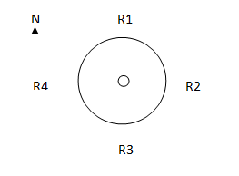
Canopy radial measurement | R1: ~5.0m  R2: ~6.0m  R3: ~5.0m  R4: ~6.0m
Trunk circumference: | ~2.4m
Number of trunks: | 1
Grid co-ordinates:  MGA 1994 | X 693,573.259 to 693,565.406  Y 6,093,979.141 to 6,093,922.781

Registration Criteria that presently apply, other criteria may apply after further assessment.
(1) Natural or cultural heritage value
The object of this value is to identify trees that are of particular importance to the community due to their intrinsic heritage values.
A tree may be considered to be of natural or cultural heritage value when it is:
(a) associated with a significant public figure or important historical event; or
(b) of high cultural heritage value to the community or cultural group, including trees associated with aboriginal heritage and culture; or
(c) associated with a heritage nominated place and representative of that same historic period.
(2) Landscape and aesthetic value
The object of this value is to identify trees that are of particular importance to the community due to their substantial contribution to the surrounding landscape.
A tree may be considered to be of landscape and aesthetic value if it is situated in a prominent location when viewed from a public place and it:
(a) contributes significantly to the surrounding landscape based on its overall form, structure, vigour and aesthetic values; or
(b) represents an outstanding example of the species, including age, size or habit; or
(c) is an exceptional example of a locally native species that reached maturity prior to urban development in its immediate vicinity.
RT256B

Platanus x hispanica syn. Platanus x acerifolia (London plane)

ACT Tree Register
(Registration)
Pursuant to Division 7.2 of the Tree Protection Act 2005 as the Conservator of Flora and Fauna the following decision has been made under section 52(1) to enter or not enter the above tree(s) to the ACT Tree Register

Registration

Yes
Conservator of Flora and Fauna 19/3/2010
Requests for further information should be made to:
Tree Protection Unit Telephone: (02) 6207 8145
PO Box 158 Facsimile: (02) 6207 5956
Canberra City, ACT 2601 Email: treeprotection@act.gov.au

