## **Tree Registration**

### **Nomination 1024 RT1024**

Species: *Eucalyptus melliodora (*Yellow box)

Location: Adjacent to Block 15 Section 43 Amaroo

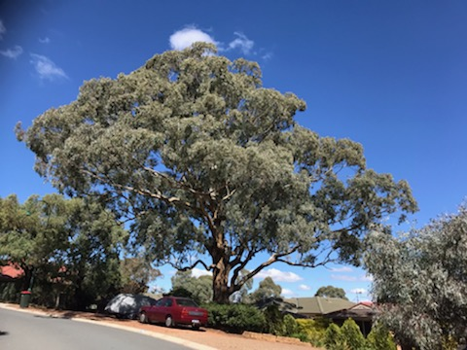 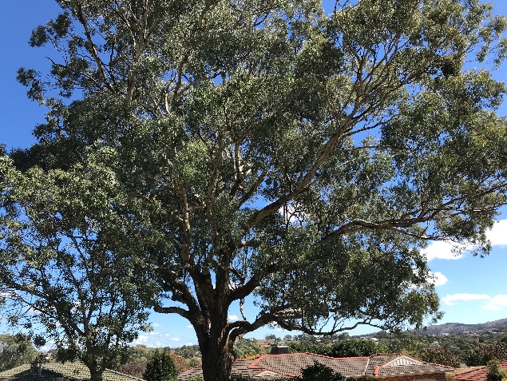

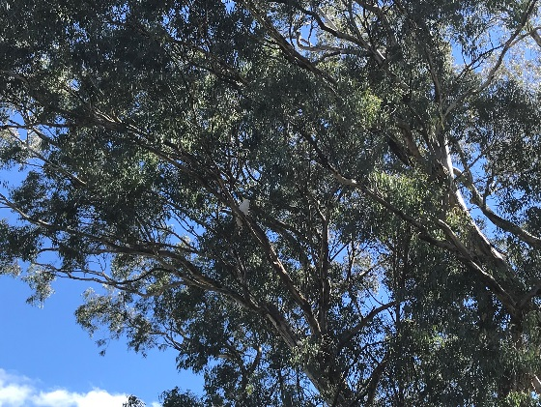

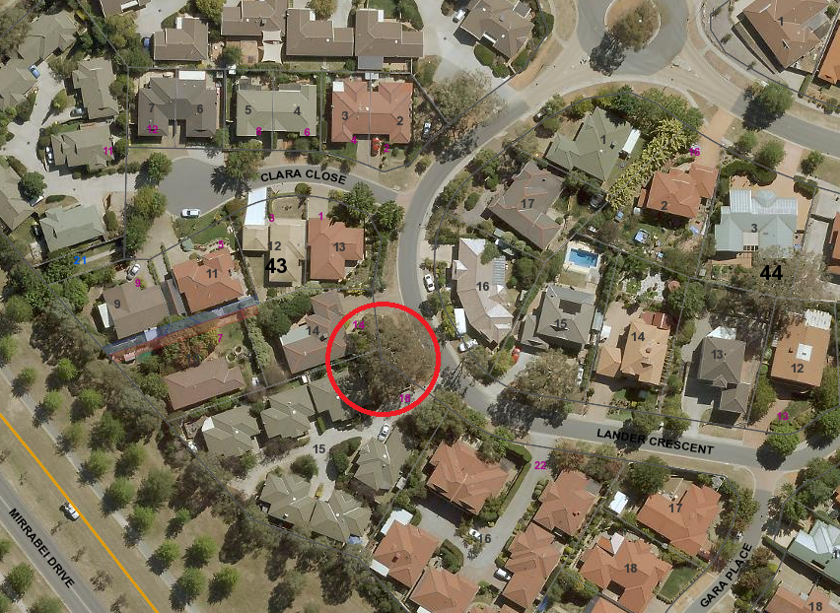

Location of *Eucalyptus melliodora* RT1024 in Amaroo

| **Field** | **Details of tree** | |
| --- | --- | --- |
| Street address | Adjacent to 18 Lander Crescent Amaroo | |
| Location | On the nature strip | |
| Botanical name | *Eucalyptus melliodora* | |
| Common name | Yellow box | |
| Tree height | 19m | |
| Canopy broadest diameter | 26m | |
| Description of radial measurement | Diagram of description of radial measurement in relation to north. Radial measurement 1 is located to the north of the tree trunk, radial measurement 2 is located on the east of the tree trunk, radial measurement 3 is located to the south of the tree trunk and radial measurement 4 is located to the west of the tree trunk. | |
| Canopy radial measurement | R1: 16.0m  R2: 10.8m  R3: approx. 10m  R4: 12.6m |
| Trunk circumference | 3.4m |
| Number of trunks | 1 |
| Tree Protection Zone | Canopy plus two (2) metres |
| Grid co-ordinates  MGA Zone 55 | X 693306.64  Y 6105531.09 |

**Registration Criteria that presently apply, other criteria may apply after further assessment.**

(2) **Landscape and aesthetic value**

The object of this value is to identify trees that are of particular importance to the community due to their substantial contribution to the surrounding landscape.

A tree may be considered to be of landscape and aesthetic value if it is situated in a prominent location when viewed from a public place and it:

(a) contributes significantly to the surrounding landscape based on its overall form, structure, vigour and aesthetic values; or

(b) represents an outstanding example of the species, including age, size or habit; or

(c) is an exceptional example of a locally native species that reached maturity prior to urban development in its immediate vicinity.

**Statement against the Criteria**

This tree is located on built-up urban area to which the above criteria applies. The tree meets the criteria of landscape and aesthetic value defined under the *Tree Protection Act 2005*. This beautiful tree represents an exceptional example of a local keystone native species that has reached maturity prior to urban development in the area. It is a sound, healthy tree that contributes significantly to the surrounding landscape.

For the above reasons I am satisfied that the landscape and aesthetic value is high, and that the tree significantly contributes to this value.

Furthermore, I am not satisfied that the tree meets the criteria for cancellation of registration.

**Number PTR1024**

***Eucalyptus melliodora* (Yellow box)**

## **ACT Tree Register**

**(Registration)**

Pursuant to Division 7.2 of the *Tree Protection Act 2005* as the Conservator of Flora and Fauna the following decision has been made under section 52(1) to enter or not enter the above tree(s) to the ACT Tree Register

### **Registration**

#### Yes

Ian Walker

Conservator of Flora and Fauna 10/02/2020