## Tree Registration

### Nomination 1004 PTR1004

Species: *Quercus robur* (English oak)

Location: Block 11 Section 75 Ainslie

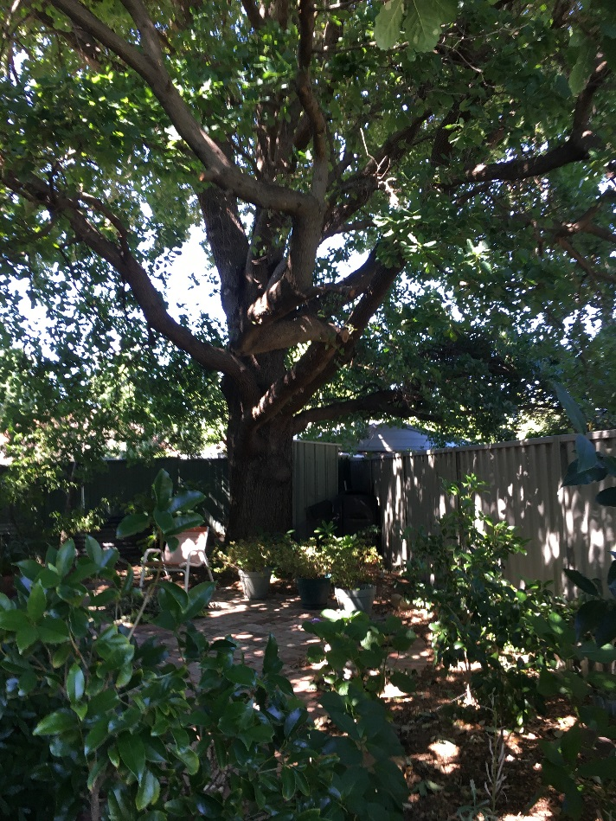

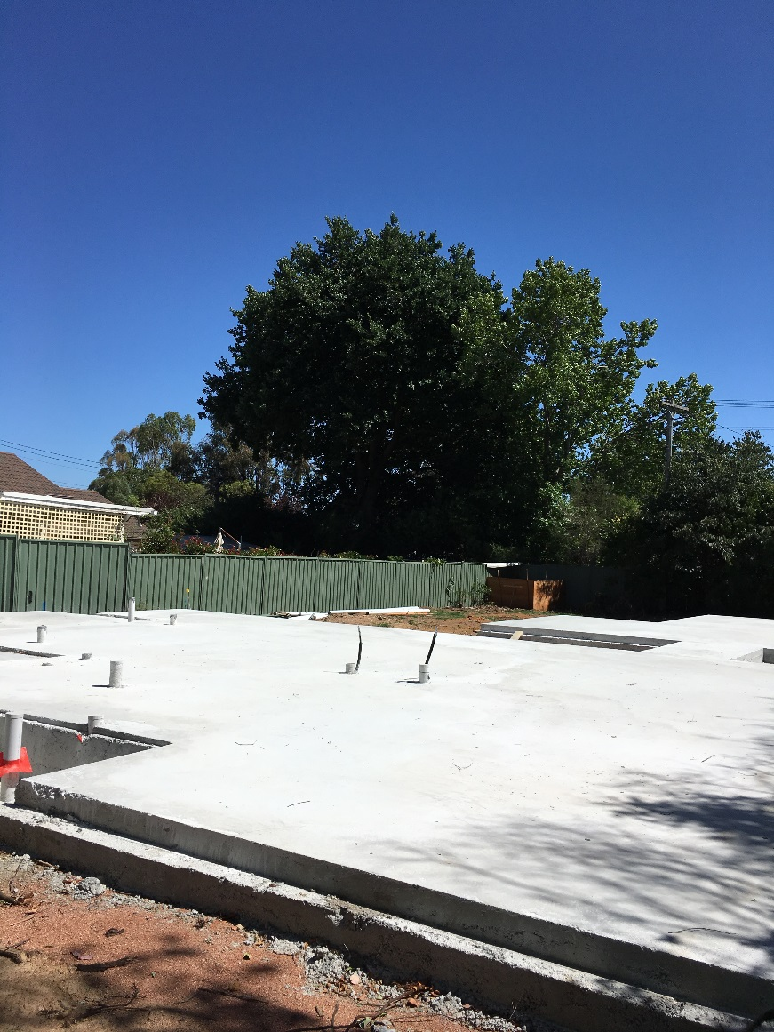 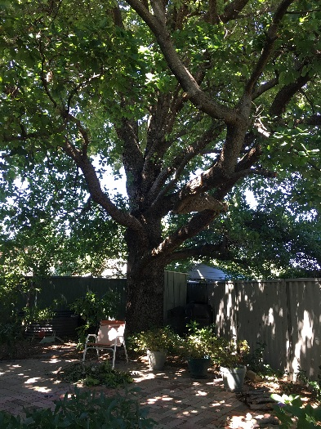

Location of *Quercus robur* PTR1004 in Ainslie

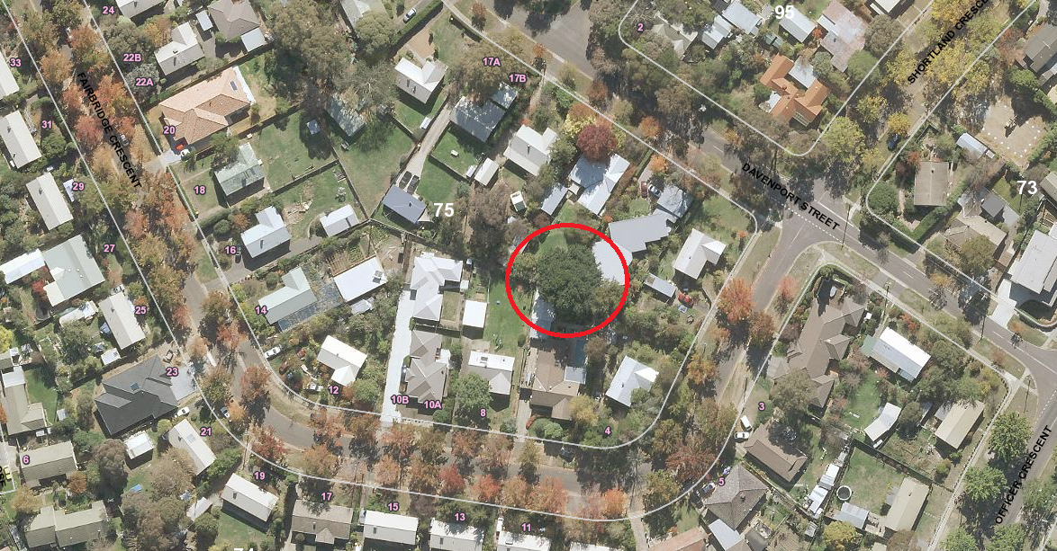

| Criteria | Details of tree | |
| --- | --- | --- |
| Street address | 11 Davenport Street Ainslie | |
| Location on block | In the backyard | |
| Botanical name | *Quercus robur* | |
| Common name | English oak | |
| Tree height | Approx. 17m | |
| Canopy broadest diameter | Approx. 19m | |
| Description of radial measurement | Diagram of description of radial measurement in relation to north. Radial measurement 1 is located to the north of the tree trunk, radial measurement 2 is located on the east of the tree trunk, radial measurement 3 is located to the south of the tree trunk and radial measurement 4 is located to the west of the tree trunk. | |
| Canopy radial measurement | R1: 12.5m  R2: approx. 8.0m  R3: approx. 7.0m  R4: approx. 10.0m |
| Trunk circumference | 3.16m |
| Number of trunks | 2 |
| Grid co-ordinates  MGA Zone 55 | X 695282.76  Y 6096270.58 |

### Registration Criteria that presently apply, other criteria may apply after further assessment.

(2) **Landscape and aesthetic value**

The object of this value is to identify trees that are of particular importance to the community due to their substantial contribution to the surrounding landscape.

A tree may be considered to be of landscape and aesthetic value if it is situated in a prominent location when viewed from a public place and it:

(a) contributes significantly to the surrounding landscape based on its overall form, structure, vigour and aesthetic values; or

(b) represents an outstanding example of the species, including age, size or habit; or

(c) is an exceptional example of a locally native species that reached maturity prior to urban development in its immediate vicinity.

**Statement against the Criteria**

This magnificent oak rises over the surrounding homes. It is a sound and healthy tree with a symmetrical, dense canopy and has the unique characteristic of having never produced an acorn**.**

It represents an outstanding example of the species due to its age, large size and sculptural habit. It contributes significantly to the surrounding landscape and is a worthy inclusion to the ACT Tree Register.

## Nomination 1004

**Number PTR1004**

***Quercus robur* (English oak)**

## ACT Tree Register

**(Registration)**

Pursuant to Division 7.2 of the *Tree Protection Act 2005* as the Conservator of Flora and Fauna the following decision has been made under section 52(1) to enter or not enter the above tree(s) to the ACT Tree Register

### Registration

#### Yes

Conservator of Flora and Fauna 12/12/2018

Requests for further information should be made to:

Tree Protection Unit Telephone: (02) 6207 8145

PO Box 158 Facsimile: (02) 6207 5956

Canberra City, ACT 2601 Email: [treeprotection@act.gov.au](mailto:tree.protection@act.gov.au)