## **Provisional Tree Registration**

### **Nomination RT1125**

Species: *Eucalyptus blakelyi* (Blakely’s red gum)

Location: Behind 76 Hurley Street Mawson

|  |  |
| --- | --- |
| **Photo of the tree** | **Close up photo of the tree** |
| **Photo of the tree** | **Photo of the tree** |

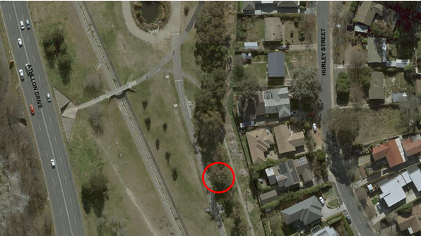

Location of *Eucalyptus blakelyi* RT1125 in Mawson

| **Field** | **Details of tree** | |
| --- | --- | --- |
| Street address | Behind 76 Hurley Street Mawson | |
| Location | In open space near the Mawson ponds | |
| Botanical name | *Eucalyptus blakelyi* | |
| Common name | Blakely’s red gum | |
| Tree height | 20.0m | |
| Canopy broadest diameter | 25.5m | |
| Description of radial measurement |  | |
| Canopy radial measurement | R1: 12.0m  R2:7.0m  R3: 13.5m  R4: 12.0m |
| Trunk circumference | 3.8m |
| Number of trunks | 1 |
| Tree Protection Zone | Canopy plus two (2) metres |
| Grid co-ordinates  MGA Zone 55 | S 35.56157  E 149.09315 |

**Registration Criteria that presently apply, other criteria may apply after further assessment.**

(2) **Landscape and aesthetic value**

The object of this value is to identify trees that are of particular importance to the community due to their substantial contribution to the surrounding landscape.

A tree may be considered to be of landscape and aesthetic value if it is situated in a prominent location when viewed from a public place and it:

(a) contributes significantly to the surrounding landscape based on its overall form, structure, vigour and aesthetic values; or

(b) represents an outstanding example of the species, including age, size or habit; or

(c) is an exceptional example of a locally native species that reached maturity prior to urban development in its immediate vicinity.

**Statement against the Criteria**

This tree is located on built-up urban area to which the above criteria applies. The tree meets the criteria of landscape and aesthetic value defined under the *Tree Protection Act 2005*.

This grand old tree contributes significantly to the open space area near the Mawson ponds. It is full of habitat with hollows and nests present in its canopy. It is an exceptional example of a locally native species that reached maturity prior to urban development in the area and adds character and beauty to the landscape.

For the above reasons I am satisfied that the landscape and aesthetic value is high, and that the tree significantly contributes to this value.

Furthermore, I am not satisfied that the tree meets the criteria for cancellation of registration.

**Number RT1125**

***Eucalyptus blakelyi* (Blakely’s red gum)**

## **ACT Tree Register**

**(Provisional Registration)**

Pursuant to Division 7.2 of the *Tree Protection Act 2005* as the Conservator of Flora and Fauna and for the reasons stated against the criteria above, I hereby make a decision under section 47 (1) to provisionally register the above tree on the ACT Tree Register.

Period of provisional registration: 1 year beginning from today. The provisional registration may end earlier if, prior to the end of that period, I decide to fully register, or not to fully register, the tree.



Conservator of Flora and Fauna / /20