Tree Registration

Nomination 117 Tree Number PTR117 - Group
Species: Quercus bicolor (Swamp White Oak)
Location: Sections 23, 28, 29, 30 Ainslie
Photos of trees:
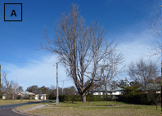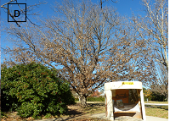
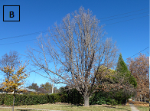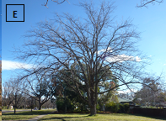
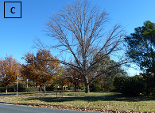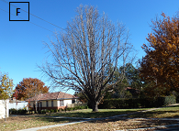

Aerial photo showing location of Quercus bicolor PTR117-Group trees A, B, C, D, E & F in Ainslie
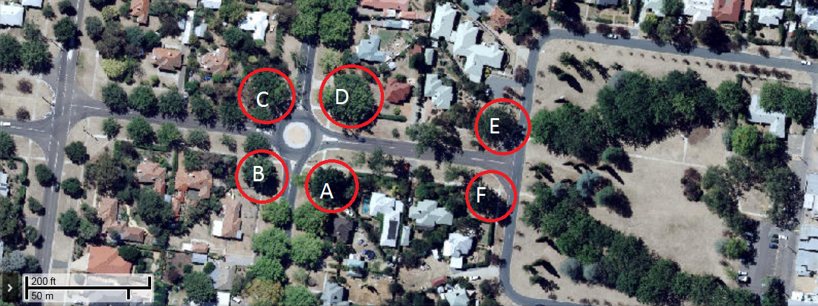

Criteria | Details of trees
Street address | Cowper Street and Wakefield Avenue
Location on block | The trees are located on each corner of Cowper Street and Wakefield Avenue and Wakefield Avenue and Wakefield Gardens in Ainslie
Botanical name: | Quercus bicolour
Common name: | Swamp White Oak
Tree height | PTR117A 21.0m;  PTR117B 20.0m;  PTR117C 21.0m;  PTR117D 24.0m;  PTR117E 18.0m;  PTR117F 19.0m.

Description of radial measurement | N  R1  R2  R4  R3
Canopy radial measurement | Tree A  R1: 12.0m;  R2: 12.0m;  R3: 11.5m;  R4: 10.0m  Tree B  R1: 10.7m;  R2: 11.5m;  R3: 9.5m;  R4: 8.7m  Tree C  R1: 10.9m;  R2: 9.0m;  R3: 9.2m;  R4: 8.3m  Tree D  R1: 11.0m;  R2: 10.5m;  R3: 9.4m;  R4: 10.3m  Tree E  R1: 8.0m;  R2: 12.0m;  R3: 12.0m;  R4: 10.0m  Tree F  R1: 10.0m;  R2: 8.5m;  R3: 6.5m;  R4: 9.0m
Trunk circumference: | Tree A 2.75m;  Tree B 2.37m;  Tree C 2.86m;  Tree D 2.40m;  Tree E 2.24m;  Tree F 2.54m
Number of trunks: | Each tree has a single trunk
Grid co-ordinates:  AGD 66 Grid | Tree A  X 211974.948  Y 606,009.669  Tree B  X 211,938.217  Y 606,015.739  Tree C  X 211,942.731  Y 606,061.575  Tree D  X 211,984.543  Y 606,053.871  Tree E  X 212,059.761  Y606,039.778  Tree F  X 212,053.031  Y606,001.596

Registration Criteria that presently apply, other criteria may apply after further assessment.
(1) Natural or cultural heritage value
The object of this value is to identify trees that are of particular importance to the community due to their intrinsic heritage values.
A tree may be considered to be of natural or cultural heritage value when it is:
(c) associated with a heritage nominated place and representative of that same historic period.

(2) Landscape and aesthetic value
The object of this value is to identify trees that are of particular importance to the community due to their substantial contribution to the surrounding landscape.
A tree may be considered to be of landscape and aesthetic value if it is situated in a prominent location when viewed from a public place and it:
(a) contributes significantly to the surrounding landscape based on its overall form, structure, vigour and aesthetic values; or
(b) represents an outstanding example of the species, including age, size or habit; or
Statement against the Criteria
This group of six exceptional Quercus bicolor have been selected for inclusion to the ACT Provisional Tree Register because of the important contribution they play within the heritage precinct of Wakefield Gardens in Ainslie. The trees are significant because of their mature size, good health and very prominent location. The trees are set out on six corners at the intersection of Cowper Street and Wakefield Avenue and Wakefield Avenue and Wakefield Gardens. It is unusual that so much space was provided for the planting of additional trees when the suburb was already well endowed with planned street tree plantings located on very wide nature strips. These six trees are in excellent health and condition and are likely to continue to grow and develop well into the future. The registration of the trees may allow more Canberrans to appreciate these fine trees.

Nomination 117
Tree Number PTR117-Group (6 trees)
Quercus bicolor (Swamp White Oak)

ACT Tree Register
(Registration)
Pursuant to Division 7.2 of the Tree Protection Act 2005 as the Conservator of Flora and Fauna the following decision has been made under section 52(1) to enter or not enter the above tree(s) to the ACT Tree Register

Registration

Yes

Alan Traves
A/g Conservator of Flora and Fauna 08/03/2013

Requests for further information should be made to:

Tree Protection Unit Telephone: (02) 6207 8145
PO Box 158 Facsimile: (02) 6207 5956
Canberra City, ACT 2601 Email: treeprotection@act.gov.au

