Tree Registration

Nomination 71 PTR054
Species: Ulmus Americana (American elm)
Location: Block 1 Section 52 Braddon
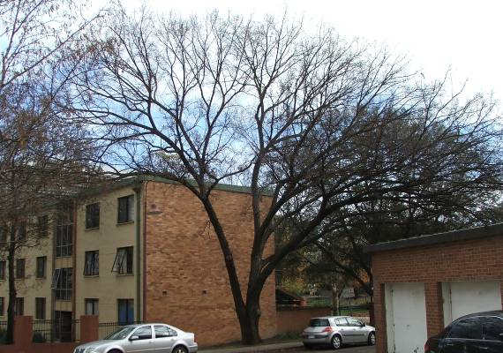
Location of Ulmus Americana PTR054 in Braddon
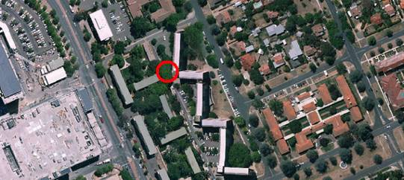
Criteria | Details of tree
Street address | Balumbir Street, Braddon
Location on block | On the northern corner of the Allawah Court apartments, next to the footpath.
Botanical name: | Ulmus Americana
Common name: | American elm
Tree height | 21.5m
Canopy broadest diameter: | 29.0m
Description of radial measurement | 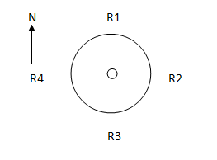
Canopy radial measurement | R1: 13.0m  R2: 18.0m  R3: 6.0m  R4: 8.5m
Trunk circumference: | 2.6m
Number of trunks: | 1
Grid co-ordinates:  MGA Zone 55 | X 694225.3  Y 6094095.7

Registration Criteria that presently apply, other criteria may apply after further assessment.
(2) Landscape and aesthetic value
The object of this value is to identify trees that are of particular importance to the community due to their substantial contribution to the surrounding landscape.
A tree may be considered to be of landscape and aesthetic value if it is situated in a prominent location when viewed from a public place and it:
(a) contributes significantly to the surrounding landscape based on its overall form, structure, vigour and aesthetic values; or
(b) represents an outstanding example of the species, including age, size or habit; or
(c) is an exceptional example of a locally native species that reached maturity prior to urban development in its immediate vicinity.
Statement against the Criteria
This mature Ulmus americana has a large spreading canopy which overhangs the service road between Allawah Court and Currong Apartments in Braddon. The tree was planted next to the footpath and provides significant amenity values by providing shade in summer and allowing sun light to penetration in winter. The tree has been nominated for inclusion to the ACT Tree Register because of the significant aesthetic and landscape contribution it provides.

Nomination 71
PTR054
Ulmus Americana (American elm)

ACT Tree Register
(Registration)
Pursuant to Division 7.2 of the Tree Protection Act 2005 as the Conservator of Flora and Fauna the following decision has been made under section 52(1) to enter or not enter the above tree(s) to the ACT Tree Register

Registration

Yes
John Meyer
A/g Conservator of Flora and Fauna 22/9/2011
Requests for further information should be made to:
Tree Protection Unit Telephone: (02) 6207 8145
PO Box 158 Facsimile: (02) 6207 5956
Canberra City, ACT 2601 Email: treeprotection@act.gov.au

