Tree Registration

Nomination 1003 PTR1003
Species: Eucalyptus nicholli (Willow-leaved peppermint)
Location: Block 19 Section 22 Lyons
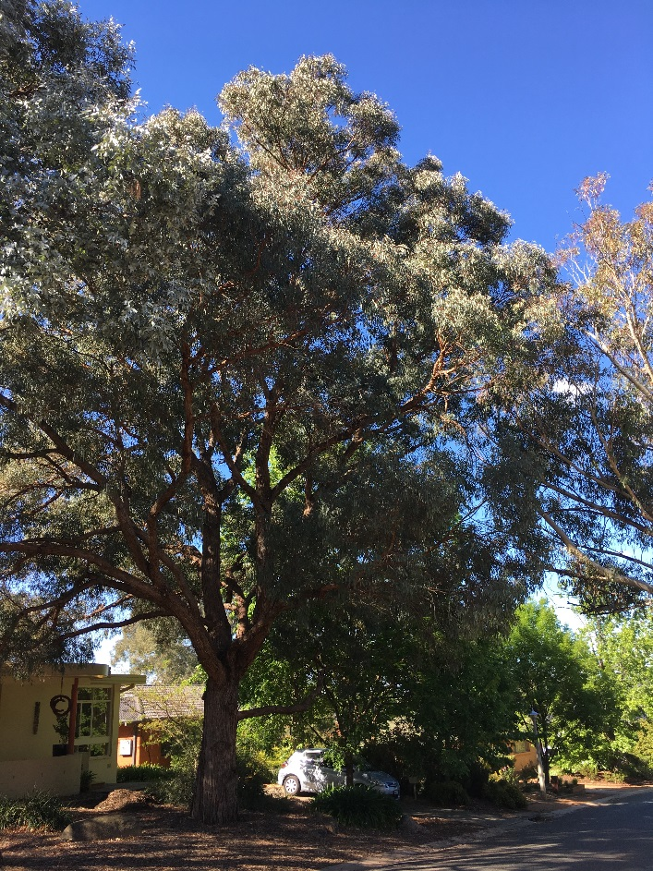
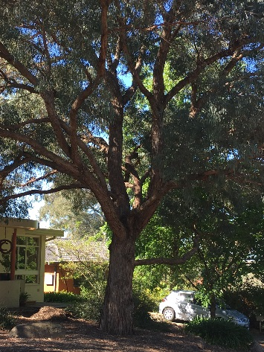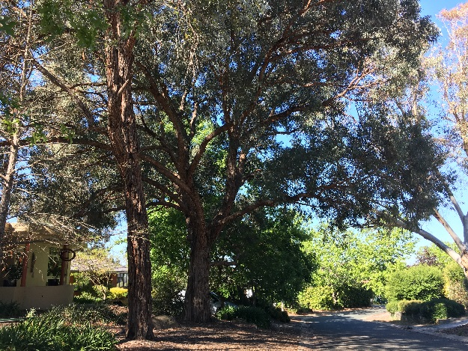

Location of Eucalyptus nicholli PTR1003 in Lyons
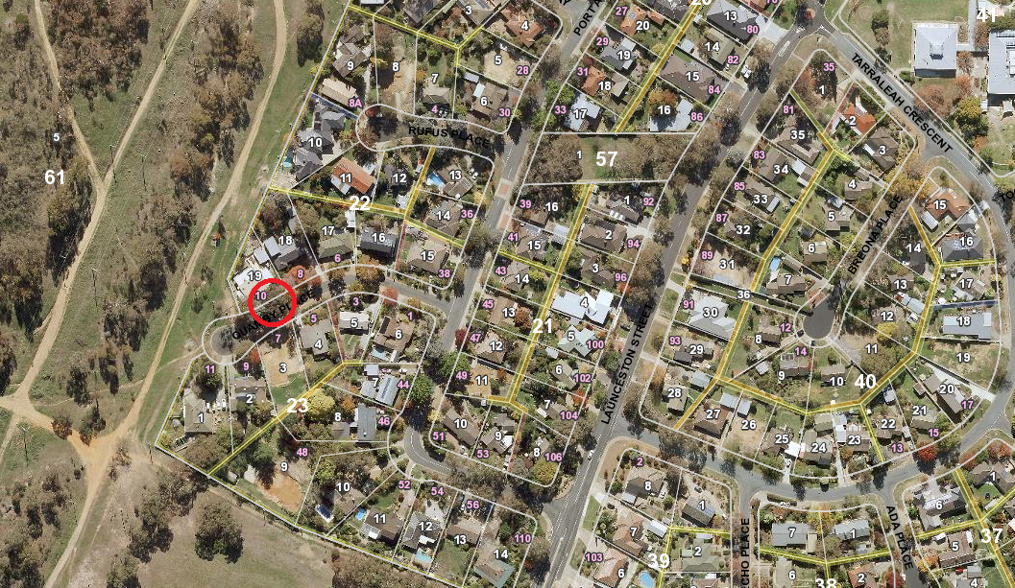
Criteria | Details of tree
Street address | 10 Quamby Place Lyons
Location on block | On the nature strip
Botanical name: | Eucalyptus nicholli
Common name: | Willow-leaved peppermint
Tree height | 18.0m
Canopy broadest diameter: | 20.0
Description of radial measurement | 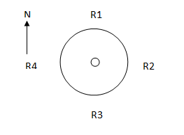
Canopy radial measurement | R1: 10.0m  R2: 9.5m  R3: 10.0m  R4: 9.5m
Trunk circumference: | 3.0m
Number of trunks: | 1
Grid co-ordinates:  MGA | X 688326.28  Y 6086940.33

Registration Criteria that presently apply, other criteria may apply after further assessment.
(2) Landscape and aesthetic value
The object of this value is to identify trees that are of particular importance to the community due to their substantial contribution to the surrounding landscape.
A tree may be considered to be of landscape and aesthetic value if it is situated in a prominent location when viewed from a public place and it:
(a) contributes significantly to the surrounding landscape based on its overall form, structure, vigour and aesthetic values; or
(b) represents an outstanding example of the species, including age, size or habit; or
(c) is an exceptional example of a locally native species that reached maturity prior to urban development in its immediate vicinity.
(3) Scientific value
The object of this value is to identify trees that are of particular importance to the community due to values associated with their ecological, genetic or botanical significance or ability to substantially contribute to the scientific body of knowledge and understanding.
A tree may be considered to be of scientific value when it:
(a) is evidence of the former range limits or extent of the species or an ecological community; or
(b) is endangered or vulnerable species that is endemic to the Territory or local region now reduced in range or abundance; or
(c) demonstrates a likelihood of providing information which will contribute significantly to a wider understanding of natural history by virtue of its use as a research site, teaching site, type locality or benchmark site; or
(d) is of botanical or genetic value and is not well represented elsewhere in the Territory; or
(e) is a significant habitat element for a threatened native species.
Statement against the Criteria
This beautiful willow-leaved peppermint tree has a large, symmetrical canopy that offers valuable habitat to a number of native bird species. It is sound and healthy and contributes greatly to the surrounding landscape based on its size, form, structure and vigour. Eucalyptus nicholli has been listed as vulnerable under the Environment Protection and Biodiversity Conservation Act 1999 making this exceptional individual important for its scientific value. It represents and outstanding example of the species and is a worthy inclusion to the ACT Tree Register.

Nomination 1003
Number PTR1003
Eucalyptus nicholli (Willow leaved-peppermint)

ACT Tree Register
(Registration)
Pursuant to Division 7.2 of the Tree Protection Act 2005 as the Conservator of Flora and Fauna the following decision has been made under section 52(1) to enter or not enter the above tree(s) to the ACT Tree Register

Registration

Yes
Conservator of Flora and Fauna 12/12/2018
Requests for further information should be made to:
Tree Protection Unit Telephone: (02) 6207 8145
PO Box 158 Facsimile: (02) 6207 5956
Canberra City, ACT 2601 Email: treeprotection@act.gov.au

